User Experience Research and Analysis Report for the Mobility Program at UNICEF
Submitted by Susan Stuart, June 14, 2019 – final draft

Table of Contents
Introduction 7
Methodologies 8
Stakeholder (DHR management) and secondary research 8
Primary research methodologies (focus groups, interviews, (minimal) observation, and survey) 9
Approach 9
Surveys 9
Focus groups and interviews 9
Observation 9
Calls for Participation 10
Quantitative phase details 10
Qualitative phase details 11
Focus group format 11
P6/ D1/ D2 interviews 13
About the participants 13
Timing 14
Possible slant of responses 14
Analysis 15
Thematic discourse analysis 15
Primary motivators (psychographic segmentations) 16
Comparative cohorts 16
From analysis to ideation 16
Historical and political context of Mobility at UNICEF 16
Mobility’s goals and rationale 18
Broadening of skillsets globally 20
Breaking down “silos” (better understanding between all locations and functions) 19
Increasing UNICEF’s agility to move between developmental and humanitarian mandates 20
Safeguarding against fraud 20
Equitable sharing of UNICEF’s responsibilities and opportunities 21
Assumptions, questions, and staff insights about “C/ D/ E” duty station service 21
What it means to be “IP” 23
What Mobility is doing well 23
Reasons to consider significant changes to Mobility 24
General Perceptions of Fairness and Equity 25
Managed Rotation Exercise Reported Outcomes and Impact on Staff Well Being 25
Levels of discontent 26
Extreme discontent 26
Signficant discontent 26
Minor discontent 27
Other issues ranked in the survey 27
Most challenging aspects 27
Most important aspects to consider for next move 28
Making Mobility easier for managers 29
Usefulness to career 29

Findings by theme 30
Clarity of the Mobility Policy + Procedures 29
Communications 32
Timing Issues 33
Application + Hiring Process 33
Perceived Biases in Candidate Selection 34
Stigmatization of the managed rotation exercise 35
Networking + “Club of Friends” Culture 35
Emergency versus non-emergency 37
Transparency 38
Centralized versus decentralized rotation process 39
Supply and demand issues 40
Reassignment outcomes 40
Non-rotational posts + deferments 41
Career development 41
Functional area issues 42
Cross-functional movements 43
Inter-agency movements 43
Promotions/ lateral moves 44
Relocation and acclimation 44
Personal Life and Challenges for Specific Populations 46
Personal suitability for different duty stations 47
Family patterns (found through the survey) 48
UN Context 49
General Issues with Mobility and Arguments Against the Policy 52
Participant analysis 52
Primary Motivators (Psychographic Segmentations) 52
Suggestions by area of focus 56
Suggestion 1: Review Mobility’s goals 57
Objective: better confidence about the program’s purpose, and possibly more realistic goals
Suggestion 2: Develop realistic motivation and encouragement tools for self-assessing next moves 57
Objective: easier beginnings for harder posts or harder moves (such as cross-functional)
Suggestion 3: Conduct a more thorough post inventory and functional area analysis 57
Suggestion 4: Address networking, bias, and stigma barriers through alternative power structures and performance remedies 59
Objective: less bias, less time spent, more fairness, better matches, less displacement
Suggestion 5: Facilitate broad ideation of new systems (co-creation) 60
Objective: more matching and rotation ideas; greater input into and acceptance of solutions 60
Design thinking approach 60
Systems thinking approach 62
Futures thinking approach 63
A final recommendation: think out of the box—especially the confining exercise box 64
A final option: Stay the course and improve communications only (low-hanging fruit) 64
Appendix A: More ideas 66
From IP staff 66
From HR staff in Nairobi 67
Appendix B: Survey analysis 69
HR Survey Branch 101
Appendix C: Survey Questions 103
Appendix D: Collaborative Mobility Impact Diagrams 110

Introduction

A User Experience Research and Analysis project for the Mobility program at UNICEF was undertaken as a way of studying more deeply and broadly the perceptions and experiences of Mobility at UNICEF—both in the context of voluntary Mobility, and UNICEF’s managed rotation exercise. Thorough investigation and analysis of the experiences, including pain points, of various players in this complex system can serve as a framework for further exploration of improvements in three areas: policy, process, and communications.
User Experience (UX) is an umbrella discipline for many functions such as research, design, and strategy. It aims to analyze and improve three aspects of complex systems: Usefulness, Usability, and Desirability—sometimes referred to as the Human Factors “triad.” How many of the challenges surrounding Mobility are cognitive (having to do with clarity, intuitiveness, mental models, navigating and getting information—general usability)? How many are a result of motivation—the perceived usefulness to UNICEF, the organization, and to one’s career? How many have to do with desirability, or general appeal of Mobility—often gauged through emotions or cultural associations with the topic? This study aims to answer these questions and explore the systemic challenges and possibilities for prioritizing improvements to the Mobility program going forward.

Methodologies

Stakeholder (DHR management) and secondary research
The first step in the project was to interview senior management in DHR and to produce an initial stakeholders’ findings report (MobilityUX_InitialFindings.doc). This document served mostly as a vehicle for internal discussions with the Mobility team, to ensure agreement and clarity on the overall problem, context, data points, and key issues to investigate. Feedback on any minor discrepancies between the findings (what was said) and actual data was provided.
Over the course of the interviews, two members of senior management put forth a request for our UX research project: to interview staff who may have been resistant to field service at first, only to eventually find it significantly deepened their job satisfaction at UNICEF. Despite many efforts, we were unable to uncover these kinds of use cases for Mobility within the context of this project.
A key finding from the interviews were the following agreed-upon goals for Mobility at UNICEF:
- Broadening of skillsets globally
- Equitable sharing of UNICEF’s responsibilities (including burdens) and opportunities
- Breaking down “silos” (better understanding between all locations and functions)
- Increasing UNICEF’s agility to move between developmental and humanitarian work
- Safeguarding against fraud
Secondary research included the review of various policy documents, past surveys, Mobility lessons learned and strategy documents, benchmarking documents, EDGE survey and global report, Harvard Retention & Promotion study, HR dashboard data, various HR intranet components (especially those potentially accessed throughout the application and managed rotation process), web searches on related topics, and IP staff and rotation data spreadsheets. Access to deeper data from other organizations’ Mobility programs was requested, but benchmarking documents provided were minimal, and did not, in the end, match staff’s perceptions (either from direct experience or, more often, their friends’ and colleagues’).

Primary research methodologies (focus groups, interviews, (minimal) observation, and survey)

Approach
A blended approach of qualitative and quantitative research methodologies was employed, mostly remotely with staff around the world, but some in-person research was completed as well. Qualitative research involves a smaller number of participants, as it is time-intensive, requiring dialogue and/ observation. It aims to explore “why,” more than “what” or “how often” (which is the focus of quantitative research).

Surveys
The field of User Experience incorporates qualitative methodologies into its research more often because of needing to explore the reasons behind behaviors, along with context, and analyze how experiences actually match project rationale and goals. Our surveys did include many open text fields for written comments, and these were incorporated in the qualitative analysis—they did, in fact, validate many of our qualitative research findings. One minor caution about survey comments, however: for especially emotional topics, these can be somewhat skewed toward negative “rants,” (or even attempts to bully). Online surveys, especially, are often accompanied by a feeling of “screaming into the void”—with respondents using many exclamation points, for example, and repeated comments as devices for trying to break through what feels like an impersonal medium—because there is generally low confidence that actual attention by researchers to what’s said. But limited choice questions, for which surveys are better suited, provide limited options in analysis as well.

Focus groups and interviews
The investigation of staff experiences with Mobility was best handled, therefore, by simply hearing staff members’ stories and exploring various issues relating to Mobility through conversation formats, including interviews and focus groups. These sessions were structured, but with room for unstructured dialogue as well. Visual mapping of Mobility impacts was also incorporated as device for helping participants analyze their own perceptions and experiences during in-person focus groups.

Observation
Opportunities for observation of actual contributing factors to the behaviors related to Mobility were minimal, but experiencing the different settings of Headquarters (“H”) duty stations, a Regional Office (“RO”) duty station with heavy security (described by one staff member in the survey as misclassified as an “A,” more like a “B”) still provided some minor insights on various attributes and challenges of UNICEF duty station perceptions and work settings. Observation of body language and facial expressions added insight to interpretation as well. Budget was limited for more extensive travel to field locations, where participant volunteer numbers were generally much lower; these locations also had the challenge of visa restrictions and other logistical factors. But even the experience of setting up the sessions in “H” and “RO” duty stations provided some minor insights on Mobility and the challenges UNICEF is trying to address though cross-regional interactions and logistics. Interestingly, there is a parallel between this project and IP staff careers, in that IP staff are, in some ways, are also being asked to be their own ethnographers, as part and parcel of their jobs as International Professionals.

Calls for Participation
The calls for participation were met with a strong response, both to the survey and the invitation to attend focus groups. In fact, the participant numbers for the focus groups and interviews were over double of those normally deemed necessary for qualitative research, reinforcing confidence levels in the exhaustiveness and validity of the findings, even for a group as diverse as UNICEF IP staff.

All IP staff were invited to participate in the study, whether or not they had yet rotated, as we were interested in perceptions from all staff subject to the policy. A substantial number of staff who had participated in the managed rotation exercise (or were currently participating) gave detailed feedback on their experiences.

Quantitative phase details

Two surveys were designed and distributed with help from the Mobility team: one for IP staff, and one for P6/ D1/ D2 managers of IP staff. The IP staff survey had 1,231 responses (around 35% response rate), with an 85% completion rate (about 1059 respondents completed the entire survey). The P6/ D1/ D2 managers’ survey was much shorter and had 15 responses, with a 100% completion rate. The primary intent of the surveys was to gain a better overview of career context and general views on Mobility, and to refine questions for the qualitative research phase. The answering of multiple choice questions can often be considered a “gut reaction” until greater discussions around complex associated topics can be had. A secondary, but critical, function the surveys served was as a recruitment tool for further qualitative research.

The response from IP staff to the was quite balanced and representative regionally (respondent numbers were: 199 in WCAR, 230 in ESAR, 46 in ECAR, 118 in MENAR, 97 in SAR, 99 in EAPRO, 50 in LACRO, 235 in New York, 67 in Copenhagen, 76 in Geneva, 1 in Washington). The gender balance of respondents was 50.28% women, 49.07% men, with 8 respondents self-identifying as gender-variant/ non-conforming.

Qualitative phase details
While many qualitative researchers do not believe that the standards used to judge quantitative methods are appropriate for evaluating qualitative research methods, they do believe that a systematic protocol of "good science" should be retained by incorporating methodologies to ensure context is considered, bias is eliminated as much as possible, and credibility is maintained. Because of the high number of participants, the qualitative portion of this project also lends itself to some quantitative analysis (for example, counting the number of times a point of view was expressed). The design of the survey collector in the quantitative phase lent itself to qualitative analysis as well, given the open comment fields. However, quantitative metrics in the analysis of dialogue are also limited due to scope constraints. Raw data is provided for further analysis, if desired.

Focus group format

Groups had between two and six attendees, and lasted for about 90 minutes. In the case that only one staff member showed up, the session usually lasted an hour, but the format was typically the same, unless the staff member requested to give a summary of their own prepared thoughts on Mobility. The largest remote focus group was five participants. Remote groups were conducted with Zoom software which allowed some anonymity for staff who desired it, and also provided recording and transcription capabilities. The largest in-person group was six participants.

- Private versus group sessions: each had their own advantages and disadvantages—in focus groups, group dynamics could be observed, participants could comment on each other’s views, and interesting debates sometimes emerged. But private sessions often resulted in IP staff confiding information they may not have otherwise, such as a decision to resign from UNICEF, displeasure with the quality of IP applicants from the rotation pool, or uncertainty about whether they followed policy guidelines as a manager.

- In-person versus online/ remote groups: In-person groups lent themselves to more natural group discussions (and debates/ arguments) than did the online groups, where the conversation is a bit more careful, singular, and steadied. However, participants did sometimes show strong feelings of frustration, anger, and remorse even in remote groups. “E” duty station staff were found to have quite a different communication style from other staff—with quite fast speech, and “rapid-fire” point-making. They often communicated their main points at the beginning of the conversation (they clearly spent time preparing for the session and organizing their most critical thoughts), not necessarily answering my questions at first—implying a different conversation manner and pace for those living under daily emergency pressures. This communication style could have implications for their job interviews as well.

- Anonymity: IP staff were asked to invent names having something to do with their interests, which served as an icebreaker, as well as providing some level of anonymity for staff who preferred it. Many did seem to appreciate that effort was made to create a safe space to share, though there were instances where staff knew one another already; this didn’t appear to deter the frankness of their feedback (but may have, in some cases). One caveat: Skype for Business was needed for communicating with some countries, which did not allow staff names to be hidden from one another. One drawback of offering anonymity was that explorations of functional area topics and location specifics were somewhat limited (so as not to expose a staff’s position), but many staff offered some of this information anyway.
Focus group topics were structured to loosely and abstractly mirror the sequential journey through the experience of Mobility, as follows:
- Exploration of what it means to staff to be an International Professional (inspiration for staff’s careers, what they have experienced as unique about the category or their work, if their attraction to the job was related to being IP)
- Clarity of the Mobility program—the policy, process, communications, and fulfilling the requirement of being mobile
- Impacts of Mobility on UNICEF the organization, career, and personal life, based on staff’s perceptions and experiences
- Managed rotation exercise review
- Optional exploration of common subtopics that hadn’t come up as part of discussion of topics 1-4, such as relocation and acclimation, performance evaluation, succession planning, non-rotational posts and deferments, timing, and equity between duty stations
Where it made sense, participants were given space to talk in an unstructured way about their top concerns, as well.

P6/ D1/ D2 interviews
P6/ D1/ D2 sessions were always one-on-one, shorter (30 minutes), and structured only to the extent of asking some questions as a follow-up to their responses to the survey.

About the participants

Staff interviewed:
- 110 IP staff in focus groups or one-to-one
- 14 Human Resources staff in a workshop or one-to-one
- 6 D1/ D2 managers of IP staff
- Senior management staff members at DHR, as well as all Regional Chiefs of HR
- Additional senior management in the Supply Division, along with a staff member who has conducted an independent study of Mobility with Supply staff
Fifty-three women and forty-nine men attended IP staff focus groups/ interviews. Staff who participated are serving in duty stations with all levels of hardship (“H,” “A,” “B,” “C,” “D,” and “E”), some in remote or isolated locations, and represent a wide spread of grade levels and functional areas (with 35 staff members responding from HR). Participants reported varying personal circumstances, years of service, and career ambitions. We committed to not including any staff member names in our final report, so they could feel comfortable expressing their views openly, and the recordings were destroyed shortly after the sessions.
Representatives from two staff groups were also interviewed: the Global Staff Association and the Gender PUSH Initiative.
The IP staff participant mix for the qualitative research was quite balanced and representative in terms of basic demographics, such as locations, levels, functions, and gender. Total numbers of IP staff were analyzed in a recruitment matrix against these criteria to help determine what the actual distribution of IP characteristics looks like. It’s worth noting that in UX research, we typically recruit by determining ahead of time a representative segmentation for the target user base, and finding participants who fit those profiles, but in this case, we had to invite and accept every interested staff member to an interview or focus group for this Human Resources project, as we couldn’t turn away anyone who wanted to voice an opinion. Over 400 staff expressed interest in our qualitative research phase. But the response rate to the follow-up invitation was about 50%, and the focus groups also had about a 50% show rate. Hence, the total was less than 25% of the 400+ volunteers—still a very large sampling for a qualitative study, which tend to top out at 50 participants.

The focus in User Experience research and analysis is on “end users” in this system—in this case, IP staff who have little input on determining the policy or processes, but are the most affected by them. Human Resources staff, including Regional HR Chiefs, provided some helpful input on what service design challenges exist for Mobility, and also communicated their understanding of staff views (which were largely validated). They also provided their interpretations of the core challenges of Mobility as a policy. However, in terms of UX research, this feedback is considered to be data one step removed and filtered from its source, and therefore, not the focus.

Timing

The surveys were distributed in late February, after hiring managers participating in the managed rotation exercise had finished their reviews of applicants, and the rotation panel was about to begin. Focus groups and interviews took place after the rotation panel and during the managed exercise’s waiting period for reassignments. Emotion levels were noted to increase the closer the groups were to the reassignments announcement, and were especially high during the period when reassignment announcements were delayed.

Possible slant of responses
Communications around recruitment for this study had a tone of seeking critique, and conceding that the Mobility program needed to be redesigned. Therefore, it is assumed that mainly participants with the most critical points of view came forward. Also, over 60% of IP staff did not respond at all the survey, implying a lack of opinion on the program—though it should be noted that surveys rarely have a high response or completion rate (especially lengthy ones, and our survey was quite lengthy). Hence, the study should not be considered an overall assessment of levels of satisfaction with Mobility at UNICEF, but a tool for exploration of presumed Mobility program shortcomings and necessary refinements.

Analysis
A brief UX digital audit of communications and digital artifacts staff encounter throughout their Mobility journey was conducted, but scope for the project has limited a thorough evaluation. The bulk of the analysis completed was on the survey results and dialogue/ observations from interviews and focus groups.
It’s worth noting that dialogue analysis also includes interpretations of what is not said. Users can’t always articulate what they want, and often don’t even know—however, it is more likely they know what they don’t want. But a common human tendency is to try to solve problems as they are discussed, and staff have suggested some promising ideas, along with some that are, most likely, unworkable. Most often, participants suggest the outcomes they want without a solution on how to achieve them attached. Many staff members admitted they don’t know what a good Mobility policy and process looks like, and understand that DHR undertaken a difficult task with the creation of the Mobility program.
Specific analysis methods included thematic discourse analysis, analysis of primary motivators (psychographic segmentations), and comparative cohorts (segments or groups of participants, based on demographics).
The nature of much of design-oriented analysis involves mentally testing early ideas or conclusions against use case scenarios encountered. Though it is presented in a linear fashion here, the collect-synthesize-analyze-ideate cycle of UX design is somewhat iterative.

Thematic discourse analysis

A theme captures something important about the data in relation to the research objectives, and represents some level of patterned response or meaning within the data set. Themes can also be thought of as “issues” to be dealt with and solved. Categorizing staff perceptions and experiences under themes helps to better understand the role an issue is playing in creating challenges for the Mobility program. This report uses themes discovered as a way of categorizing many of the analyzed findings, as well.

Primary motivators (psychographic segmentations)

Primary motivation patterns in determining where, when, and if to rotate, were discovered during our research. These priorities, or primary motivators, were categorized into psychographic segmentations that capture every type of scenario for IP staff. They are similar to personas, but in this case, users can belong to more than one segment. These become almost essential to the ideation and testing of improvements and ideas, especially for such a diverse user group.

Comparative cohorts
Cohorts are also segmentations, but based on gender, family situation/ status, region, current duty station hardship classification, managed rotation experience, and managerial responsibilities. Comparing staff answers by cohort, especially in the survey analysis, can be helpful in analyzing the issues that most affect specific populations.

From analysis to ideation

The last section of this report, Suggestions by Area of Focus, provides a framework for transitioning from analysis of the findings to pathways forward in ideation, using brainstorming and design thinking, systems thinking, futures thinking, and other methodologies.

Historical and political context of Mobility at UNICEF
In the secondary (background) research and immersion phase, a UN Mobility reform background document was provided by DHR, dating efforts to create structured Mobility processes back to 1997. Another resource, this dissertation study, references Mobility policy exploration as early as the early 1990s (see page 181). Several approaches to Mobility have been tried at the UN, it seems, yet there is no indication of levels of success gauged by key metrics that would logically be applied (low displacement, high staff satisfaction, high levels of performance in the organization, and so on).
Over the course of the interviews and focus groups, it was found that several female IP staff from donor or industrialized countries believe that the Mobility policy has roots that date back to a time when there was more sexism in their cultures (the 1940’s or 1950’s). They theorize that Mobility is an outdated policy, since it was created at a time when families with one working spouse (male) could be uprooted more easily to follow him around the world. This societal expectation of only uprooting for a male spouse seems to still persist in regions with IP staff—a few African staff members reported that African males usually won’t follow their wives for her career. Most staff agreed that Mobility works best for couples with one working spouse and no children—an uncommon scenario. Documentation on the history of Mobility at the UN dating back to the 1950’s or earlier could not be uncovered.
Political context is acknowledged as a backdrop to conversations around Mobility—often not articulated directly, but reasonably assumed to be present in the minds of staff. Current political context can be said to include migration discussions and anti-migrant sentiments, dialogues about diversity’s importance and complexity, family separation, and more.
This excerpt from a study and analysis on Human Resources Management at the UN, conducted in 2016 by the UN University Center for Policy Research, gives some background context with HR implications for Mobility, some of which may still apply today:
1. | Lack of resources: The UN has to do HR management on the cheap, spending less than 1% of staff costs on learning and development. As a result, HR management lacks proper tools and assessment methods for recruitment, often leading to poor outcomes.
2. | Archaic recruitment processes: Recruiters and applicants alike are frustrated by recruitment processes that on average take 273 days from the issuance of an advertisement to staff selection.
3. | Insufficient managerial latitude: Managers have little scope to reward high-performing staff or to remove deadwood. This, coupled with the slow pace of recruitment, creates a profound sense of risk aversion, wherein managers are understandably reluctant to embrace diversity and mobility.
4. | Internal justice system: The UN’s dysfunctional internal justice system reinforces a widespread aversion among managers to provide honest feedback to poorly performing staff as this results all too often in years of litigation.
Another study by the UNOG Staff Coordinating Council provides an interesting historical perspective on various Mobility initiatives attempted at the UN since 2002. Many of the outcomes and roadblocks that were encountered over the years, according to this study, have been found, as a result of the research summarized here, to still exist today.

Mobility’s goals and rationale
Are we adding value, or are we creating artificial chaos? So many times, we end up recruiting for a post that we vacated unnecessarily, and we don’t have people to fill it. – Regional Chief of HR
Depending on whom we asked at UNICEF, the Mobility policy that was equally likely to be described in any of the following ways: “expensive,” “disruptive,” “enriching,” “radical” or “essential.”
The goals of the Mobility system, or rationale behind it, were because the perception of these can affect the behaviors of the system’s participants to a large degree. In the survey, staff were asked to rank which were the most clear and compelling reasons for Mobility at UNICEF:
- Broadening of skillsets globally (survey indicated that 73.49% of IP staff agreed)
- Equitable sharing of UNICEF’s responsibilities and opportunities (survey indicated that 63.86% of IP staff agreed)
- Breaking down “silos” (better understanding between all locations and functions) (survey indicated that 62.31% of IP staff agreed)
- Increasing UNICEF’s agility to move between developmental and humanitarian work (survey indicated that 53.96% of IP staff agreed)
- Safeguarding against fraud (survey indicated that 28.06% of IP staff agreed)
17.9% of IP staff listed other reasons such as: career development, promotion, higher performance and greater innovation across different contexts and cultures (better understanding of all UNICEF work contexts), spreading knowledge (and being a medium of knowledge and tested methodologies), preventing stagnation, breaking routine, freshening one’s perspective, breaking down sense of ownership and entitlement in regards to specific roles, reducing “empire building,” diversity, and simply part of being an International Civil Servant and working for the UN—i.e., no rationale needed.
But 39% of IP staff, according to our survey, weren’t aware that Mobility was a requirement upon signing their contracts. (Various opinions were given in the focus groups as to how prominent the fine print clause was, but no staff member claimed that this requirement was openly explained to them at an interview.) A few staff said they saw no reason at all for Mobility at UNICEF. Most who attended the focus groups said they agreed “with the principles” as noted above, but not the implementation; however, when explored in depth, quite a few didn’t agree with at least one point of the above rationale. There were also many staff members who didn’t believe in strictly mandated Mobility at all.
Some staff seemed most attuned to the generalized goals and spirit of Mobility, almost as a philosophy—these staff sometimes quoted a requirement to “go where organization needs you to go”—and others saw Mobility almost exclusively in terms of their own career development. The wide variance in understanding and general resonance of the points of rationale behind of Mobility is asserted here to be a primary challenge. Further analysis, and, perhaps, ranking of Mobility’s goals is important, because in a system where participants rely on one another to keep things functioning, it’s a struggle to get them to rise to a disruptive challenge they don’t collectively understand, or agree with.
It's also important to note that staff members occasionally mentioned, or hinted at, suspected hidden agendas for the Mobility program. The most common agenda perception was the goal of managing low-performing staff out of the organization; some saw this as a positive motivation for a necessary—if unpleasant—remedy at UNICEF, and others thought this goal stigmatized the Mobility program and its outcomes.
Details on staff members’ reactions to the stated goals of Mobility are as follows:

Broadening of skillsets globally (73.49%)
While most agreed that broadening skillsets was the most important goal of Mobility, specific examples were based more upon spreading ideas and knowledge, rather than “skills,” which implies training and possibly crossing over functions.

Breaking down “silos” (better understanding between all locations and functions) (62.31%)
Some staff members mentioned that “private armies” and “fiefdoms” would get worse without Mobility, and that, as in government, you can’t have the same people running things in one place for too long. Others made note of functional silos that have prevented them from rotating cross-functionally: an implication here could be that functional silos are a “chicken and egg” scenario—that is, while Mobility could help alleviate functional silos, it can only do so if pressure is applied to allow the movements to happen.

Increasing UNICEF’s agility to move between developmental and humanitarian mandates (53.96%)
This point wasn’t discussed often, except when staff debated various points around Mobility possibly turning staff members into “jacks of all trades, masters of none,” or that Mobility seems to results in generalists, who can be perceived as not performing as well as specialists. Some staff debated how developmental and humanitarian movement in UNICEF’s Mobility program design would work realistically—if it was it feasible, or posed special challenges—as compared to other UN agencies, such as UNHCR, who are primarily humanitarian in their focus. The conclusion was that the split between developmental and humanitarian mandates may make Mobility more complex at UNICEF.

Safeguarding against fraud (28.06%)
This goal resonated with some staff, while others said it applied to the field or National Officers (NO) only, and therefore wasn’t a reason to implement Mobility. One staff member in Nairobi also thought the implication was that it applied to the field only, and found it offensive. Many staff didn’t see the connection right away, or at all. But the point raised by staff members about preventing positions of power and influence by being occupied by the same people for too long seems to be closely related.

Equitable sharing of UNICEF’s responsibilities and opportunities (63.86%)
Of the above possible arguments for Mobility, one stands out as different from the rest, and was often the most intensely debated: equitable sharing of UNICEF’s responsibilities and opportunities, or often summarized as “equity in duty station staffing” or just “equity”—particularly when it comes to serving in higher hardship areas. This policy goal appears to be different from the rest because:
- it requires specific movements, as opposed to more generalized ones
- it is urgent in nature
- it requires a relative high frequency of movement
- it requires an often high level of sacrifice related to well-being of staff members and family
- it is more greatly impacted by personality
Despite these challenges, many staff saw “equity” as the main or only real reason or valid point of discussion around Mobility. Scholastica Madowo, the chairperson of the Global Staff Association, has suggested that this objective was the primary one (perhaps the only one) when a Mobility mandate was first discussed with DHR.

Assumptions, questions, and staff insights about “C/ D/ E” duty station service
Relief for staff in higher hardship category duty stations—such as Emergency—while resonating as a worthy cause to a staff dedicated to social justice, was perceived by some staff as a “niche” staffing problem, as there are specific metrics for success and failure with this objective. Many staff expressed that they felt their personalities and aspirations were not suited to “E” duty station service work.
Staff members have lost their lives at “E” duty stations; one staff member spoke openly in a Geneva focus group about an experience of seeing staff members shot to death in front of him, and a staff member who had to resign due to PTSD from the incident. Another staff member told of staff dying in UN health clinics near her “D” duty station. While the conditions associated with these job environments are probably best suited to those attracted to emergency responder, law enforcement, or military careers (a few staff who had these backgrounds were interviewed and seemed most comfortable at “E” and “D” duty stations), staff who had a more planned approach to a career in international civil service also seem to be more open to serving in these settings, or even had a preference for them. However, it’s not out of the question that many staff who just “fell into” an international civil service career, have been, or could be, convinced to rise to the uncommon challenges of service in these areas. But aside from an emergency service questionnaire, no communications seem to exist at UNICEF to help inspire staff or evaluate their own capacities for coping and even thriving in these difficult situations.
And despite the conclusions and implications put forth by some staff serving in “C/ D/ E” locations that staff in “H/ A/ B” duty stations are being unfair to prefer a comfortable life, not many of those same staff could offer suggestions or advice to motivate others to want to move to a “C/ D/ E” duty station. Even a D2 manager at an “E” duty station couldn’t say. Few could directly address the fear factor, although one did say it’s not as bad as you might think. Staff members in Kabul offered the insights that follow—but they sidestep issues of well-being and fear; and often, staff can’t seem to talk about it without including gender-influenced perceptions:
- “One of the most important things is being a team player. Difficult personalities and negativity don’t work because you’re under such deadlines, in close confines. You need to be to adapt to change, things move around all the time… it may be more suited for men who are okay with seeing their families only every 4-6 weeks… also, for men, these places never have enough people and there are perpetual opportunities. It’s addictive doing emergency—the adrenaline high, making decisions in the now.” – female staff member

- “People who come here are “copers,” everyone makes an effort to get along... I don’t mean to be sexist, but it may be more challenging for ladies, especially between 30 and 40, who feel the need after a while to be out there in regular society again… I’m not sure an ‘H’ to ‘E’ move is a workable one, especially if you’ve never been to the field. Better to try a ‘B’ or ‘C’ first.” – male staff member
Indeed, many participants reported that staff in “H/ A/ B” duty stations regularly have their applications rejected by “C/ D/ E” duty stations. In the end, many “E” duty station staff conceded to me that “it’s a personality thing” when it comes to suitability for service in these locations; yet the debate about the urgency of Mobility to address this staffing need is both ongoing—and a primary focal point.

What it means to be “IP”
It was noted that during the rotation panels, DHR would occasionally cite “being IP” as a rationale for applying more pressure to a staff member who had resisted rotation multiple years in a row. The implication was that the staff member was not living up to the responsibilities that came with the job category. It was this comment that provided the inspiration for the first focus group question to staff, of what it means to be IP—how it affects their work or has affected their career choice. Was being “IP” reason enough in most staff members’ mind for rotation, and why?
The majority of participants in the study cited career reasons of greater responsibility, achievement, and pay and benefits as primary reasons for wanting to become an International Professional—or just, “the job itself”—rather than anything specifically having to do with international experience or moving to different countries. A few did see Mobility as central to being IP, but for most, this was not the first association it brought to mind. Some said they would willingly take a National Officer position to stay put and avoid Mobility all together—if “H” duty stations offered them, and that they don’t currently receive most IP benefits serving at “H” duty stations anyway.
Some staff members related stories of starting their careers at UNICEF as GS or NO and becoming IP. Others discussed the complex relationships of working with National Officers. It seems an argument might be had that one doesn’t know the real meaning of being IP until they’ve worked with NO staff in the field.

What Mobility is doing well

As previously mentioned, this study has a slant toward a critical perspective, but positive/ affirmative viewpoints were expressed by staff as well—though these comments were less likely to have any specifics attached. Comments of a positive nature (mostly from the survey) are provided here to ensure balance of the overall feedback, before focusing on pain points and analysis of Mobility’s primary challenges.

- “This has been the greatest innovation of Unicef. Thank you so much for it.”
- “It’s a good thing. Very useful for the career.”
- “Very useful”
- “Keep going, nearly there!”
- “I think the rotation team is doing a great job.”
- “Its a good programme that should not be stopped. It just needs to be tweaked. It can only get better.”
- “I think it is a great initiative of the organization, to be further strengthened!”
- “A great exercise from which I gained great support in 2016. I benefited from professional career coaching, I was able to be in direct contact with colleagues from HR who were managing the exercise. I received support to be moved rather very quickly as part of the mobility from one duty station to the other. Even though the new duty station, implied separation from family, the process went rather fast. The fast process, contributed to avoid any unnecessary stress.”
- “Career discussions (Brazen) was positive HR support, an improvement.”
- “It is a very well-managed exercise. I think DHR needs to emphasize to both old and new staff members that Mobility is part of the conditions when one joins the UN.”
- “I had a positive outcome and experience overall”
- “I have seen staff happy in moving to new duty station after getting stuck in one place for over 8-9 years.”
- “It is a good initiative which needs to be improved a little”
- “Mobility program is a very useful tool. Making it more systematical for every UNICEF staff could be a good thing”
- “A great system, avoids staff geting stuck in duty-stations for too long, transfers knowledge and skills, but needs to be managed together with the RO and the CO.”
- “We acknowledge that everything that has been done to transform our HR policies and practices has been done with very good intentions and that this in itself, is appreciated.”
- “The Mobility team is doing a great job. Communication, briefing and other materials are great.”
- “Really grateful for this focus group opportunity. Glad the organization hired you; you have an easygoing way to help people participate.”
- “Was rotated in August 2018, process went well, kept informed by DHR, offices were in contact, no challenges. Received guidance, availed of a coach to support me, it was very helpful. Whole process was very clear”
- “What I love the most about the rotation was the coaching opportunity provided. It was fantastic. DHR, at my request, provided a third coaching session at no cost to me. DHR very supportive. The onboarding process with GSSC went very smoothly – a positive experience.”
Reasons to consider significant changes to Mobility
Despite the accolades from some staff members, research for this study indicates that UNICEF is facing significant challenges in meeting its objectives of the Mobility program. While most staff see both positive and negative aspects of the Mobility program (the survey indicated 53.26% saw positive impacts, and 54.61% saw negative impacts, with both options selectable), qualitative research revealed that many staff members expressed a need for significant improvements in the way Mobility is being implemented.
General perceptions of fairness and equity

In the survey, staff rated Mobility as follows: fair and equitable as it stands (10.6%), in need of minor improvements (38.5%), in need of significant changes (51%). On the whole, women feel Mobility in its current form is less equitable than men, by an average of about 7%.

Written comments in the survey also indicated that staff had many experiences with Mobility that were quite challenging, beyond not wanting to rotate for personal reasons. Of the over 2500 comments submitted, the ones listed in the previous section were the only positive ones; the remainder skewed slightly or significantly negative, even when respondents were in support of Mobility at UNICEF.
Managed rotation exercise reported outcomes and impact on staff well being
The qualitative research provided deeper insight into why Mobility is falling short of its goal of increasing staff well-being overall. The most commonly cited emotions were “stress and anxiety,” especially due to “uncertainty.”
- Many field duty station staff, who are required to move more often, reported feeling more stress than they did before the exercise, due to the overall uncertainty of the rotation exercise outcomes, coupled with a stricter mandate to move, more competition for posts, and little assistance with placement
- “I never stop hearing from my manager about how I need to leave here soon anyway… in some duty stations, this is like a song. So I have a question. What is the Mobility program, anyway?”
- The application process is time-intensive, and the exercise is perceived by most staff as taking too long (there were several comments about lowered productivity due to time required for applications and the stress level)
- Many staff are reporting a lack of suitable posts both inside and outside the exercise
- Several poor matches were reported in the qualitative research, in terms of skills, education, and interests staff members held and the offers they received (note: the survey, on the other hand, seems to indicate that most staff who have rotated are currently content with their posts)
- Displacement was quite high, especially this year; many cases of near-displacement were described, only resolved upon the staff member escalating their issue to various staff groups, the Ombudsman or DHR
- Both applicants and hiring managers reported feeling powerless
- Staff reported stigmatization, unhealthy judgments from others, and peer pressures
- Some staff described the process as ‘’demoralizing,’’ ”traumatizing,” or “humiliating”
- “One colleague of mine burst into tears in the middle of a meeting and stormed out, very unlike her. She later told us it was because of the managed rotation.” – manager who recently rotated through a lateral move, satisfied at her D duty station
- “One colleague just left [resigned] because she was so traumatized by the experience of managed rotation.” – staff member placed through managed rotation
- The Mobility program seems to be creating a deepening resentment against management, with much discussion of suspected bias in rotation outcomes, from candidate selection to deferments and non-rotational post designations
- The previously mentioned suspicions of hidden agendas (some talked about Mobility as "purifying exercise’’ or ‘’shaking things up’’) have created rumor mills full of disinformation and even paranoia
- Some staff discussed feeling unappreciated by UNICEF, and lack of respect for staff members’ skills, loyalty, or personal or family needs

Levels of discontent

A brief analysis of the various types and levels of discontent yielded the following :

Extreme discontent
- Those who are against the policy all together (they don’t want to rotate)
- Those who are in favor of the Mobility policy, but were under extreme duress throughout the rotation exercise, or encountered an unpleasant surprise at the end due to the threat of potential separation
- “Mobility opens the organization up for liability and lawsuits.” – staff member on abolished post and in rotation pool, greatly fearing displacement

Signficant discontent
- Those who eventually landed a job (or were assigned a staff member) that was a poor match
- Those who thought that rotation was for career progression, and would help them cross into new functional areas or get a promotion
- Those had a good or acceptable outcome from rotation (or still have hope for one), but see the process, guidelines, power structures and rules as unfair and time-consuming

Minor discontent
- Those who found rotation stressful, largely because of lack of communication
- Those who wanted to rotate earlier (or later)

Other issues ranked in the survey

The survey asked staff to rank various challenges and concerns around the Mobility program.

Most challenging aspects

Perception of challenges varied, but spousal employment, securing a new position, timing issues, and support for family issues related to moving ranked highest. Securing a new position was viewed by many, in the qualitative research, as something that should not be challenging at all in a properly run Mobility program.

 | Very challenging | Challenging | Somewhat | Not at all
Securing a new position | 47.67%  543 | 35.38%  403 | 13.78%  157 | 3.16%  36
Support for family issues related to moving | 43.93%  499 | 31.60%  359 | 17.17%  195 | 7.31%  83
Spousal employment | 63.88%  695 | 17.10%  186 | 8.00%  87 | 11.03%  120
Relocation support and acclimation issues | 15.80%  179 | 32.92%  373 | 33.19%  376 | 18.09%  205
Frequency of rotation | 15.90%  179 | 26.82%  302 | 30.73%  346 | 26.55%  299
Language barrier | 11.99%  136 | 21.43%  243 | 35.10%  398 | 31.48%  357
Timing issues (application periods, waiting to hear about  reassignment, preparing for the move, rotation cut-off dates) | 45.34%  520 | 37.40%  429 | 13.51%  155 | 3.75%  43

Most important aspects to consider for next move

Staff could select as many options from the below as they liked in the survey. Suitability of the posts to one’s interests and skills was the most popular selection, followed by location of the post, and then by ease of moving family, which was tied with the chance to assume greater responsibilities.

Take-aways from this question’s responses: location of the post seems to be a far more important factor than hardship classification, which was one of the least selected options (and did not vary according to gender)—implying that some of the attention and discussion around hardship could, perhaps, be less warranted than may have been thought. As validated through the qualitative research, many staff reported in the survey that they are eager to assume greater responsibilities through rotation.

Suitability of the post to my interests and skills | 84.52%  917
The location of the post | 70.05%  760
The hardship classification of the duty station | 29.68%  322
Ease of moving my spouse and/ or family with me | 60.65%  658
Financial incentives and package | 22.21%  241
The chance to learn new skills | 52.63%  571
The chance to advance in grade level | 54.19%  588
The chance to assume greater responsibilities | 60.92%  661
Having adequate time to prepare | 22.95%  249
Other (please specify): | 8.20%  89

Making Mobility easier for managers

Both IP and P6/ D1/ D2 managers chose “help with succession planning” most often (61-66%) as the option that would make Mobility easier for them in the survey, but when probed in the qualitative research, this topic often was narrowed down to having more flexibility through deferments and non-rotational posts (the second most popular responses to this question, along with improvements in the guidelines around hiring communications). “Succession planning is something that sounds good on paper,” one staff member commented, but with UNICEF’s lack of solid induction and hand-overs for staff, Mobility was generally seen by managers as adding more disruption and narrowing their choices of good candidates.

Usefulness to career

No one in a “C,” “D,” or “E” duty station indicated that Mobility was not useful to their career, while 10% of “H” duty station staff indicated that Mobility is not useful to their careers.

Findings by theme

Findings that follow are organized by themes that emerged in the qualitative research (or the qualitative data from the survey, in the form of written comments), with staff quotes to support them.

Clarity of the Mobility policy + procedures
While staff varied in their understanding of the Mobility policy and its corresponding rules, guidelines, and procedures, almost all staff felt uncertain about how the candidate selection process worked, including the relationship between hiring office, regional office, functional area, and DHR inputs. Additionally, many staff members were unsure how their Tour of Duty (TOD) end date determined their inclusion in the managed rotation exercise.

The basic architecture of the Mobility program was found to be counterintuitive to many staff as they tried to grasp how the Mobility program works, its potential outcomes, as well as advantages and disadvantages of waiting for rotation.

- Staff were unsure whether or not to wait to be included in the managed rotation exercise, as there are advantages and disadvantages associated with either action. Some took DHR’s advice to try to avoid the exercise as doctrine, while others saw rotation as a career opportunity for cross-functional moves or advancement. The paradox of a key guideline for end of Tour of Duty as the ultimate rule of rotation, versus the advice to not wait for the end of Tour of Duty, caused confusion.
  - “I chose the name ‘Double Jeopardy’ for today: the name means risks if you stay out, risks if you go into the exercise.”
- “HR people will tell you if you’ve made it to the managed rotation, you’ve failed.”
  - “Especially in certain duty stations, you’re asked to wait your full cycle before you move. Works out to us spending an extra year in duty station which has so many implications personally and professionally. It would be great to have flexibility for 1 year less, 1 year longer. Why isn’t everyone on managed mobility [when they want to be]?”
- Basic mental models of what it means to have a contract with UNICEF were conflicting, with many staff feeling that they had signed up “for my current post only,” versus those who think their contracts with UNICEF are to “go where the organization needs me to go.”
- The concept of rotation as “managed” (per the “managed rotation exercise”) caused problems in its interpretation. Many staff members interpreted this name to mean that “DHR will manage this for me,” or, on the flip side, that “management is using a heavy hand by mandating this.”
- “Mobility must make sense to the organization (go where we need you to go) and the individual, but the responsibility is dumped on the individual—that you go out there and start networking. There’s not much about it that’s managed.’”

There was some confusion around some rotation jargon, such as “rotation panel,” or “unplaced” versus “displaced.” The concept of a minimum versus maximum Tour of Duty—specifically, the window of time between—was also not always clear to staff. How Mobility aligns with contract terms also caused confusion.
- “I just renewed a contract for two years. Then I found out two months later [after being included in rotation] that it can be terminated 90 days later.”

Some hiring managers expressed confusion around flexibility in candidate selection, or exactly how they should be expected to help current staff members who needed to rotate. One staff member who received a great level of individual help from his supervisor and regional advisor credited them, mostly, with positive rotation outcome.

  - “It’s very rare that the supervisor will give you the support to prepare. They won’t even give you stretch assignments.”
- “What planet is DHR on that they think my supervisor will help me find a new job? He has no time and no connections in the functional area I want to move into.”

Many staff expressed that communications throughout the managed rotation exercise, such as status updates, were not frequent enough, and applicants generally felt they didn’t receive sufficient feedback from hiring offices. Staff complained of a lack of transparency in the managed rotation process and application of the Mobility rules, but this point was usually made in reference to perceived bias, which is discussed later. There was a general lack of understanding of rules around edge cases such lateral moves (“swaps”), and it was clear that some staff members learned that they could move laterally within the same duty station to avoid rotation for two years—while others had no idea of this option.

- “I’ll be very honest. Of course, I'm looking for a lateral move as long as the rules allow for it... my goal of next two years is to get a lateral move because I don't trust the rotation. I don't trust that in the true rotation, I will have enough chances to get a job that will keep all my criteria, personal, career and professional. But I think that shouldn’t be an issue— I shouldn’t be allowed to do a lateral move. I should be allowed to do a rotation sooner.”
  - On the positive side, a lateral move between two different duty stations is being implemented in my duty station. It’s always harder to get qualified Francophone candidates, but now it looks like two WASH chiefs will swap. The process is not complete, but working well so far. The two staff spoke with each other and they organized the switch. But I don’t know if we should advertise the posts to make them more open and transparent.”

Communications
Guidelines around deferments and non-rotational posts were difficult for staff to find (both of these were often mentally grouped under the same category of “exceptions” by IP staff), and Mobility program information was generally perceived as too lengthy and scattered. While the staff notification timeline was seen a good example of a concise type of reference document that IP staff applicants and hiring managers appreciated, the timeline itself was sometimes seen as a bit misleading and incomplete. Many staff were surprised that separation, in particular, might be an outcome for them. Some also indicated the tone of some communications were lacking in sensitivity.

Many staff expressed a desire for a better orientation to Mobility, more concise “tool kits” or “one-pagers” to explain its rules, guidelines, and expectations.

Staff members had mixed views on Yammer—many staff appreciated the prompt responsiveness of the Mobility team to their questions, but others said there was misinformation in Yammer, and the critical information everyone wanted wasn’t answered.
- “No one puts the actual information in Yammer. It’s like a dark secret.”

Timing issues

The managed rotation exercise was generally seen as taking too long, especially because of the high stakes and uncertainty around the outcome. Additionally, most staff members wanted to know their reassignments much further in advance (even 1-2 years). There were quite a few perceptions that UNICEF’s managed rotation wasn’t timed with the school year, even though that is currently the intent (for northern hemisphere staff). Some staff members commented that international schools often have deadlines in the spring and the reassignment announcement, with its current schedule, can easily miss these deadlines. Other staff members mentioned needing to give three months’ notice on rental contracts in expensive cities, such as Copenhagen.

Several staff members asked about the possibility of being included earlier or later in the rotation exercise, and didn’t understand the lack of flexibility, particularly for being included earlier—though these staff admitted they weren’t sure of the necessity of being on rotation as a full commitment—if they would be required to give up their posts at the end of the exercise (unless another staff member wasn’t found for their posts).

Staff were split on whether the rotation exercise should be done more frequently, or less frequently, with staff in “C,” “D,” and “E” duty stations generally in favor of a more frequent exercise.

Human Resources staff at a Regional Office indicated that November-December is the worst time of year for staff because of many competing priorities, and the rotation exercise should try to avoid any deadlines in December especially.

Application + hiring process
The Mobility program has incorporated a competitive application and hiring process that has proven problematic, according to many IP staff. Staff generally feel that Mobility the current process is time-consuming, inconsistent, and untrustworthy, whether one waits for the managed rotation exercise or not. Some staff in “E” duty stations reported having to spend their R&R working on applications. Many staff felt it is unfair (or even insulting) to be asked to retest for the same level post—and even the nature of the test or reported results have been perceived to be “rigged,” so as to exclude the consideration of staff members by managers who have decided in advance they wanted a specific candidate.
- “ ‘What is your vision for this role?’ I can’t think of a question more designed to tailor to results to a person a manager already knows they want.”

Some staff were understandably confused by why their applications and qualifications (with solid Performance Evaluation Reviews (PERs), and even fifteen years of experience, for example) were not receiving more attention and follow-up, even after a year of applying. Various interviewing practices that lacked professionalism and integrity were reported by IP staff. For example, quite a few staff members reported being invited to “chats” by hiring managers, with very little notice, only to be told at the end of the session they actually just completed an interview, and that no further discussion about the position would be had.

Some IP and P6/ D1/ D2 hiring managers openly discussed concerns about low performing staff at UNICEF, leading them to be suspicious of internal candidate pools, and wanting their posts to be opened up to external hires. Hiring managers generally seemed risk-adverse when it came to hiring at UNICEF, due to the “results-driven” mandate, and their general distrust of the accuracy of the PERs. Some reported behavioral issues from internal hires. Many staff, both applicants and hiring managers, felt that the PERs are not an effective tool in building trust between potential managers and applicants. The new Performance Improvement Program (PIP), while winning accolades from one manager, was said to be unreasonably time-consuming by others. Some managers felt the demand to consider so many pools of internal staff (abolished posts pool, talent pools, and now the rotation pool) before focusing on qualifications was adversely affecting appropriate candidate selection.

- “It’s hard to get rid of someone who is a bad performer, and we have some horrible people, so the office just abolishes their post. But the person on the abolished post actually gets preferential treatment for future posts.”
- “Hiring managers sometimes think candidates have behavioral issues. The releasing office is trying to get rid of them. UNICEF is a very big organization, and some people are only comfortable hiring who they know.”

Additionally, one staff member mentioned that some staff in Geneva are seeing posts treated as “parking spots” for staff members needing to recover from stressful duty stations in the field, implying a lack of suitability or productivity.

Throughout the qualitative research, participants would speak primarily from one side of the hiring issue—as an applicant or hiring manager. Interestingly, when staff were prompted to speak from both sides of this issue, there was an admission of “being an accomplice” in the hiring scenario at UNICEF, again, largely because of lack of trust around the PERs. One hiring manager admitted “someone needs to stop me from [hiring only inside my comfort zone].” Another alluded that some PER problems were due to typically long work hours at UNICEF and the focus only on results and objectives, to the exclusion of exceptional amounts of effort often asked of staff members.

On the other hand, one manager reported getting good results from proactively giving opportunities to staff members who had gotten a “bad rap,” which won admiration from other managers in the room, and led to another participant commenting that “UNICEF doesn’t teach management skills.” Some hiring managers asked if additional reassurance in the form of remedies for dismissals or other actions could be given in the Mobility system, should a staff member they hired turn out to be a low performer.

Comparisons were noted by some staff to the SSRE, which avoids a competitive process all together, provides personalized matching, and gives staff members more notice for moves.

Perceived biases in candidate selection

Biases of various sorts were perceived by a large number of IP staff to exist in the candidate selection process for Mobility (and some apply to UNICEF in general). These were conveyed both through survey comments and in the focus groups and interviews.

Stigmatization of the managed rotation exercise

One of the primary biases negatively impacting Mobility at UNICEF is a pervasive rumor around the managed rotation exercise—specifically, that it is lacking in quality of both candidates and posts. Some managers reported viewing much of the rotation pool as full of staff who didn’t put any effort into applying for posts until the “last minute,” or having candidates no one else wants. On the other hand, many candidates reported that the pool contained a lack of good posts (yet, posts outside the exercise were also perceived to be dwindling in number). Though there are many examples of these perceived biases against candidates and posts on rotation being clearly untrue, the biases seem to especially disadvantage “D” and “E” duty station staff, who simply don’t have much time or opportunity to apply for posts outside of the exercise.

  - “It was a humiliating experience. Being on rotation is like being a ‘left-over.’” - staff member in Geneva
  - “How patronizing it felt being in the rotation pool, the way you’re viewed by other colleagues. It has a very negative connotation of being full of ‘left-overs.’ If one more person told me, ‘oh my God, you shouldn’t have waited until the rotation’ I was going to punch them. The reality is that six months before rotation there were no jobs to apply to outside of rotation.” – staff member in Kabul

Networking + “Club of Friends” Culture
This topic emerged as a significant theme, both in the survey (30 submitted comments) and the qualitative research. It’s important to note that this topic was not probed; participants raised the issue on their own repeatedly.

While breaking down regional “silos” was confirmed by most staff to be a clear and compelling reason for Mobility at UNICEF, the Mobility program seems to fall short in breaking down other silos, such as cross-functional ones. But one other key issue emerged around the challenge of silos at UNICEF as a result of this study: the “clubs of friends” silos that seem to be preventing Mobility from taking place in an effective way. In fact, the Mobility program in its current form might even be making these kinds of silos worse, as staff have been advised to view networking as an essential part of seeking out opportunities, either before or during the formal Mobility exercise.
- “People who are well-connected get jobs, even let in on jobs others don’t know about. It’s very wrong—it should be based on merit.”

  - “This whole idea having to network to find your next job goes against everything I’ve known in the past. You shouldn’t try to interfere to win favor.”
  - “I have yet to talk to a single staff member who doesn’t have serious values-based issues with the advice to ‘just network.’”
  - “There are two types of workers: one that works, one that is networking.”

Staff in the managed rotation exercise have reported significant consequences and high frustration as a result of the networking aspect of Mobility, including skepticism around whether posts inside (or outside) the exercise were already informally filled, and having to “waste” ranked preferences and application time on such posts. Deferments and non-rotational posts were commonly viewed as existing mostly, or exclusively, for those in “H” duty stations with good networks.

- “Deals struck before the exercise. No 'objective' criteria visibility seen as yet (e.g. scoring system)”
- “I am one that believes that no job should ever be advertised if there's someone that is already being thought of because it wastes everyone's time…. I don't know a ton of people, and that may be a hindrance for me, because if the mobility is dependent very, very highly on who you know, then I might not be able to move so well.”

Regional Directors, Country Representatives, and Deputy Representatives were often seen as holding an inappropriate amount of power and influence over candidate selection, despite many staff members having little to no direct contact with them. Many IP staff expressed discontent about the pressure to find a senior staff member to “sponsor” them (lobby on their behalf) for a particular post; this custom is viewed by many as part of an unhealthy “Old Boys/ Old Girls Club” culture at UNICEF, and was described, even by newer staff who had a good outcome from rotation, as something they were unpleasantly surprised to see existing at UNICEF, to the degree that it does.

“There’s always a feeling that a lot of the processes are hidden or behind closed doors or between individuals, particularly Regional Directors, you know, or directors who are lobbying behind the scenes for a particular person—somebody they know. So there's a lot more… Old Boys Club sort of stuff. Weirdly, that happens a lot more in an international organization like UNICEF than where I was before in the UK, which invented ‘Old Boys.’”

Staff who spoke primarily from a managerial perspective also tended to agree that there is too much “cliquishness” at UNICEF. Additionally, some staff members commented that such a culture, in combination with the current Mobility policy and process, might increase the risk of abuse of power by management.

- “I think the whole organization is sort of lost on that, you know, how do we go about it, like what is nepotism, what is objective, what is fair and I think people are truly waiting for guidance on that.”
- “Without Godfather or Godmother, staff will not be get an opportunity to move.”
- “HQ panels are biased and cliquey.”
- “No support from HR. I was only able to get an opportunity not by track record or reputation, but by knowing someone who recommended me, my Rep talked to their Rep.”
- “Networking— I watched a video on that. It means you have to know someone especially in a senior position.”

- “Authority needs to be pulled back. Reform has given more power to Regional Directors…. decentralization has a created a culture of patronage.”

- “HR is just an instrument. It’s the Rep who plays a major role. We understand they need to be comfortable with team they are gathering around themselves. But there is ongoing dissatisfaction. Although Eva came and gave a lot of hope, apparently this system is old and heavy… we really appreciate her efforts… but UNICEF is still making a big mistake. While we’re recruiting high caliber people to P5 and D1 level, we all see how many ineligible people are promoted to high managerial positions. And it’s very demotivating.”

Emergency versus non-emergency (or HQ versus field)

Many staff reported feeling that they were “labeled” or perceived as able to work only in emergency or non-emergency settings by hiring managers, which therefore greatly limits their options for movement between the two.

“I thought staff having served in multiple ‘E’ duty stations would be prioritized. It was suggested that I apply to other functional areas but ‘E’ staff have difficulty translating transferable skills to ‘non-E’ duty stations. I’m currently going on 6 ½ years in ‘E’ duty stations. Hiring offices in ‘E’ duty stations don’t want to select me, as offices would receive push-back. I had more mobility prior to mobility exercise, with zero mobility help—now I have added stress. I’m happy to resume my career in ‘E’ duty stations if approved by DHR.”

It’s important to note that, while the attention has been primarily on staff in “E” (and “D”) duty stations not having ample opportunity to move to “H/ A” duty stations, staff in “H/ A” duty stations also expressed that they aren’t being fairly considered for field positions either.

- “There are people in PFP who really want to go to field, but don’t know anyone.”

Some staff members mentioned an additional concern that while UNICEF needs talented people to go into the field, including into some of the most difficult locations, the perception at UNICEF is that being assigned to such a location implies a poor judgement by the organization on the overall performance of the staff member, which stigmatizes such a move.

Transparency

Lack of transparency was another key theme that arose without probing it specifically. This term was mentioned over one hundred times in the survey comments alone, and continued to be mentioned frequently during the focus groups and interviews. It was mostly discussed in relationship to non-rotational posts and deferments, but also placements, and even promotions or demotions. In other words, staff were suspicious about the rationale for exceptions and assignments, and the lack of reported data of Mobility’s outcomes (and rationale for those outcomes) was seen as problematic. The rotation panel was often viewed with suspicion as well—like a “black box”—which has led to many rumors and increased stress levels. Furthermore, lack of transparency was also seen as a problem with hiring offices accurately reflect their stages of application review, shortlisting, and selection, which has led many staff to believe, again, that “private deals” and lateral “swaps” were taking place.

- “That panel meeting in New York seems very, very murky.”

The lack of transparency in outcomes of the rotation exercise, according to one staff member, led some IP staff in Supply to start their own Facebook group, and eventually include staff from other divisions as well, to determine rotation outcomes on their own. Between them, they determined there were no placements at all from the managed rotation exercise in 2017.

While most staff conceded that a certain amount of confidentiality is required around hiring matters, other staff felt that DHR needed to be much more open with information. There were quite a few reports of staff members being upset over comparison of deferment outcomes for similar situations, and reassignments for similarly qualified staff.
- “There are a lot of questions about a lot of things, for example, in rotation we had 3 P4 IPs. One was excellent—wanted to stay longer to finish project, and extension was approved. The other colleague then started getting suggestions to go to South Sudan, but had already done a lot of emergencies. She wanted to go to Asia. She took a job that she didn’t want. She was an amazing talent that didn’t have a choice. Many staff have had to take jobs they don’t want, but it seems that Geneva staff go to NY and vice versa. Maybe it’s a rumor, but there doesn’t seem to be a lot of senior staff who have to rotate.”
- “Reference checks, secret phone calls (between panel and supervisor), and no way to defend yourself…. your boss doesn’t have a 360 assessment in his file saying he’s a crummy boss. You can be stellar in exams, in interviews, and one phone call could shoot you down. The whole mobility [could be] based on one person’s phone call. And there’s no record of that phone call.”

Centralized versus decentralized rotation process

Many staff members conveyed the opinion that the only way to create a fair rotation process would be to centralize the control of candidate selection—take it out of the hands of hiring offices and regional offices, and give much more control to DHR or other parties less likely to be biased.

When asked through the survey, on average, 23.5 % of IP respondents indicated they wanted the rotation panel to take control of the candidate selection process, while 54.5% of IP respondents (80% of P6/ D1/ D2) were satisfied with hiring managers having control. However, the comments indicated that this question was apparently confusing to some, and loaded to others. Quite a few respondents had no idea what was meant (as anticipated; “rotation panel” is most likely an unfamiliar concept to many). Further, several respondents said they already felt as a hiring manager that they had no control, so the question didn’t make sense to them.

Many said in the comments that they wanted both to have “joint control” (29 respondents), the rotation panel to have control (12), and control to remain with the hiring manager (15). Three respondents want the candidate selection process to be outsourced (a few others in the qualitative research suggested this as well), and in other comments in the survey and interviews, a few respondents indicated a functional owner lead should take control.

It’s worth noting that “H” duty stations and Regional Offices responded similarly, with only 13% and 18%, respectively, wanting the rotation panel to take control, while 64% wanted control to remain with hiring managers. “D” and “E” duty station opinions were split nearly 50/ 50, except for comments provided that indicated joint ownership. “C” duty station opinions indicated a preference of 58% hiring manager control, and 28% rotation manager control, and “B” and “A” duty stations mirrored the overall average of IP preference on this controversial matter. In the qualitative research, it was staff at “H” duty stations that were the most likely to mention lack of flexibility and rigidity of rules.
- “Inheritance of a military setting is still alive at UNICEF—titles usually have ‘Officer” in them. You have to go through every step; otherwise, something is wrong. HR is especially strict—there is no other way.”
- “UNICEF… is really rule-oriented, if you miss cut-off by a month, not included. To jump levels, you need a huge amount of justification. We are losing strong performers because of all this.”
More about a centralized option is mentioned in the Suggestions section at the end of this report. There are reasons to consider a more centralized process, even beyond bias: the competitive application process being so time-consuming is a key one. However, hiring managers are likely to express great resistance to centralization (and have already done so in the survey and interviews), though the admission from a few managers that they might need to be pushed outside their comfort zone, when pressed in the qualitative research about this issue, indicates a possibility for more flexibility than what some may communicate. But remedies for poor matches may be needed.

  - “And it means that New York will be telling you you're taking that person. That is not a good situation. I mean, I would be furious and, in particular, because these are senior folks… honestly, I would not be very happy. And good luck to them. It's not a good start.”

Supply and demand issues

Reassignment outcomes

While some staff indicated positive reassignment outcomes either from taking part in the managed rotation exercise, or from applying to posts outside the exercise, many felt there were insufficient suitable posts available within the rotation pool, and that outside of it, the number of suitable posts had greatly diminished as well. The lack of potential posts was reported to result in staff members accepting positions that were not a good match—on either a professional or personal level—or in potential separation, or other uncertainties. Some staff members suggested that better matching algorithms be developed and applied, but others felt that, under the current system, the potential for suitable outcomes for all would still be limited.

Many staff members felt that rotation still had too much of a “lottery” nature, due to the timing of the end of the Tour of Duty being the only determinant of posts being available at any given time.

- “Randomness unites us, nothing else.”

There was disagreement about whether staff on abolished posts should be added to the rotation pool, as doing so increases the number of staff competing for posts, but the issue of suitability goes beyond just numbers. Some staff reported positions being vacated, only to find that there were no suitable candidates to fill them for many months.

Staff members who were struggling to find posts on rotation reported that it wasn’t for lack of trying, or good PERS, or solid qualifications. One example is a staff member with a PhD who said he sent out 100 applications, ended up taking his case to the Ombudsman, and had to accept a post that has nothing to do with his field or face separation.

Other issues with outcomes reported were posts remaining vacant for months on end, or a large number of staff in a duty station vacating at once.

Non-rotational posts + deferments
Many staff took issue with the number of posts deemed to be non-rotational as well as a perceived high number of deferments in “H” duty stations. One staff member commented that “all problems with rotation start with non-rotational posts.” Others didn’t object at all to some posts being designated as non-rotational—as long as those posts didn’t take opportunities away from them.

Career development

The majority of staff participating in the study felt that career development should be a top priority of Mobility at UNICEF, and needed to be taken much more seriously. However, there was a debate that Mobility is a policy that expects too much from one staff member, and if staff become “generalist” workers, they may be less competitive in a modern workforce that tends to value specialists more highly.

- “If UNICEF wants to do Mobility, as is, you have to hire everyone with a masters degree, who can speak two languages, and can work in a variety of places. You need to change whole recruitment policy.”

On the other hand, staff members appreciated that successful international Mobility experience can be helpful to those who focused exclusively on a career in international organizations.

While some staff expressed appreciation of career coaching options provided at UNICEF, many staff wanted more career path conversations, with more flexibility on rotation, directly linked to Mobility. Some staff members (even one in an “E” duty station, with many years at UNICEF and over ten years recently in “E” duty stations) believed this alone would create many more voluntary movements, without the need to mandate movement so strictly at a given time—a practice that many staff feel disrupts careers, and sometimes, important projects, work efforts, and the accountability associated with them.

As things stand, Mobility was not reported a career-booster, even for excellent performers; careers have actually suffered substantially in some cases. Staff want Mobility more closely linked to talent management, and, perhaps, for HR to be less administrative and in more of an advisory role.
- “I’ve been with UNICEF for 20 years, and I’ve only had a career conversation twice.”

Functional area issues

Some staff reported miscategorizations of the primary functional area assigned to their profiles, or feeling forced to rotate into a because of their associated functional area that doesn’t at all represent the actual focus of their work. Some staff took issue with classifications of their title and functional area as a result of a process that was “not human enough,” as these were apparently assigned by Systems Analysts.

Other staff expressed that the same job title could have completely different duties depending on location, which would seem to indicate the staff in these posts are not interchangeable.
- “Now, for example, my job here is called Emergency Specialist and I have nothing to do in an emergency. I'm drafting reports and… I need to be fast, I need diplomatic skills, this kind of stuff. In the field, an Emergency Specialist is out there with his boots and a jeep, distributing something of supply systems, setting up preparedness systems, working with partners. You need a whole bunch of different skills. You don't need to write well, you just need to be good with partners, you know, you need to know how to manipulate the system. It's a whole different skill set. I don’t think they’re interchangeable.” – staff member at an “H” duty station

Some staff felt that certain functional areas seem to require Mobility (especially the interplay between field and HQ experience it brings) more than others. Examples mentioned were WASH or the Programme Division. One staff member mentioned that only those who have been in the field can only speak with authority on WASH; however, the learning curve flattens out in other functional areas. In the Suggestions section of this report, a recommendation is put forth to invest in greater functional area analysis to determine use cases where rotations (including specific types of movements) are critical to performance and outputs, rather than treating all IP staff the same in their Mobility requirements.

Cross-functional movements

There were no staff who felt that rotating cross-functionally is adequately supported by the Mobility program, despite its mention in the policy, or at UNICEF in general. Yet several staff interviewed were primarily interested in cross-functional moves.

According to the survey, only 6.97% of IP staff are very confident that they would be considered for cross-functional moves, and only 23.75% indicated they were somewhat confident. Most staff (40.79%) are somewhat unconfident, and 28.5% are very unconfident. Staff in “E” duty stations indicated through the survey that they are “very confident” about their candidacy for cross-functional moves, by a margin of 7% over “H” duty station staff, and they were “somewhat confident” 5% more than “H” staff.

Inter-agency movements

Again, no staff felt there was support provided for inter-agency Mobility, despite its mention in the Mobility policy. But such support was seen as a way to possibly help staff who want or need to stay in one location longer, and one staff member mentioned such support exists for movements between other UN agencies in Vienna.

Promotions/ lateral moves

Most staff saw rotation as providing lateral move opportunities only, despite quite a few promotional moves that have happened during each rotation exercise. However, there were a few staff who viewed rotation primarily as providing them with promotional possibilities—only to become greatly disappointed at the outcome of the managed rotation exercise.

There was a general lack of understanding of how lateral moves or “swaps” between duty stations fit into Mobility—whether or not they were officially allowed (or should be). Some staff admitted they intend to keep doing lateral moves at same duty station to avoid rotation. One staff member wondered about the timing of the managed rotation exercise for those hoping for a promotion into P6/ D1/ D2 levels, as it is not timed with the SSRE.

Relocation and acclimation
Relocation and acclimation was rarely mentioned as a key issue by staff in the qualitative research, but this topic was proactively probed, due to senior management’s interest in creating better options for staff. Survey respondents indicated most often that relocation and acclimation were challenging or somewhat challenging, with only 16% indicating they were very challenging, and 18% indicating they weren’t a challenge at all. Quite a few participants in the focus groups and interviews had no requests from DHR at all on this topic. In short, efforts in this area may be appreciated by staff, but shouldn’t be viewed as a “silver bullet” to improve overall satisfaction with Mobility.

Those who were strongly vocal about this issue stressed the lack of time off between duty stations at the greatest challenge they faced. Many staff wanted two weeks minimum, not part of annual leave, to deal with uprooting from one country and settling into another. There were some gender patterns found, as women seemed to be bearing the burden of logistics and coordination of housing, schooling, caregiving, and so forth, more often and to a greater degree than men. Women living alone also communicated more concerns around safety in choosing a residence and transport options.

Quite a bit of variance was reported in logistical and acclimation support provided by UNICEF, dependent mostly on the duty station—but there was even a wide disparity in the relocation experience within the same duty station (from no support at all, to the best support yet at UNICEF). Many staff said that information around relocation logistics were shared informally only, through personal networks, and that staff groups usually had to collate resources into information packets themselves. Senior staff were perceived by some to receive more support of the kind IP staff could benefit from as well, such as training on political context (including tolerance needed to certain views), living conditions, and cultural primers. In general, staff felt there should be a better repository of duty station information, which should especially provide details on hardship and family status classification issues; on occasion, lack of knowledge of these led to detrimental impacts felt by staff members’ children.

Onboarding with GSSC was reported to be smooth, and small country offices were said to generally offer the best welcome and support. In terms of work transitions, however, induction and onboarding are seen as sorely lacking across UNICEF, and some staff members mentioned wanting a mandatory in-person or Skype handoff between rotations.

Other requests were:

- Language courses for staff and families of staff
- Help with logistics: housing, school (or even provided housing), nanny, determining level of medical and psychological services available
- More transparency on entitlements (like a car being provided)
- Counseling or written guides on adjusting to very new environments
- Maps for remote areas
- Flexi-work (transitional telework)
- Grace period/ ramp-up period
- Banking support (fluctuations of exchange rate can be problematic for non-US/ European staff needing income proof for housing contracts)
- Better explanation of education grants
- Buddy system as mandatory
- Reassessment of the assistance needed for individuals versus families
- Shipping help, support groups, help with pets, help with drivers licenses and utilities

Personal Life and Challenges for Specific Populations

Staff expressed concerns about the effect of the Mobility program on specific populations, such as women, the LGBT community, staff of certain nationalities, and staff with families. However, staff also discussed the high demand that Mobility places on everyone’s personal life, and some felt that bias based on personal life issues has led to unfairness in the outcomes of reassignments.

Issues discussed included: Mobility’s impact on marriage and partnership stability (spousal employment being ranked as a high concern among those with spouses, and with occasional data requests around divorce rates or family mental health); the challenge of creating and uprooting social networks; caregiving for extended family, general personal stability; and, of course, challenges with raising children. Most staff agreed that Mobility works best for couples with one working spouse and no children—an uncommon scenario.

Staff also agreed that Mobility can bring great personal rewards, such as cultural enrichment and greater adaptability skills, and career advantages for those wanting to stay in international careers.

The following are the specific populations that have reported Mobility to be especially challenging:

- single parents, particularly those with legal obligations to stay geographically close to their dependents to access visitation or custody privileges
- married staff members, including UNICEF couples
- parents with young children in formative years
- parents with children in high school who want to minimize educational disruption
- LGBT staff, who experience additional challenges around spousal employment and harassment or targeting at certain duty station locations
- women, who are often primary caregivers, with partners less likely to follow them in a career move (especially women of certain nationalities), and experience harassment and targeting to a higher degree than men in some duty station locations
- single staff members who have noted greater difficulties in creating personal networks in many duty station locations, as compared to staff with children in international schools especially

Though family issues were often at the center of personal life impact debates, no easy answers emerged in this study for UNICEF, where staff’s family concerns are equally shared around the globe, and which has a mandate to work in very difficult locations.

According to the survey responses, by a margin of 5-10%, depending on the wording of the question, women felt, more than men, that Mobility was not fair and equitable as it stands, were less confident about cross-functional candidacy, and that Mobility was not useful, or less useful, to their careers. Women also had 5-10% more concern about family impacts than men (again, depending on the exact wording of the question), although, according to the survey responses, there are 18% more men than women with dependents among IP staff.

Personal suitability for different duty stations

Some staff who self-identified as LGBT, via the survey, sent concerns about lack of tolerance for same-sex partnerships in various UNICEF duty station locations. It may be worth noting where staff chose “gender-variant” as a gender identity option in the survey: MENAR (Alexandria (1) and Amman (1)), ESAR (Asmara (1) and Juba (1)), Copenhagen (1), Geneva (2), and SAR (Kathmandu (1)). A conclusion could be drawn that these locations may have higher levels of tolerance toward the LGBT community—but since the selection of this option was quite private, a firm conclusion can’t be reached on this issue.

There were quite a few women and men who would prefer to continue with “E” to “E” duty station rotations—a movement pattern that Mobility is aiming to limit—precisely because of personal circumstances. These staff members felt the stress levels from doing so were manageable, compared to the stress they would experience by being several flights away from their families, for instance—or the stress of separation.

Some staff members have apparently not felt adequately prepared for the situations that various duty stations have presented to them, as there is not enough realistic information provided on duty stations for them to make an assessment (they most often asked friends or associates, who provide them with limited views.) There was a case of an excellent performer (described as such by D1 manager in ESAR, otherwise quite critical of the quality of rotation pool staff) who had accepted a post in a “C” duty station because she “panicked”; she ended up disliking it immensely and has resigned from UNICEF. Another staff member in a “D” duty station wasn’t prepared for the challenges it would present for her young daughter, as the duty station was classified as being “family”:

- “I am dealing with a country where my daughter has been attacked at knifepoint [by an adult]….I'm scared for her safety. I'm in a country where the medical care is so poor. We all risk dying. It's unbelievable. And even if you pay for the most expensive health care… it is really, really substandard. And so being pregnant was very difficult. And I'm someone that's very lucky where myself and my kids are very healthy… one of my friends… her son has a heart condition and now there's no special care and what are we supposed to do. And yes, we get to go home. Leave once a year. But when you're looking at medical things it does become very difficult and very worrying. There's a lot of things. My daughter's experienced racism. She's experienced religious, I don't know what to call it, not persecution, it's not quite that bad, but she's been treated very poorly and told that she's a horrible person. So I'm dealing with a lot to do with my children that I wasn't expecting before. Just so you know I'm Caucasian, but she is mixed. And we're in a country with different backgrounds, but somebody said that she was a bad person for not following Islam and she came home crying. And so I wasn't expecting that…. For in this community because it was a previous war zone, the tolerance for violence is very high. So they will take knives out and will threaten to kill our dogs on to my daughter, because they think it's funny in a form of entertainment, but it is actually harassment and causes a lot of anxiety in that country. We don't even have psychological support. Luckily, someone did come into the office… to provide psycho social services….And there is a reason that we feel a lot of pressure to move us that I have to move to in order to safeguard her well being.”
Other comments about personal suitability including a perception of an “authoritarian” management style in the field, where “everyone is in it for the money”; finding that being around those who are deeply suffering is very draining; and finding adjusting to life in New York, with all its demands—housing, schooling, culture, performance pressures at work—puts a great toll on staff who haven’t lived in a city like it before.

Some staff mentioned that overcoming some hurdles has made them (and their family) more adaptable. On that note, “A” duty station staff reported having the most rotation experience (58%), and “H” duty station staff the least (38%); 54% of “E” staff indicated having rotation experience, followed by 50% of Regional Office staff, 49% of “B” staff, 49% of “C” staff, and 47% of “D” staff.

Family patterns (found through the survey)

Most IP staff indicated they had a partner or spouse (73%) and dependents (70%). Single status with no dependents or caregiving responsibilities was assumed when respondents did not select any applicable family situation, but since this question was optional, some respondents may have preferred to not offer family information. At most, 7.2% respondents were single with no dependents nor caregiving responsibilities. More staff in LACRO, SAR, and E duty stations have caregiving responsibilities above the average overall (7% higher in LACRO, 11% higher in SAR, and 13% higher in “E” duty stations.

The highest percentage of responses from staff indicating they have dependents are: “D” and “A” duty stations (75%; ROs at 71%) and “B” duty stations (72%). Nearly the same number of “H” and “E” duty station staff indicated having dependents—67%— while “C” duty station staff responded affirmatively at 65%.

UN Context

Again, while this issue wasn’t at all probed in the qualitative or quantitative research, there were quite a few requests (over 70) from staff members to analyze other agencies’ Mobility programs, as these programs were generally—though not always—perceived as having fewer complaints (this was said of other international organizations as well). Some staff also felt that Mobility might be best discussed within the context of UN reform with a view toward inter-agency movement strategies.
The Supply division’s Planned Mobility Exercise was also mentioned several times as having a better reputation than the managed rotation exercise.

It’s interesting to take note of the language used in the other UN agencies’ Mobility program descriptions below, and how several keywords emerged in our study of UNICEF’s Mobility as themes.

From the UN Secretariat:

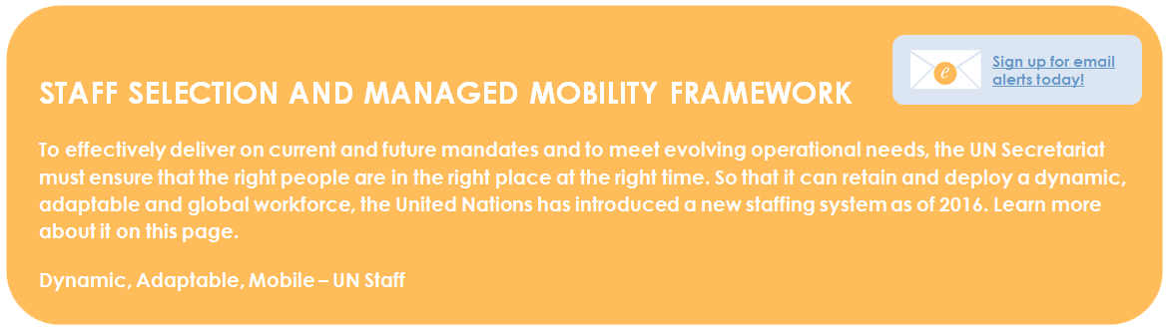

From UNHCR:

A unique, even defining, aspect of UNHCR is its mandatory mobility policy for international professional staff. A system of staff rotation is essential to UNHCR’s capacity to deliver its mandate, as it ensures the availability of staff worldwide to respond to the needs of people of concern, even in duty stations with difficult living and working conditions. Operationally, the rotation system brings added complexity to the responsibility of managing, caring for and supporting UNHCR staff, yet it is contingent upon a degree of burden-sharing among staff. This People Strategy first commits to ensure that rotation is implemented in a fair and transparent manner. In addition, it will seek to implement rotation in a way that builds skills and experiences that are supportive of career development, and is aligned with evolving organizational needs.

UNHCR is committed to managing the assignments process to provide greater notice in advance of staff moves and to administer assignments in timeframes that are sensitive to the impact on their personal lives. The policy and processes behind assignments must provide an equitable framework for rotation and preserve the operational flexibility required to meet today’s global challenges. They must also give due consideration to the welfare of staff and their families through substantial forward planning and timely, open communication.

What participants reported about other agencies’ Mobility programs (all reports are unverified)

- Candidate selection is a joint process, but always more centralized (75% DHR input, 25% hiring office input) ; it seems no one else uses a competitive application process
- No staff member is asked to rotate unless there are at least 3 (?) suitable positions (women can name 10 preferences) in the pool that year
- "Lowest common denominator" strategy is used to make auto-matches (not "matches made in heaven," as UNICEF does) to reduce displacement. The posts that are hardest to fill, and the staff who are hardest to place, are matched first, and even if the candidate is lowest in the rank of preferences by a hiring manager, and the post is the staff member’s lowest ranked preference—a match will be assigned if that match is the only option in the pool.
- Point system for past moves (several UNICEF staff did indicate they felt their previous field experience—even at other agencies—should give them a better chance at "H/ A/ B" posts.
- Staff Between Assignments pool (SBA)
- Return to home country intermittently
- Organization tells staff where to live and send kids to school (housing option provided by default)

A strategy could be to bring a proposal for a joint exploration of Mobility to the UN reform meeting in September.

General Issues with Mobility and Arguments Against the Policy

Though the focus of this research project was to determine what might improve the implementation of mandated Mobility at UNICEF, the following general contentions with mandated Mobility were expressed as follows:

- The expense of relocation, as well as the cost to Country Offices for double incumbency—they often can’t
afford it.
- There was one report of having no local HR contact who works with Mobility—or HR staff being swapped out so frequently that they can’t understand the context.
- Staff members feeling fear of getting “stuck” in the field (even in “A” duty stations that are more isolated), especially considering the networking aspect, and stigmatization of “H” to field moves.
- “I would be careful about accepting a post somewhere like Macedonia. You’re likely to be forgotten there.”
- Family issues; staff members often hinted at the relationship to UNICEF’s mandate when they would comment that “UNICEF wants you to care about everyone’s children but your own” or “I’m married to UNICEF.” Some staff members wanted the research team to conduct focus groups with staff’s children or to gather data on divorce rates and mental health issues.
- “My daughter said ‘UNICEF must hate children, they keep separating moms and children.’”

- Many staff wondered what was being done to assess whether Mobility was meeting organization goals, if this was being measured. Staff also cited the need to “reset the cycle on proficiency” every time a move is made, as well as loss of both institutional memory and commitment to seeing projects through as potential detractors from the benefits Mobility may bring. Staff discussed the limited amount of time they have, as a result of the Tour of Duty rules, to adjust to the new post, focus on the job at hand, and start looking for a new post.
- “When people are on the way out, they often give up and leave things a mess.”
- “I did the math once with HR in headquarters—out of a four-year period you're only getting two and a half years of actual work in. And the rest of time is either spent arriving are leaving or thinking about the next place. And so if you think about as an organization, you multiply that out. That's a huge amount of time.”
- Some staff members described any policy that tries to “force” a move as having low appeal. There was even one parallel drawn to slavery, and criticism of applying rules retroactively.
- “In any other workplace seems it would be illegal to change someone’s job contract. That is a general problem at UNICEF— it changes rules and entitlements that kicked off our contracts.”
- A few staff discussed the awkwardness of planning moves while working, and that managers don’t always support valuable staff members leaving an office, despite the mandate.

Participant analysis
Primary Motivators (Psychographic Segmentations)
Derived through extensive conversations in the qualitative phase, motivational patterns were noted based on how staff conveyed their top priorities in working through decisions around Mobility—what’s most important to them, what they are willing (or not) to comprise on, sacrifices, desires, and pain points.

Some staff members can be categorized under several of the following segments. Note that staff in the first two segments have already made up their minds that they will either just abide by the policy, or won’t. Mobility appears to be more of a principle or philosophy to them—very "black and white”—rather than something to make a decision about, based on dependencies.

- Mobility believers/ accepters (often managers or staff with many years’ tenure, TODs ingrained – “7, 8 years in an H duty station is just way too long”)  a. Those who believe their jobs should be rotational (but are not) | 8. “Field person”
- Mobility non-believers (usually qualification arguers)* | - HQ person (“my personality is not suited to the field”)
3. Relief seekers (almost always C/D/E staff, but not all) | 10. Those with especially limited options (specialists/ higher level), but in posts still currently categorized as rotational
4. R&R preferers (don’t want UNICEF to tell them they can’t move E to E) | - Family-restricted (Mobility is a deal-breaker due to dependents, period)*
- Security seekers  a. UNICEF “lifers”* | 12. Settlers (tired of moving)*
 | 13. “Homing pigeons”
- New challenge seekers  - Promotion seekers*  - Cross-function seekers*  - Free agent/ variety seekers (often inter-agency) | - UNICEF couples (spousal dual employment challenge)
7. Functionally miscategorized (want to be presented in a more accurate way functionally) | 15. LGBT (spousal employment + targeting issues)* (Women have targeting issues to some extent too)
*appear to be most dissatisfied with either the mandate or policy/ process – highly emotional responses

Some specific staff scenarios that match the above segmentations were as follows:

- Mobility believer/ accepter: a manager in Geneva who have moved several times, even with a baby (with childcare support from her mother-in-law help and teleworking); she still just accepts and believes in Mobility

- Mobility non-believer: a Copenhagen staff member who criticized any kind of mandated Mobility— his group had to vacate a fellow staff member’s post only to find the post could not be filled by staff on rotation; he added that, “we could have hired someone locally”

- Relief seekers: staff member in a “D” duty station, described as “non-family for political reasons” whose daughter has received harassment and threats (previously quoted)

- Security seekers: most staff from program or developing countries; many staff in “E” duty stations, including those happy to move “E” to “E”
- UNICEF “lifers”: staff members who became very emotional the final week before the reassignment communications were sent out, fearing that rotation would mean separation, and that after their 20+ years at UNICEF they would have few other options

- Promotion seeker: staff member who turned down several Head of Field Office posts because he was holding out for a promotion to P5 on rotation

- Cross-function seeker: staff member who set his sights on crossing over into Fundraising, had “PFP on speed dial,” but was highly suspicious that he was being taken seriously as a candidate
- Free agent/ inter-agency: staff member in Kabul who commented that he thrived on variety in his work, didn’t see UNICEF as a “cradle to grave career,” and seemed confident that he would have other agency options for moves if another post with UNICEF didn’t work out in the near future
- Functionally miscategorized: staff member categorized under Programme Management who feels her focus is more on Operations, but won’t be considered for Operations roles
- “Field person”: self-described staff member in Copenhagen (also a cross-function seeker) who wanted to join the rotation exercise, but had a TOD end date that was a few months too early, and has now accepted another job offer
- HQ person: staff member in New York who said that being around others who are suffering drains her of her productive work energy
- Those with especially limited options (specialists): staff member in Nairobi who is a Statistician
- Family-restricted: quite a few staff members (men and women) with a spouse who refuse to move, and those with children
- Settlers: staff member in Geneva, who had been relocated from New York, served in Sri Lanka, got pregnant in an “E” duty station, and now wants to settle in one place with her children (and stop buying IKEA furniture)
- “Homing pigeons”: staff member in Copenhagen who wants to return to Kenya so his kids can experience the culture he grew up with “before it is too late,” but knows he would have to become NO again; staff member who took a demotional move on rotation, happily, because he and his family are moving to the country where his wife is from
- UNICEF couples: staff members, one managerial, not currently living with partner due to challenges of rotating to the same place at the same time
- LGBT: staff member who may have set his sights on a difficult “H” to “H” cross-functional move, partly because of issues around spousal employment and having to “hide” his spouse in many field locations
The above can aid in testing various Mobility policy and process scenarios to predict outcomes—such as if, where, and under which circumstances staff members are most likely to move to fulfill the policy requirements, as well as pain points they will encounter along the way.

Suggestions by area of focus

The following are general groupings of suggestions for pathways forward, by area of focus for further investigation or ideation—rather than specific fixes for the complex problems that the Mobility program is facing. Not all areas may be feasible or desirable to pursue, but these should be considered potential pathways to ensuring the Mobility team has done all it can to think through solutions.

Several areas of focus could be pursued at once, and each one requires different co-creators and time investments.

Suggestion 1: Review and debate Mobility’s goals

Objective: better confidence about the program’s purpose, and possibly more realistic goals

Discuss the Mobility program’s goals or points of rationale, and score the program on how well it’s achieving them. Flesh out and analyze all the objections to the current goals. Then consider if there are other reasons for Mobility that may be more motivating and achievable.

Example - Current goal: To increase UNICEF’s agility in shifting between humanitarian and developmental mandates (by sending IP staff where the organization needs them to go)

  - Does the Mobility team feel staff members are being placed where UNICEF truly needs them? And for the length of time they are needed? Are staff getting a good mix of humanitarian and developmental experiences, and are they happy shifting between them? (How might you gather this feedback?)
  - Do the Tour of Duty dates serve as the best organizing principle to help fulfill UNICEF’s needs in this manner?

A more effective goal usually results in fewer objections:

Example - Proposed goal: To ensure proper field context is considered in the creation of UNICEF deliverables, thereby maximizing efficiency and effectiveness

Rationale: Mobility is essential to IP staff in achieving top performance because it allows them to fully understand and stay current with different duty station experiences and contexts. For example, if “H” duty station staff members in IP roles don’t have recent field experience, the quality of results needed for their roles will suffer, such as:
  - Policies
  - Working knowledge of IP/ NO interactions
  - Creating efficient work flows for field processes

Suggestion 2: Develop realistic motivation and encouragement tools for self-assessing next moves

Objective: easier beginnings for harder posts or harder moves (such as cross-functional)

Rationale: If it doesn’t work for the individual, either for personal or professional reasons, they can’t be effective. If they can’t be effective, it doesn’t work for the organization.

Themes: personal suitability and career development

Ideas:
- Written guides on adjusting to life at a “H” duty station or in the field (or counseling)
- Better duty station information through Yammer, better duty station profiles with staff videos, aggregated list of resources on each location
- Personality testing—link to, or integrate with, emergency response intake form
- Model career path stories by functional area (and cross-functional stories)

Suggestion 3: Conduct a more thorough post inventory and functional area analysis
Objective: better matching, less displacement

Analyze upcoming posts (by TOD end dates), associated skills needed; perform a more extensive functional area analysis to determine which posts are interchangeable, and when the most of a given type will become available to rotate.
Theme: supply and demand
Idea: Partner with functional area experts or analysts (possibly independent/ external) to:
- list out specific skillsets needed for different roles (partnering with managers in that functional area)
- create a matching system based on the above parameters
- pinpoint reasons why each IP role requires periodic international exposure (and of what type) or not; in the future, staff members must substantiate how got the field perspective (stretch, previous duty station, communications)
- tie the above to performance; if the role doesn’t require international exposure (repeated), should it be IP?

Then set a threshold for minimum number of posts required at any point there is a rotation; use this as the definition of non-rotational—do away with manager discretion. For example, if there aren’t at least X positions like yours in this year’s potential pool (based on TODs), it’s non-rotational, for this year (see you next year).

Theme: supply and demand
Ideas to free up more "H/ A/ B" posts:

- Cross-functional training program stretch—leave your “H/ A/ B” job to train cross-functionally
- Assist people who want to give up their IP status to return to home country (Mobility team indicates they are working on this, and IP status can be kept now—a plus)
- Assist people who want to rotate early, especially from “H” to the field. (Mark them as “maybes” in the pool). Possibly incentivize with bonus + time off. (One staff member indicated this would help take away stigma too.)
- From the survey - people not aware of entitlements associated with different duty stations (112 just in H’s and RO’s):
- New York 51 - Geneva 22 - Copenhagen 13
- Budapest 3 - Bangkok 3 - Panama City 3
- Dakar 2 - Kathmandu 2 - Amman 6
- Nairobi 7

Theme: supply and demand
Idea : incorporate mathematical/ statistical modeling :

- Write algorithms
- “E” duty station service: if everyone did it once, would it work?
- Past successful rotational periods within functional areas: for example, a statistical analysis of how WASH staff have moved

Suggestion 4: Address networking, bias, and stigma barriers through alternative power structures and performance remedies

Objective: less bias, less time spent, more fairness, better matches, less displacement

Explore centralization: redistribution of power from hiring managers and Regional Directors to DHR, functional area leads, or functional analyst consultants.

Keep in mind that when managers have so much power in this system, they have more leverage in deciding the goals, rationale, and rules on their own. Examples: to keep a dream team around me, to help my friends keep jobs, “H” to “H” is not true Mobility, I can’t ask a single mom to separate. Some of these were actual reasons cited by managers I interviewed (and some reasonable objections to Mobility—but the rules need to be clear and consistently handled).

Themes: performance, transparency (distrust), application process
Idea: centralize the candidate selection process, but give managers an easier remedy for poor performers
- Fast-track PIP, “rubber room?” Are there options for rotating staff who are found to be poor performers?
- Staff member signs “terms of acceptance” of agreeing to direction and specific responsibilities of a post upon applying, and additional training if needed (idea: provide budget for training).
- Organize a hiring managers’ follow-up discussion about performance after you announce you are leaning toward a more centralized structure. Facilitate a frank discussion on PERS, perceived quality of internal candidates, minimizing the networking/ “who you know” culture, concerns with candidate screening. See “inclusive networking” idea, next, for rough ideas on help a better kind of screening for all.
- Important: how to regulate “private swaps” and delayed post advertisements? Make rotational pool continuous and prioritized, like abolished posts pool?

Themes: networking
Idea: facilitate inclusive remote networking that’s more interesting and effective than the "Old Boys + Girls Club"

- Functional gatherings by Skype/ Zoom with show and tell—required attendance to X per year
- Expanded profile pages where staff can add different types of content showcasing their accomplishments at UNICEF (and outside)—like a creative CV; make it mandatory to add a video or audio clip, so managers can hear how staff speak (make sure they can understand them, communicate with them effectively).
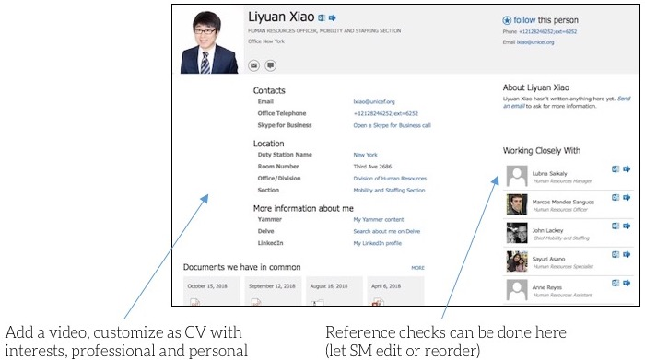

Suggestion 5: Facilitate broad ideation of new systems (co-creation)

Objective: more matching and rotation ideas; greater input into and acceptance of solutions

Design thinking approach

Brainstorm and test your ideas against the discovered Mobility primary motivators (psychographic segmentations)
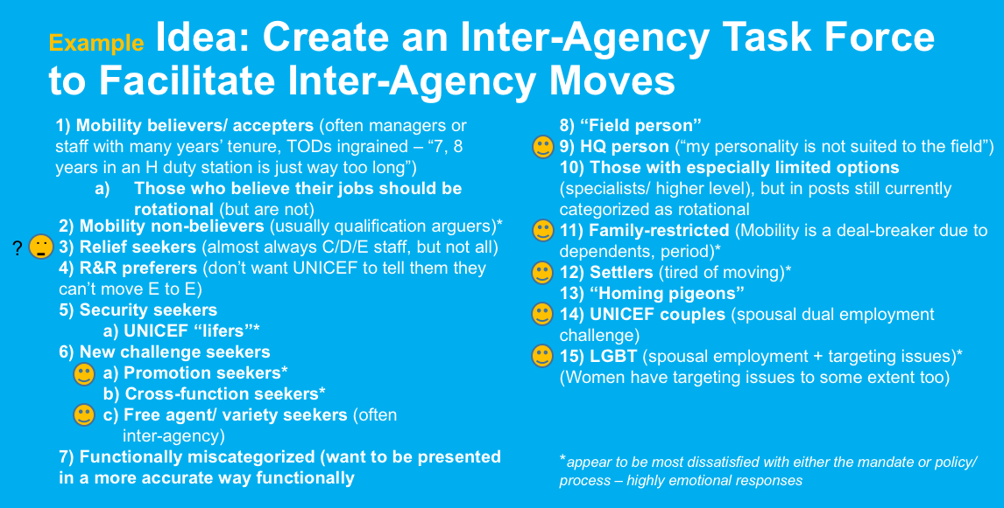

Collect and review ideas (see Appendix A), brainstorm your own.
Brainstorming rules: no idea is too outrageous or out of bounds. Sometimes, the more outrageous the idea, the more likely it is to point out parameters of the problem.

Be sure to list out all the possible objections to any idea by both hiring managers and rotating staff.
Some things sound great on paper, until you see how they actually play out (staff said a few times).
Ideas such as…
- Giving staff advance notice (publishing posts with correlating TODs far in advance)
- Encouraging private swaps, minimizing the actual rotation pool
- Skipping interviews all together
… all have their dark sides (potential for poor outcomes).

      - Test a few ideas of your best ideas with staff: gather feedback via a survey, or test pilot the new approach with a smaller group.

Systems thinking approach

Integrate systems theory in your analysis. Map known issues by theme against potential leverage points using systems theory.

Places to intervene in a system (Donella Meadows)

- Mindset or paradigm behind the system
- Goals of the system
- Power structures
- Rules (including penalties and incentives)
- Information Flows (who has access to what information)
- Material Flows (supply and demand)
- Regulating positive feedback loops
- Regulating negative feedback loops
- Constants, parameters, numbers

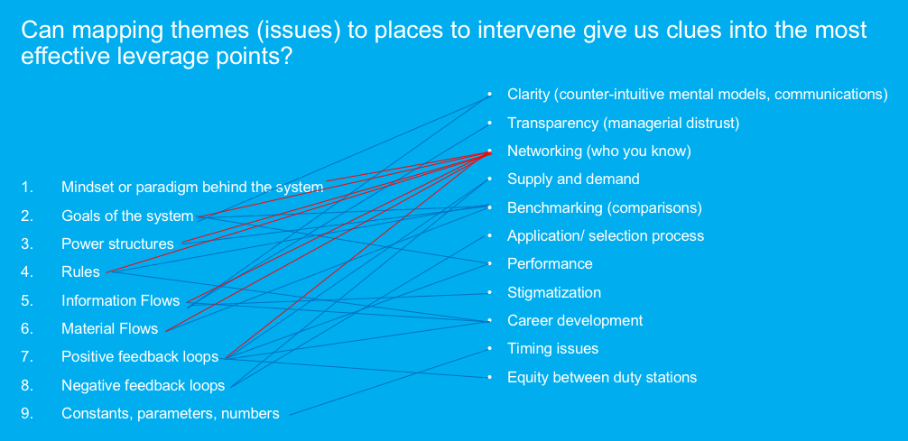

Futures thinking approach

How might the following impact Mobility at UNICEF?
- UN reform
- UN assessing and aiming for net zero on its own carbon footprint
- … ?

A final recommendation: think out of the box—especially the confining exercise box

Rotation exercise... or...
- periodic regional restructuring? (benefits: faster, no application time, implication of more realistic outcomes based on
randomness)
- better alerts for jobs matching your preferences delivered to your inbox/ intranet home page
- “field service campaign” (what if DHR inventoried all IP staff with a strong message that UNICEF needs more service in “C/ D/ E” duty stations, and see under what conditions and when they would be willing—then compared that with movements forced by TODs?)
- points off on PER for not moving (without deferment)

i.e., Considering thinking less about creating the perfect “exercise,” and more about a better mix of assistance, incentives, and penalties.

A final option: Stay the course and improve communications only (low-hanging fruit)

- Rename the exercise to something like the “Mobility Assistance Exercise.” It’s more accurate, as DHR is assisting staff, but not really managing anything—it’s still on staff to make the matches happen.
- Release a strong statement refuting rumors, busting myths (especially about the lack of quality of rotation candidates and posts), and encouraging field moves. Give them a realistic idea of outcomes. Say the word “separation.”
- Develop one-pagers for managers, reference docs, concise orientation package: include all the behind-the-scenes actions, actors making decisions, and rules applied; don’t just think in terms of “staff notifications”—they want to know what everyone else involved is doing and deciding too.
- Include a link to career coaching integrated into all communications.
- Prioritize Mobility “need to know” content on intranet pages (review information architecture of HR intranet pages)
- Consider what “radical transparency” would look like: create transparency-increasing docs and reports (early posts, deferment and non-rotational results, placement results and displacement), candidate feedback. Set stricter guidelines for hiring managers to communicate with candidates consistently and accurately.
- Find ways to keep status of applications better updated in application modules. When these weren’t updated by deadlines indicated, staff have wondered how serious the rotation team could be.

Appendix A: More ideas
- 2 years teleworking post options with intermediate stretch for “E” and “D” duty station staff (job sharing to help an overloaded staff member anywhere, remotely; UNICEF saves on the relocation money)
- Phased rotation: “C/ D/ E” chooses/ applies for posts first (and managers have to provide written justification for turning down “C/ D/ E” applicants), “H/ B/ A” chooses second; for displaced staff, give options of SBA (Staff Between Assignments) or cross-functional training programs—decide at that time if top tier or middle tier priority based on PER input not just from supervisor, but co-workers. For top-tier, first priority. For both, trial stretches.
- Stretch whenever possible to relieve “E” duty station staff of burden (deferring staff members who can feasibly do these stretches are first asked)
- Equitable sharing: is there a way for people who defer to take up some of the burden of the system they are not participating in, such as required facilitated networking, mentoring, cross functional facilitation?
- Posts for UNICEF “veterans” (+15 years) to be keepers of institutional memory and documentation, facilitators of better induction programs (option for non-management but senior roles)
- Default housing provided (helps with networking too)
- Losing IP benefits/ salary/ entitlements if staff member doesn’t rotate (Michael Bickel’s idea)—recategorizing IP to something else

From IP staff
- Start after minimum TOD, would help take away stigma, lack of focus
- No promotions within the same duty station
- Mandatory rotation only for H/ A/ B duty stations
- Org. should consider ways to be flexible; e.g. remote work, specifically around family separation issue;
- I was told could not do that, but that was crazy–I know I could do the work remotely.
- Maybe DHR should also identify staff members who are willing to go away if can come back, versus those who can move around.
- Could have everyone eligible for the next year immediately available on a list to view April 15
- Less frequent Mobility; use the money saved by not paying for so much relocation and invest it in career development
- If staff have outstanding PERs, they should be allowed to stay longer (or leave early, get personalized help)
- Do a “pre-clearance” performance evaluation, similar to SSRE, maybe with an external firm. (Maybe mandatory PIP if not a good performer; not rotating could be seen as a reward.)
- Emergency Education Specialists, Polio Immunization Specialists – could take 6-month break, have an HQ desk job working on policy, for example. These folks are labeled as Emergency but have other skillsets, could go into Surge roles, but based in NYC; if need emergency help—fill for a couple of weeks, then come back.
- Add posts to the pool from emerging areas such as climate change action, risk informed programming

From HR staff in Nairobi
- So not to just give lip service, we should prevent / limit same duty station moves, e.g. from HQ to HQ. Perception is that we are not serious about it which also affects the success of exercise.
- Start earlier; ahead of time, review staff list to start discussions and provide advice, then apply lateral reassignment approach. Thereby shortening the list for managed rotation.
- We receive link to Sharepoint, but don’t have access to confirm if a staff member is eligible for rotation.
- Staff members on rotation should have more direct communication with CO hiring offices rather than DHR/ RO.
- Note for NYHQ: Do not use the regional office as the mailing office for deferment—staff member should contact directly the COs for personal reasons. This way, RO doesn’t do the data entry.
- For organizational requests for deferment, should go through RO for endorsement then submission.
- The staff member’s preferences should be made very clear on the applications. Why not have together instead of separately? Some staff don’t realize they have to apply after providing preferences.
- November is very bad timing: annual reporting, PER, holidays, etc. All priorities happen at end of year. Stop schedule from Dec to Jan., overloaded already during this time.
- Note: posts left vacant due to rotated s/m, can’t be advertised until allowed.
- Need list of displaced /staff in functional areas shared for us to be able to “push/recommend” them for vacant posts (to encourage hiring managers).
- Rules should be applicable to everyone. With the new quadrennium, all the interesting new posts created were only slated for those on mobility exercise.
- 15 staff who moved outside the rotation exercise from “E” to “E” is okay, but within mobility, not okay to move from “E” to “E” as prior SWB clearance required.
- With functional groups, panels should be staggered as not much cross-functional moves occurring.
- Huge timeline doing staff list—should be shorter; there is an imbalance of allocation of timeline; shorten other periods.
- For displaced staff, need clarification on the process when considered for a TA and staff member accepts. How are entitlements affected and how is this flagged in TMS?
- Flags in TMS stays with the staff member—at what time is it removed? E.g. A flag was given 3 years ago and staff member already served TOD.
- When the rotation or DED decision is not aligned with the CO selection, CO should be informed.

Appendix B: Survey analysis
The IP staff survey had several skippable questions, with an 88% overall completion rate. Th P6/ D1/ D2 survey was much shorter with 100% completion rate and 2 skippable questions.
View Dashboard of overall results for all IP staff.

View Dashboard of results for women (IP).

View Dashboard of results for men (IP).

View Dashboard of results for participants of the 2018 managed rotation exercise.
View Dashboard of results here for supervisors’ questions only. (Note: it was found in the qualitative phase that a large percentage of supervisors who answered affirmatively here do not supervise IP staff—only NO or GS.)
View Dashboard of results here for HR staff questions only.
View Dashboard of results here for P6/ D1/ D2 survey.

Overview of IP respondents – demographics + professional profiles
GENDER OVERVIEW Woman 50.28% 619  Man 49.07% 604  Gender variant/ non-conforming 0.65% 8  TOTAL 1,231  REGIONAL COHORTS  Women in WCAR had a lower response rate than men in completing the survey, to a greater degree than other regions (8% variance between response rate and actual IP staff); similarly in LACRO (3% fewer) and SAR (2% fewer). Women were 5% more responsive to the survey than men in EAPRO and 11% moreso in ECAR.  WCAR 61.31% men, 38.69% women (55%, 45% actual)  ESAR 50.43% men, 48.70% women, .87 gender variant/ non-conforming (52%, 48% actual)  LACRO 54% men, 46% women (51%, 49% actual)  ECAR 36.96% men, 63.04% women (48,% 52% actual)  SAR 53.61% men, 45.36% women, 1.03% gender variant/ non-conforming (52%, 48%)  MENAR 50% men, 48.31% women, 1.69% gender variant/ non-conforming (49, 51% actual)  EAPRO 42.42% men, 57.58% women (47% 53% actual)  HQ 43.11% men, 56.12% women, .77% gender variant/ non-conforming (43%, 57% actual)  SUPERVISOR COHORT  Woman 45.55% 389  Man 53.86% 460  Gender variant/ non-conforming 0.59% | FAMILY SITUATIONS I have a spouse or partner 72.94% 833  I have dependents 69.79% 797  I am a single parent 7.27% 83  I participate in care-giving for dependents or extended family (such as parents) 25.13% 287  Total Respondents: 1,142 (89 maximum assumed single with no dependents or caregiving responsibilities – 67 women  and 16 men)  GENDER COHORTS  Women  I have a spouse or partner 64.49% 356  I have dependents 60.14% 332  I am a single parent 13.41% 74  I participate in care-giving for dependents or extended family (such as parents) 29.17% 161  Total Respondents: 552 out of 619  (67 women max presumed single/ no dependents/ no caregiving responsibilities)  Men  I have a spouse or partner 80.82% 472  I have dependents 78.94% 461  I am a single parent 1.20% 7  I participate in care-giving for dependents or extended family (such as parents) 21.40% 125  Total Respondents: 584 out of 604  (16 men max presumed single/ no dependents/ no caregiving responsibilities)  MAX SINGLES=13.32% (including single parents)  REGIONAL + DUTY STATION CLASSIFICATION COHORTS (notable regional variances):  E duty station staff, non-family duty station staff, SAR and LACRO staff indicated that they participate in caregiving for dependents or extended family 10-13% more than the average.  I participate in care-giving for dependents or extended family (such as parents) (E duty station: 38.46%, SAR: 36.96%, LACRO: 32.61%)  Non-Family Duty Stations  I have a spouse or partner 64.45% 136  I have dependents 67.30% 142  I am a single parent 6.16% 13  I participate in care-giving for dependents or extended family (such as parents) 36.02% 76  Total Respondents: 211  E Duty Stations  I have a spouse or partner 66.44% 97  I have dependents 67.81% 99  I am a single parent 6.16% 9  I participate in care-giving for dependents or extended family (such as parents) 39.04%  D Duty Stations  I have a spouse or partner 72.04% 67  I have dependents 75.27% 70  I am a single parent 7.53% 7  I participate in care-giving for dependents or extended family (such as parents) 31.18%  C Duty Stations I have a spouse or partner 68.91% 82  I have dependents 64.71% 77  I am a single parent 8.40% 10  I participate in care-giving for dependents or extended family (such as parents) B Duty Stations 25.21%  I have a spouse or partner 70.59% 120  I have dependents 72.35% 123  I am a single parent 3.53% 6  I participate in care-giving for dependents or extended family (such as parents) 19.41% 33  A Duty Stations I have a spouse or partner 66.96% 75  I have dependents 75.00% 84  I am a single parent 13.39% 15  I participate in care-giving for dependents or extended family (such as parents) 20.54% 23  ROs  I have a spouse or partner 80.39% 123  I have dependents 70.59% 108  I am a single parent 7.19% 11  I participate in care-giving for dependents or extended family (such as parents) 26.80% 41  Total Respondents: 153  H Duty Stations  I have a spouse or partner 77.08% 269  I have dependents 67.62% 236  I am a single parent 7.16% 25  I participate in care-giving for dependents or extended family (such as parents) 21.20% 74  Total Respondents: 349

REGIONAL OVERVIEW (strong congruity of respondents to actual IP staff; in other words, survey respondents reflected actual regional balance of IP staff very closely)  respondents actual IP  EAPRO 99 (8.04%) 278 of 3761 (7.39%)  ECAR 46 (3.74%) 156 of 3761 (4.14%)  SAR 97 (7.88%) 256 of 3761 (6.81%)  MENAR 118 (9.59%) 397 of 3761 (10.56%)  WCAR 199 (16.17%) 636 of 3761 (16.91%)  ESAR 230 (18.68%) 605 of 3761 (16.08%)  HQ 392 (31.84%) 1277 (33.96%)  Visualization of respondents by duty station:  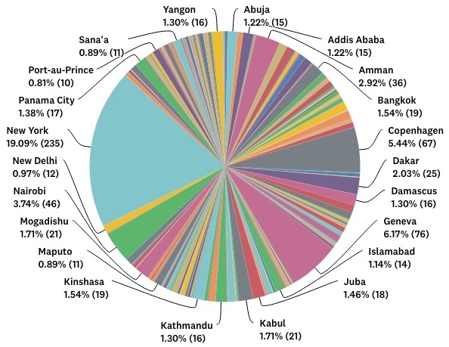 | DUTY STATIONS OVERVIEW  Non-family: 226 respondents (40.27% women, 59.29% men, .44% gender-variant)  E duty stations: 154 (37.66% women, 61.69% men)  D duty stations: 99 (40.4% women, 58.59% men)  C duty stations: 124 (53.23% women, 46.77% men)  B duty stations: 180 (50.56% women, 49.44% men)  A duty stations -282  ROs: 159 (44.65% women, 54.09% men)  Other A: 123 (59.3% women, 39.84% men)  H duty stations: 392 (56.12% women, 43.11% men)  REGIONAL COHORTS  HEADQUARTERS respondents: NYC (235), CPH (67), GENEVA (76), BUDAPEST (13), WASHINGTON (1) - 34% of respondents  WCAR (199 respondents)  RO – 25  A 28 (inc RO)  B 34  C 54  D 66  E 17  Number of respondents by duty station with corresponding classification:  Kinshasa (C 19), Abuja (C 15), Bamako (D 12), Luanda (B 10), N'Djamena (D 10), Freetown (D 10), Ouagadougou (C 9), Bangui (D 8), Conarky (D 8), Accra (B 8), Niamey (C 7), Cotonou (B 5), Monrovia (D 5), Bissau (E 5), Abidjan (B 4), Lome (B 3), Maiduguri (E 3), Nouakchott (D 3), Libreville (A 3), Tamale (B 2), Yaounde (B 2), Moroni (D 2), Malabo (D 2), Bol (E 1), Diffa (E 1), Enugu (C 1), Goma (D 1), Kaduna (D 1), Kalemie (D 1), Kananga (D 1), Katsina (D 1), Lagos (C 1), Maradi (E 1), Mongo (E 1), Moundou (E 1), Nzerekore (D 1), Port Harcourt (C 1), Sokoto (E 1), Bertoua (C 1), Bunia (E 1), Bambari (E 1), Bauchi (E 1)  ESAR (230 respondents)  RO – 46  A 60 (inc RO)  B 74  C 35  D 6  E 55  Number of respondents by duty station with corresponding classification:  Mogadishu (E 21), Juba (E 18), Addis Ababa (B 15), Antananarivo (B 12), Kampala (B 12), Bujumbura (C 11), Dar-es-Salaam (B 11), Maputo (B 11), Khartoum (C 10), Lilongwe (B 7), Harare (C 6), Lusaka (B 6), Asmara (D 5), Kigali (A 5), Pretoria (A 4), Maseru (C 4), Garowe (E 4), Dijibouti (C 3), Mbabane (A 2), Kadugli (E 2), Windhoek (A 2), El Geneina (E 1), Gambela (E 1), Gulu (C 1), Jijiga (D 1), Johannesburg (A 1), Malakal (E 1), Rumbek OLS (E 1), Zalinguei (E 1), Wau (E 3), Bentiu (E 1), Bor (E 1)  LACRO (50 respondents)  RO – 17  A 39 (inc RO)  B 1  C 0  D 10  E 0  Number of respondents by duty station with corresponding classification:  Port-au-Prince (D 10), Mexico City (A 4), La Paz (A 4), Bogota (A 3), Brasilia (A 2), Belize City (A 1), Buenos Aires (A 1), Castries (A 1), Guatemala City (A 1), Lima (A 1), Managua (B 1), Quito (A 1), San Salvador (A 1), Santo Domingo (A 1), Tegucigalpa (A 1)  ECAR (46 respondents)  A 43  B 3  C 0  D 0  E 0  Number of respondents by duty station with corresponding classification:  Ankara (A 12), Florence (A 7), Brussels (A 5), Gaziantep (B 3), Istanbul (A 3), Athens (A 2), Belgrade (a 2), Chisinau (A 2), Berlin (A 1), Bucharest (A 1), Minsk (A 1), Podgorica (A 1), Prishtina (A 1), Rome (A 1), Sarajevo (A 1), Skopje (A 1), Sofia (1), Kiev (A 1)  MENAR (118 respondents)  RO – 36  A 47 (inc RO)  B 13  C 2  D 7  E 49  Number of respondents by duty station with corresponding classification:  Damascus (E 16), Sana’a (E 11), Baghdad (E 9), Beirut (B 9), Erbil (D 7), Tripoli (E 6), Gaza (E 3), Riyadh (A 3), Dubai (A 2), East Jerusalem (B 2), Ashkabat (C 2), Tunis (A 2), Hodeidah (E 1), Aden (E 1), Aleppo (E 1), Algiers (B 1), Astana (A – 1), Cairo (A 1), Alexandria (A 1), Rabat (A 1), Taizz (E 1), Teheran (B 1)  SAR (97 respondents)  RO – 16  A 23 (inc RO)  B 20  C 27  D 1  E 26  Number of respondents by duty station with corresponding classification:  Kabul (E 21), Islamabad (C 14), New Dehli (B 12), Dhaka (C 10), Bishkek (B 3), Tashkent (B 3), Thimphu (C 3), Jalalabad (E 2), Colombo (A 2), Tbilisi (A 2), Lucknow (A 2), Cox’s Bazaar (D 1), Dushanbe (B 1), Jaipur (A 1), Kandahar (E 1), Nepalgunj (E 1), Osh (B 1), Peshawar (E 1)  EAPRO (99 respondents)  RO – 19  A 42 (inc RO)  B 35  C 6  D 9  E 7  Number of respondents by duty station with corresponding classification:  Yangon (B 16), Jakarta (A 8), Pyongyang (E 7), Beijing (A 7), Phnom-Penh (B 6), Vientiane (B 4), Suva (B 4), Port Moresby (D 4), Port-Vila (B 3), Hanoi (A 3), Dili (C 3), Sittwe (D 2), Tokyo (A 2), Honiara (D 2), Kuala Lumpur (A 1), Kupang (C 1), Manila (A 1), Pohnpei (B 1), Seoul (A 1), Tarawa (C 1), Ulan Bator (B 1), Banda Aceh (C 1), Cotabato City (D 1)  D1/ D2 Managers of IP Staff (15 respondents total)  Functional areas: 2 Programme Mgmt, 2 ICT,  2 Fundraising, 2 Dep Rep, 2 Administration,  1 Communication, 1 Operations, 1 WASH, 1 Partnerships, 1 Research/ Planning/ Monitoring  Numbers of respondents by duty station:  Brussels – 1  Bujumbura – 1  Copenhagen – 1  Florence – 1  Geneva – 1  Kabul – 1  New Delhi – 1  New York – 6  Pretoria – 1  Tokyo – 1
LEVELS P1 respondents 0.16% 2 actual IP .41% (17)  P2 6.66% 82 10.22% (423)  P3 (3 % more women than men responded, compared to gender balance of P3 IPs) 28.84% 355 34.95% (1447)  P4 (10% more responsive overall than P3 / P2 / P1 compared to actual IP at these levels) 47.20% 581 37% (1532)  P5 (4% more men than women responded, compared to actual gender balance of P5 IPs)) 17.14% 211 17.42% (721)  TOTAL 1,231 | PREVIOUS EMPLOYMENT Other UN agency 33.63% 414  Other nonprofit 42.24% 520  Government 20.23% 249  Private sector 27.13% 334  Academia 12.59% 155  Other (please specify): (research institutes, donor agencies, media/ journalism, healthcare, EU, self-employed, World Bank, banking and finance) 8.61% 106  Total Respondents: 1,231
FUNCTIONAL AREA  Administration 1.47% 16  Adolescent Development 0.55% 6  Audit + Investigation 0.37% 4  Child Protection 5.16% 56  Communication 5.25% 57  Communication for Development 1.75% 19  Deputy Representative 3.32% 36  Early Childhood Development 0.37% 4  Education 7.00% 76  Emergency 3.04% 33  Facilities Management 0.18% 2  Financial Management 3.04% 33  Fundraising 2.40% 26  Gender Development 0.46% 5  HIV/ AIDS 1.38% 15 | Health 6.73% 73  Health + Nutrition 4.33% 47  Human Resources 3.23% 35  Information Communication Technology 3.78% 41  Innovation 0.55% 6  Knowledge Management 1.20% 13  Legal 0.18% 2  Nutrition 2.30% 25  Operations 11.24% 122  Partnerships 4.88% 53  Programme Management 8.48% 92  Research, Planning, and Monitoring 6.64% 72  Security 1.94% 21  Social Policy 3.69% 40  WASH 5.07% 55  TOTAL 1,085
SUPERVISORS (Do you supervise others?) - IP
Yes (but quite a few manage only NO or GS staff)  27-29% have managed rotating IP staff (see below) | 78.93%  854
TOTAL | 1,082
EXPERIENCE MANAGING OR HIRING ROTATING STAFF

IP
I have managed staff that have rotated to duty stations outside my region | 65.83%  289 (26.71% of total)
I have hired staff from duty stations outside my duty station's region  P6/ D1/ D2 | 71.98%  316 (29.2% of total)
I have managed staff that have rotated to duty stations outside my region |  | 92.31%  12
I have hired staff from duty stations outside my duty station's region |  | 100.00%  13

ROTATION EXPERIENCE (survey branch for those who have rotated)
OVERALL Yes, I have rotated. 47.04% 532  No, I have not yet rotated. 52.96% 599  TOTAL 1,131  H Duty Stations  Yes, I have rotated. 37.82% 132  No, I have not yet rotated. 62.18% 217  TOTAL 349  ROs  Yes, I have rotated. 50.00% 73  No, I have not yet rotated. 50.00% 73  TOTAL 146  A Duty Stations  Yes, I have rotated. 57.89% 66  No, I have not yet rotated. TOTAL 42.11% 48 114  B Duty Stations  Yes, I have rotated. 48.52% 82  No, I have not yet rotated. 51.48% 87  TOTAL 169  C Duty Stations  Yes, I have rotated. 49.15% 58  No, I have not yet rotated. TOTAL 50.85% 60  D Duty Stations  Yes, I have rotated. 47.25% 43  No, I have not yet rotated. 52.75% 48  TOTAL 91  E Duty Stations  Yes, I have rotated. 54.17% 78  No, I have not yet rotated. 45.83% 66  TOTAL 144 | MANAGED MOBILITY EXERCISE PARTICIPATION  2018 56.11% 248  2017 30.54% 135  2016 24.66% 109  Total Respondents: 442
PLANNING FOR ROTATION  Over 2 years in advance 21.21% 109  Over 1 year in advance 44.94% 231  Less than 1 year in advance 33.85% 174  TOTAL 514 | JOB SATISFACTION AFTER ROTATION  (some objections to question – what does current job satisfaction have to do with rotation?)  Positive 58.37% 300  Somewhat positive 22.57% 116  Somewhat negative 5.64% 29  Negative 1.75% 9  A mix of positive and negative 11.67% 60  TOTAL 514  True –– False – Total  The post fits into my career aspirations well. 85.13% 435 14.87% 76 511  – The post is giving me valuable new skills. 88.48% 453 11.52% 59 512  – The post is helping me to gain a new perspective. 90.04% 461 9.96% 51 512  – I'm getting to see a more direct impact of my work. 63.83% 323 36.17% 183 506

POLICY + PROCESS
AWARENESS OF POLICY PRIOR TO EMPLOYMENT Yes 60.76% 748  No 39.24% 483  TOTAL 1,231 | CLEAR AND COMPELLING REASONS FOR MOBILITY (MULTIPLE-SELECT) Breaking down “silos” (better understanding between all locations and functions) 62.31% 724  Broadening of skillsets globally 73.49% 854  Increasing UNICEF’s agility to move between developmental and humanitarian work 53.96% 627  Safeguarding against fraud 28.06% 326  Equitable sharing of UNICEF’s responsibilities and opportunities 63.86% 742  Other (please specify): 17.90% 208  Total Respondents: 1,162

MOST CHALLENGING ASPECT OF MOBILITY  Very challenging Challenging Somewhat Not at all  Securing a new position 47.67% 543 35.38% 403 13.78% 157 3.16% 36  Support for family issues related to moving 43.93% 499 31.60% 359 17.17% 195 7.31% 83  Spousal employment 63.88% 695 17.10% 186 8.00% 87 11.03% 120  Relocation support and acclimation issues 15.80% 179 32.92% 373 33.19% 376 18.09% 205  Frequency of rotation 15.90% 179 26.82% 302 30.73% 346 26.55% 299  Language barrier 11.99% 136 21.43% 243 35.10% 398 31.48% 357  Timing issues (application periods, waiting to hear about reassignment, preparing for the move, rotation cut-off dates, etc.) 45.34% 520 37.40% 429 13.51% 155 3.75% 43  GENDER COHORTS  Women  Securing a new position Very Challenging 46.37% 268 Challenging 36.16% 209 Somewhat 14.19% 82 Not at all 3.29% 19  Support for family issues related to moving 45.92% 259 31.38% 177 15.43% 87 7.27% 41  Spousal employment 67.85% 363 14.58% 78 7.48% 40 10.09% 54  Relocation support and acclimation issues 18.77% 107 31.58% 180 34.04% 194 15.61% 89  Frequency of rotation 16.37% 93 27.46% 156 30.81% 175 25.35% 144  Language barrier 11.82% 67 21.87% 124 35.27% 200 31.04% 176  Timing issues (application periods, waiting to hear about reassignment, preparing for the move, rotation cut-off dates, etc.) 45.93% 265 37.44% 216 13.34% 77 3.29% 19  Men  Securing a new position Very 49.10% 272 Challenging 34.66% 192 Somewhat 13.36% 74 Not at all 2.89% 16  Support for family issues related to moving 41.95% 237 32.04% 181 18.94% 107 7.08% 40  Spousal employment 59.71% 326 19.78% 108 8.61% 47 11.90% 65  Relocation support and acclimation issues 12.77% 71 34.17% 190 32.55% 181 20.50% 114  Frequency of rotation 15.43% 85 26.13% 144 30.67% 169 27.77% 153  Language barrier 11.96% 67 20.89% 117 35.18% 197 31.96% 179  Timing issues (application periods, waiting to hear about reassignment, preparing for the move, rotation cut-off dates, etc.) 44.94% 253 37.12% 209 13.85% 78 4.09% 23  FAMILY SITUATION COHORTS  Has a spouse/ partner  Very challenging – Challenging –– Somewhat challenging– Not challenging  Securing a new position 48.91% 380 32.95% 256 14.41% 112 3.73% 29  Support for family issues related to moving 46.94% 368 30.61% 240 16.20% 127 6.25% 49  Spousal employment 68.69% 531 15.91% 123 8.80% 68 6.60% 51  Relocation support and acclimation issues 16.22% 126 33.46% 260 32.95% 256 17.37% 135  Frequency of rotation 16.10% 124 25.97% 200 31.69% 244 26.23% 202  Language barrier 12.55% 98 19.85% 155 36.36% 284 31.24% 244  Timing issues (application periods, waiting to hear about reassignment, preparing for the move, rotation cut-off dates, etc.) 45.41% 356 37.24% 292 13.90% 109 3.44% 27  DUTY STATION COHORTS  E Duty Stations  Very challenging Challenging Somewhat Not at all  Securing a new position 59.86% 85 22.54% 32 13.38% 19 4.23% 6  Support for family issues related to moving 31.69% 45 37.32% 53 17.61% 25 13.38% 19  Spousal employment 42.52% 54 19.69% 25 13.39% 17 24.41% 31  Relocation support and acclimation issues 11.97% 17 30.99% 44 34.51% 49 22.54% 32  Frequency of rotation 20.71% 29 25.00% 35 22.86% 32 31.43% 44  Language barrier 12.06% 17 12.77% 18 40.43% 57 34.75% 49  Timing issues (application periods, waiting to hear about reassignment, preparing for the move, rotation cut-off dates, etc.) 50.00% 72 28.47% 41 13.89% 20 7.64% 11  H Duty Stations  Securing a new position 50.70% 180 32.96% 117 12.11% 43 4.23% 15  Support for family issues related to moving 54.90% 196 26.33% 94 12.32% 44 6.44% 23  Spousal employment 72.59% 249 12.54% 43 6.41% 22 8.45% 29  Relocation support and acclimation issues 23.43% 82 38.29% 134 26.86% 94 11.43% 40  Frequency of rotation 23.85% 83 29.02% 101 27.87% 97 19.25% 67  Language barrier 15.95% 56 25.64% 90 31.91% 112 26.50% 93  Timing issues (application periods, waiting to hear about reassignment, preparing for the move, rotation cut-off dates, etc.) 46.35% 165 37.08% 132 12.92% 46 3.65% 13  D Duty Stations  Very challenging Challenging Somewhat challenging Not at all  Securing a new position 40.43% 38 44.68% 42 11.70% 11 3.19% 3  Support for family issues related to moving 36.17% 34 38.30% 36 20.21% 19 5.32% 5  Spousal employment 44.57% 41 28.26% 26 10.87% 10 16.30% 15  Relocation support and acclimation issues 6.32% 6 28.42% 27 40.00% 38 25.26% 24  Frequency of rotation 14.13% 13 30.43% 28 28.26% 26 27.17% 25  Language barrier 9.68% 9 25.81% 24 27.96% 26 36.56% 34  – Timing issues (application periods, waiting to hear about reassignment, preparing for the move, rotation cut-off dates, etc.) 43.16% 41 38.95% 37 15.79% 15 2.11% 2 | MOST IMPORTANT ASPECTS TO CONSIDER FOR NEXT MOVE (MULTIPLE-SELECT)  Suitability of the post to my interests and skills 84.52% 917  The location of the post 70.05% 760  The hardship classification of the duty station 29.68% 322  Ease of moving my spouse and/ or family with me 60.65% 658  Financial incentives and package 22.21% 241  The chance to learn new skills 52.63% 571  The chance to advance in grade level 54.19% 588  The chance to assume greater responsibilities 60.92% 661  Having adequate time to prepare 22.95% 249  Other (please specify): 8.20% 89  Total Respondents: 1,085  GENDER COHORTS Women Suitability of the post to my interests and skills 83.83% 446  The location of the post 73.12% 389  The hardship classification of the duty station 29.70% 158  Ease of moving my spouse and/ or family with me 61.65% 328  Financial incentives and package 20.11% 107  The chance to learn new skills 52.63% 280  The chance to advance in grade level 52.82% 281  The chance to assume greater responsibilities 58.65% 312  Having adequate time to prepare 23.31% 124  Other (please specify): 9.59%  Men  Suitability of the post to my interests and skills 85.19% 466  The location of the post 67.46% 369  The hardship classification of the duty station 29.80% 163  Ease of moving my spouse and/ or family with me 59.78% 327  Financial incentives and package 24.31% 133  The chance to learn new skills 52.83% 289  The chance to advance in grade level 55.94% 306  The chance to assume greater responsibilities 63.62% 348  Having adequate time to prepare 22.85% 125  Other (please specify): 6.40%
USEFULNESS IN CAREER PATH  Extremely useful 43.63% 507  Very useful 38.55% 448  Somewhat useful 13.77% 160  Not useful 4.04% 47  TOTAL 1,162  GENDER COHORTS  Women  Extremely useful 39.79% 232  Very useful 38.42% 224  Somewhat useful 17.67% 103  Not useful 4.12%  Men  Extremely useful 47.73% 273  Very useful 38.64% 221  Somewhat useful 9.79% 56  Not useful 3.85%  DUTY STATION COHORTS  H Duty Stations  Extremely useful 24.59% 89  Very useful 36.46% 132  Somewhat useful 29.01% 105  Not useful 9.94% 36  TOTAL 362  No one in a C/ D/ E duty station said Mobility is not useful.  E Duty Stations  Extremely useful 60.96% 89  Very useful 34.25% 50  Somewhat useful 4.79% 7  Not useful 0.00% 0  TOTAL 146  B Duty Stations  Extremely useful 47.13% 82  Very useful 45.40% 79  Somewhat useful 5.17% 9  Not useful 2.30% 4  TOTAL 174 | CONFIDENCE IN CANDIDACY FOR CROSS-FUNCTIONAL MOVEMENT Very confident 6.97% 81  Confident 23.75% 276  Somewhat unconfident 40.79% 474  Very unconfident 28.49% 331  TOTAL 1,162  E Duty Stations Very confident 12.33% 18  Confident 21.23% 31  Somewhat unconfident 36.30% 53  Very unconfident 30.14% 44  TOTAL 146  Most in RO’s, A’s, B’s and H’s are also somewhat unconfident.  GENDER COHORTS  Women  Very confident 3.77% 22  Confident 22.98% 134  Somewhat unconfident 43.22% 252  Very unconfident 30.02% 175  Men  Very confident 10.31% 59  Confident 24.30% 139  Somewhat unconfident 38.64% 221  Very unconfident 26.75%
PERCEPTIONS OF POSITIVE VS NEGATIVE IMPACTS  I've seen positive impacts 53.26% 555  I've seen negative impacts 54.61% 569  I'd like to describe the impacts I've seen: 47.02% 490  Total Respondents: 1,042  DUTY STATIONS  H Duty Stations  I’ve seen positive impacts 46.08% 147  I've seen negative impacts 65.52% 209  Responses I'd like to describe the impacts I've seen: 44.51% 142  Total Respondents: 319  RO’s  I've seen positive impacts 55.64% 74  I've seen negative impacts 57.14% 76  I'd like to describe the impacts I've seen: 49.62% 66  Total Respondents: 133  A Duty Stations  I've seen positive impacts 60.78% 62  I've seen negative impacts 43.14% 44  I'd like to describe the impacts I've seen: 41.18% 42  Total Respondents: 102  B Duty Stations  I've seen positive impacts 58.97% 92  I've seen negative impacts 50.00% 78  I'd like to describe the impacts I've seen: 50.64% 79  Total Respondents: 156  C Duty Stations  I've seen positive impacts 60.36% 67  I've seen negative impacts 48.65% 54  I'd like to describe the impacts I've seen: 39.64% 44  Total Respondents: 111  D Duty Stations I've seen positive impacts 64.20% 52  I've seen negative impacts 43.21% 35  I'd like to describe the impacts I've seen: 46.91% 38  Total Respondents: 81  E Duty Stations I've seen positive impacts 43.57% 61  I've seen negative impacts 52.14% 73  I'd like to describe the impacts I've seen: 56.43% 79  Total Respondents: 140 | IP + D1/ D2 SUPERVISORS’ PERCEPTIONS OF BENEFITS AND DRAWBACK IN STAFF’S WORK AND HIRING  IP  Yes, I've seen benefits of Mobility 74.50% 409  Yes, I've seen drawbacks of Mobility 51.00% 280  Total Respondents: 549  Comments(233)  P6/ D1/ D2  Yes, I've seen benefits of Mobility 71.43% 10  Yes, I've seen drawbacks of Mobility 71.43% 10  WHAT WOULD MAKE MOBILITY EASIER FOR SUPERVISORS (MULTIPLE-SELECT)  IP  Support with training and on-boarding new staff 39.76% 334  A cultural training program 19.88% 167  Improvements in the organizational deferment process 37.50% 315  Improvements in the process for reviewing which posts should be considered non-rotational 46.55% 391  Improvements in the guidelines around hiring communications and deadlines 43.33% 364  Relocation, acclimation and cultural training services 23.93% 201  The managed Mobility exercise happening less often 20.83% 175  The managed Mobility exercise happening more often 28.33% 238  Help with succession planning (making transitions easier by planning for who will succeed the staff member, how, and when) 60.95% 512  Responses 0ther (please specify): 22.02%  P6/ D1/ D2  Support with training and on-boarding new staff 26.67% 4  A cultural training program 20.00% 3  Improvements in the organizational deferment process 60.00% 9  Improvements in the process for reviewing which posts should be considered non-rotational 60.00% 9  Improvements in the guidelines around hiring communications and deadlines 33.33% 5  Relocation, acclimation and cultural training services 6.67% 1  The managed Mobility exercise happening less often 33.33% 5  The managed Mobility exercise happening more often 0.00% 0  Help with succession planning (making transitions easier by planning for who will succeed the staff member, how, and when) 66.67% 10  Responses 0ther (please specify): 33.33% 5  SUPERVISORS’ PERCEPTIONS OF LEVEL OF CONTROL OF CANDIDATE SELECTION PROCESS  (Several respondents indicated they didn’t understand this question)  IP  I am satisfied with owning the selection process of candidates 54.52% 458  I would like the rotation panel to take ownership 23.57% 198  I have another idea or feedback on this topic (please specify): 21.90% 184  TOTAL 840  P6/ D1/ D2 I am satisfied with owning the selection process of candidates 80.00% 12  I would like the rotation panel to take ownership 6.67% 1  I have another idea or feedback on this topic (please specify): 13.33%

CONCERNS ABOUT MOVING TO NON-FAMILY DUTY STATION  Concerns over safety and quality of life 12.73% 144  Not being able to bring my family with me 47.48% 537  Disruption of my life or work currently 5.84% 66  None of the above; I would welcome a non-family duty station position 20.69% 234  Other (please specify): 13.26% 150  TOTAL 1,131  GENDER COHORTS  Women  Concerns over safety and quality of life 14.44% 81  Not being able to bring my family with me 51.34% 288  Disruption of my life or work currently 4.63% 26  None of the above; I would welcome a non-family duty station position 13.90% 78  Other (please specify): 15.69%  Men  Concerns over safety and quality of life 10.83% 61  Not being able to bring my family with me 43.69% 246  Disruption of my life or work currently 7.10% 40  None of the above; I would welcome a non-family duty station position 27.35% 154  Other (please specify): 11.01% 62  TOTAL 563 | AWARENESS OF ENTITLEMENTS AND BENEFITS FOR DIFFERENT DUTY STATION HARDSHIP CLASSIFICATIONS  Yes 80.99% 916  No 19.01% 215  TOTAL 1,131  DUTY STATIONS  “No” (unaware of different entitlements/ benefits for different duty station): (112 staff in H and RO)  - New York 51 - Geneva 22 - Copenhagen 13  - Budapest 3 - Bangkok 3 - Panama City 3  - Dakar 2 - Kathmandu 2 - Amman 6  - Nairobi 7
FAIRNESS AND EQUITY OF THE POLICY AND PROGRAM

It’s fair and equitable as it stands. | 10.60%  115
It needs minor improvements to become fair and equitable. | 38.53%  418
It needs significant changes to become fair and equitable. | 50.88%  552
TOTAL | 1,085

GENDER COHORTS  Women  It’s fair and equitable as it stands. | 7.33%  39
It needs minor improvements to become fair and equitable. | 38.16%  203
It needs significant changes to become fair and equitable. | 54.51%  290
TOTAL | 532

Men
It’s fair and equitable as it stands. | 13.71%  75
It needs minor improvements to become fair and equitable. | 38.76%  212
It needs significant changes to become fair and equitable. | 47.53%  260
TOTAL | 547

COMMUNICATIONS
CLARITY (HOW EASY IS IT TO UNDERSTAND THE MOBILITY PROCEDURES AND POLICIES - WHAT IS REQUIRED OF YOU, AND YOUR OPTIONS?)

Easy to understand | 13.77%  160
Somewhat easy to understand | 37.87%  440
Somewhat difficult to understand | 32.19%  374
Difficult to understand | 16.18%  188
TOTAL | 1,162
REGIONAL COHORTS
In LACRO, 7% fewer than average indicated that Mobility was easy to understand. A substantial segment of HR staff (20%) feel Mobility is difficult to understand.

LACRO
Easy to understand | 6.67%  3
Somewhat easy to understand | 42.22%  19
Somewhat difficult to understand | 40.00%  18
Difficult to understand | 11.11%  5
HR
Easy to understand | 17.14%  6
Somewhat easy to understand | 45.71%  16
Somewhat difficult to understand | 17.14%  6
Difficult to understand | 20.00%  7

HR Survey Branch
Had skippable questions. Of a total of 35 HR respondents, between 29 and 34 staff answered questions in this branch.
(New York: 13, Budapest: 4, Copenhagen: 3, Kinshasa: 2, Abuja: 1, Ankara: 1, Bangkok: 1, Cairo: 1, Damascus: 1, Dhaka: 1, East Jerusalem: 1, Kabul: 1, Libreville: 1, Monrovia: 1, Nairobi: 1)
HELPS IMPLEMENT MOBILITY LOCALLY  Yes (17) 58.62% 17  No (12) 41.38% 12 | HAS FELT ADEQUATELY SUPPORTED BY DHR  Yes (10) 52.63% 10  Somewhat (4) 21.05% 4  No (5) 26.32% 5  “Deadlines and timelines are not realistic and assessments of candidates not an ideal time of the year for both staff, incoming candidates and hiring managers. Year end in COs is very busy.” (-E duty station staff member)  “Guidance and instructions are not often clear to who should be handling what. In addition, access is limited to the SharePoint for confirming positions although offices request who should have access as a result we are asked to reconfirm multiple times.” (-RO staff member)  DHR provides country Offices enough support and guidance on the mobility exercise. (-D duty station staff member)  I don't know yet. Survey does not allow me to not answer. (-A duty station staff member)
PERCEPTION OF MANAGED ROTATION  EXERCISE FREQUENCY  too frequent 20.59% 7  at about the right frequency 64.71% 22  not often enough 14.71% 5  TOTAL 34 | PERCEPTION OF HOW OFTEN STAFF HAVE ROTATED AT DUTY STATION BEFORE EXERCISE BEGAN  Quite often 20.59% 7  Somewhat often 38.24% 13  A little 35.29% 12  Hardly at all 5.88% 2  TOTAL 34

Appendix C: Survey Questions

*required questions

Mobility Survey for IP Staff  Please speak up and have a voice in helping us determine the future of the Mobility program through this survey. Thank you! | Mobility Survey for P6/ D1/ D2 Managers of IP Staff  Please speak up and have a voice in helping us determine the future of the Mobility program through this survey. Thank you!
* 1. Please select * your duty station:  * 2. Please select the gender you identify with:  Woman  Man  Gender variant/ non-conforming  * 3. Please select your level:  P1  P2  P3  P4  P5  * 4. Before working at UNICEF, in which of the following sectors did you work? (select all that apply)  Other UN agency  Other nonprofit  Government  Private sector  Academia  Other (please specify):  5. Please tell us a little about your family situation: (optional, select all that apply)  I have a spouse or partner  I have dependents  I am a single parent  I participate in care-giving for dependents or extended family (such as parents)  * 6. When you joined UNICEF, were you aware that Mobility (rotation) was part of a requirement of employment?  Yes  No  * 7. Which do you feel are the most clear and compelling reasons for Mobility at UNICEF? (select all that apply)  Breaking down “silos” (better understanding between all locations and functions)  Broadening of skillsets globally  Increasing UNICEF’s agility to move between developmental and humanitarian work  Safeguarding against fraud  Equitable sharing of UNICEF’s responsibilities and opportunities  Other (please specify):  * 8. How challenging do you find each of the following aspects of the Mobility program? (Please rank the level of challenge for each option, as indicated below):  Very challenging Challenging Somewhat challenging Not challenging  Securing a new position  Support for family issues  related to moving  Spousal employment  Relocation support and  acclimation issues  Frequency of rotation  Language barrier  Timing issues  (application periods,  waiting to hear about  reassignment, preparing  for the move, rotation  cut-off dates, etc.)  Other (please specify and indicate level of challenge):  * 9. How easy or difficult are the Mobility program procedures and policy to understand (what is required of you, and your options)?  Easy to understand  Somewhat easy to understand  Somewhat difficult to understand  Difficult to understand  * 10. How useful do you think gaining experiences in different duty stations will be in your career path?  Extremely useful  Very useful  Somewhat useful  Not useful  * 11. How confident are you that you would be considered for posts outside your functional area?  Very confident  Confident  Somewhat unconfident  Very unconfident  12. Please indicate if you've seen positive or negative impacts of Mobility (rotation) at your current or previous duty station(s), and describe them, if you wish: (optional, select all that apply)  I've seen positive impacts  I've seen negative impacts  I'd like to describe the impacts I've seen:  * 13. Are you aware of entitlements and benefits associated with different duty station hardship classifications?  Yes  No  * 14. Which of the following is your greatest concern about moving to a non-family duty station?  Concerns over safety and quality of life  Not being able to bring my family with me  Disruption of my life or work currently  None of the above; I would welcome a non-family duty station position  Other (please specify):  * 15. Have you moved (rotated) to a different duty station, either on your own or with the help of the  managed Mobility program?  Yes, I have rotated. [GO TO ROTATION BRANCH]  No, I have not yet rotated. [GO TO QUESTION 21]  ROTATION BRANCH (FOR THOSE WHO HAVE ROTATED)  16. Please select the years you have participated in the managed Mobility exercise (even if you did not rotate, due to deferments or other reasons): (optional, select all that apply)  2018  2017  2016  * 17. In general, how far in advance have you begun planning for your * past rotation(s)?  Over 2 years in advance  Over 1 year in advance  Less than 1 year in advance  From duty station:  To duty station:  Other moves (please specify):  * 18. For your most recent duty station move within UNICEF, please select which hardship classifications you moved between (example: C to A). If you've made additional moves, use the text box to list them in the  same way.  (Need help with hardship classifications? View the map on ICSC)  From duty station:  To duty station:  Other moves (please specify):  * 19. Overall, how positive did you feel about your new post(s) after you moved?  Positive  Somewhat positive  Somewhat negative  Negative  A mix of positive and negative  * 20. Please select whether the following are true or false about your current post:  The post fits into my career aspirations well.  The post is giving me valuable new skills.  The post is helping me to gain a new perspective.  I'm getting to see a more direct impact of my work.  Please list any other benefit you'd like to mention (optional):  * 21. Which are the most important aspects to consider for your next move? (select all that apply)  Suitability of the post to my interests and skills  The location of the post  The hardship classification of the duty station  Ease of moving my spouse and/ or family with me  Financial incentives and package  The chance to learn new skills  The chance to advance in grade level  The chance to assume greater responsibilities  Having adequate time to prepare  Other (please specify):  Add details, if you wish: (optional)  * 22. How do you feel about the fairness and equity of the Mobility program?  It’s fair and equitable as it stands.  It needs minor improvements to become fair and equitable.  It needs significant changes to become fair and equitable.  Add details, if you wish: (optional)  * 23. Almost finished! Please select your functional area:  HR – [GO TO HR BRANCH]  OTHER – [GO TO QUESTION 28]  HR BRANCH  24. Do you help with implementing the Mobility program at your duty station (please answer if you are not  in DHR)? (optional)  Yes  No  If you answered Somewhat or No, please explain why (optional):  25. If you answered Yes to the above question, have you felt adequately supported by DHR in helping to administer the Mobility program at your duty station? (optional)  Yes  Somewhat  No  * 26. Do you feel the managed Mobility * exercise happens:  too frequently  at about the right frequency  not often enough  * 27. How much, on a voluntary basis, has IP staff at your current duty station rotated over the years, before  the managed Mobility exercise?  Quite often  Somewhat often  A little  Hardly at all  28. Do you * supervise others?  Yes – [GO TO SUPERVISORS BRANCH]  No – [GO TO QUESTION 33]  SUPERVISORS BRANCH  29. Please select the following that apply to you: (optional)  I have managed staff that have rotated to duty stations outside my region  I have hired staff from duty stations outside my duty station's region  Please summarize the benefits or drawbacks you've seen (optional):  30. Please indicate if you've seen benefits or drawbacks that Mobility (either voluntary or through the managed Mobility exercise) brings to your staff’s work: (optional)  Yes, I've seen benefits of Mobility  Yes, I've seen drawbacks of Mobility  * 31. Which of the following would help make Mobility an easier process for you (select all that apply)?  Support with training and on-boarding new staff  A cultural training program  Improvements in the organizational deferment process  Improvements in the process for reviewing which posts should be considered non-rotational  Improvements in the guidelines around hiring communications and deadlines  Relocation, acclimation and cultural training services  The managed Mobility exercise happening less often  The managed Mobility exercise happening more often  Help with succession planning (making transitions easier by planning for who will succeed the staff member, how, and when)  0ther (please specify):  * 32. During the managed Mobility exercise, are you satisfied with having ownership of the selection process of candidates, or would you rather the rotation panel take ownership of the selection and decision process?  I am satisfied with owning the selection process of candidates  I would like the rotation panel to take ownership  I have another idea or feedback on this topic (please specify):  33. Are you willing to talk with us about the Mobility program in a focus group or interview? (Please note: while we need your e-mail address to get in touch, your answers in this survey and any related discussions will be kept anonymous in our final report—we won't use your name.)  Yes  E-mail address:  34. Please tell us your other ideas or feedback for the Mobility program: | * 1. Please select your duty station:  Not listed:  * 2. Please select the gender you identify with:  Woman  Man  Gender variant/ non-conforming  * 3. Please select your level:  P6  D1  D2  * 4. Please select your functional area:  5. Please select the following that apply to you: (optional)  I have managed staff that have rotated to duty stations outside my region  I have hired staff from duty stations outside my duty station's region  6. Please indicate if you've seen benefits or drawbacks that Mobility (either voluntary or through the managed Mobility exercise) brings to your staff’s work: (optional)  Yes, I've seen benefits of Mobility  Yes, I've seen drawbacks of Mobility  Please summarize the benefits or drawbacks you've seen (optional):  * 7. Which of the following would help make Mobility an easier process for you (select * all that apply)?  Support with training and on-boarding new staff  A cultural training program  Improvements in the organizational deferment process  Improvements in the process for reviewing which posts should be considered non-rotational  Improvements in the guidelines around hiring communications and deadlines  Relocation, acclimation and cultural training services  The managed Mobility exercise happening less often  The managed Mobility exercise happening more often  Help with succession planning (making transitions easier by planning for who will succeed the staff member, how, and when)  0ther (please specify):  * 8. During the managed Mobility exercise, are you satisfied with having ownership of the selection process of candidates, or would you rather the rotation panel take ownership of the selection and decision process?  I am satisfied with owning the selection process of candidates  I would like the rotation panel to take ownership  I have another idea or feedback on this topic (please specify):  9. Are you willing to talk with us about the Mobility program in a short interview? (Please note: while we need your e-mail address to get in touch, your answers in this survey and any related discussions will  be kept anonymous in our final report—we won't use your name.)  Yes  E-mail address:  10. Please tell us your other ideas or feedback for the Mobility program:

Appendix D: Collaborative Mobility Impact Diagrams

NEW YORK | NEW YORK
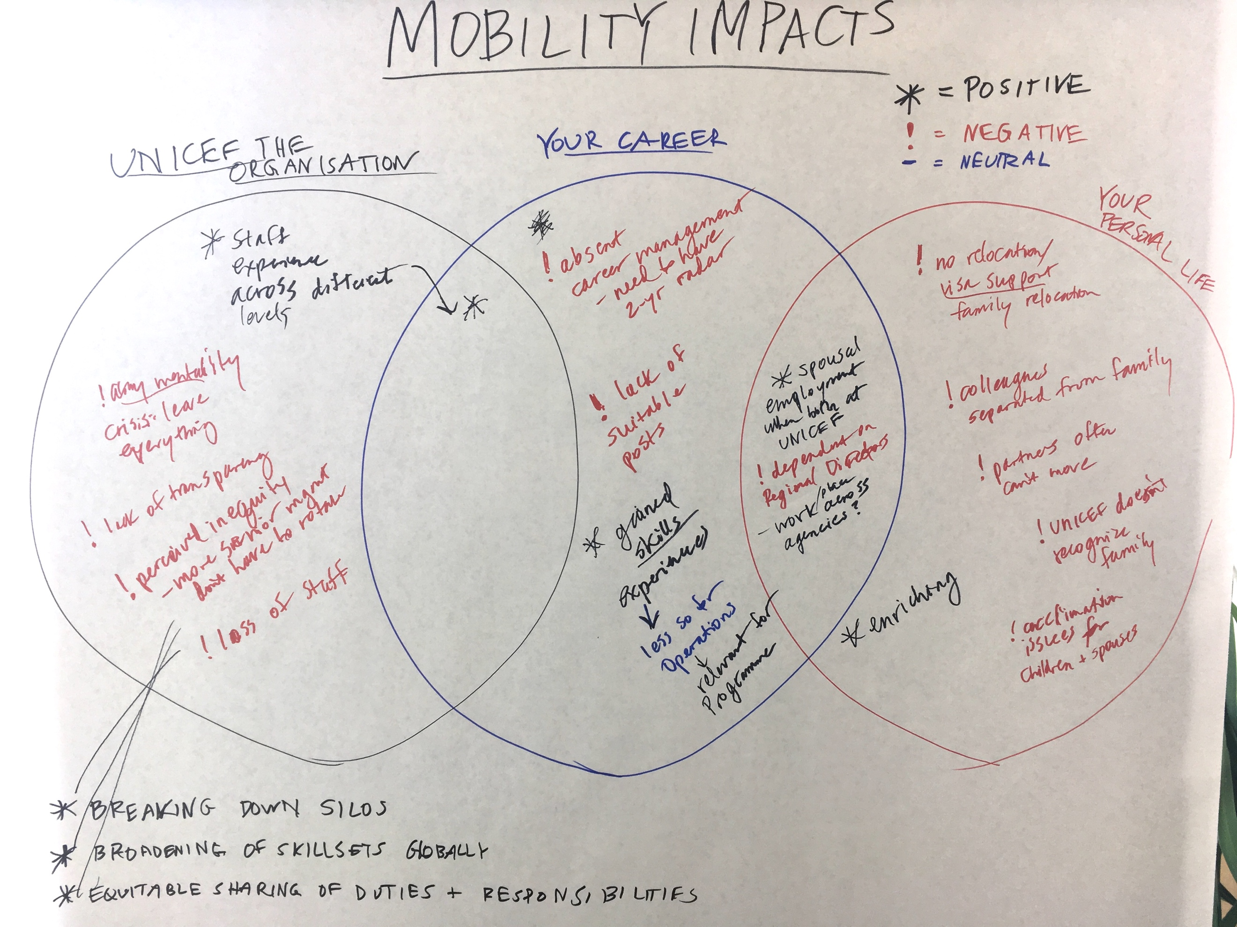 | 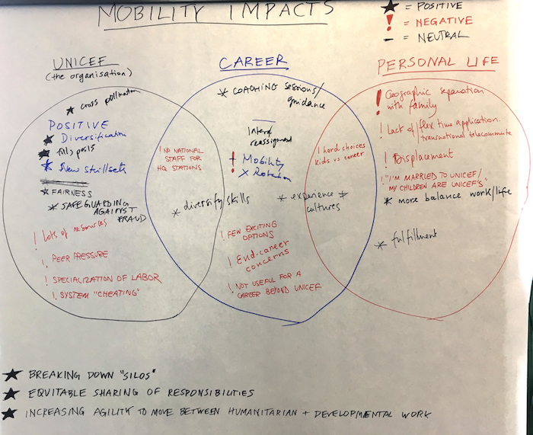
NEW YORK
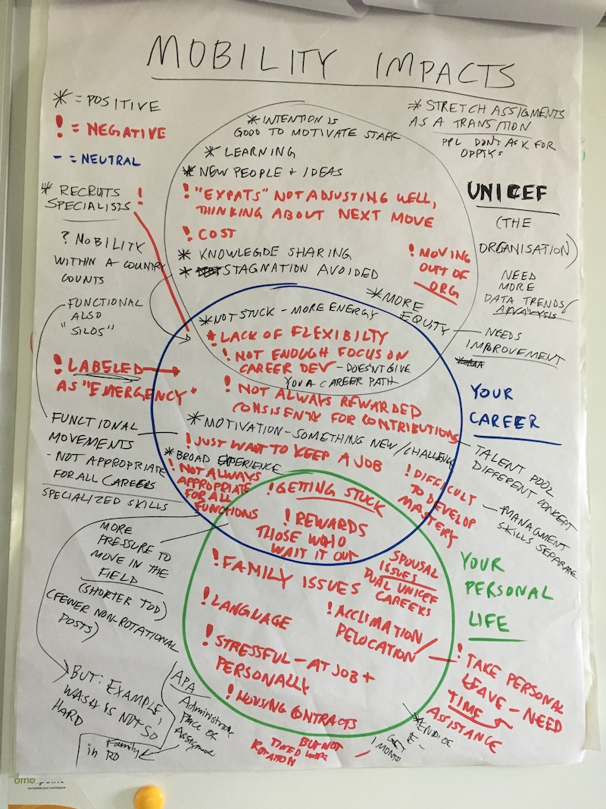
NAIROBI (HR workshop)  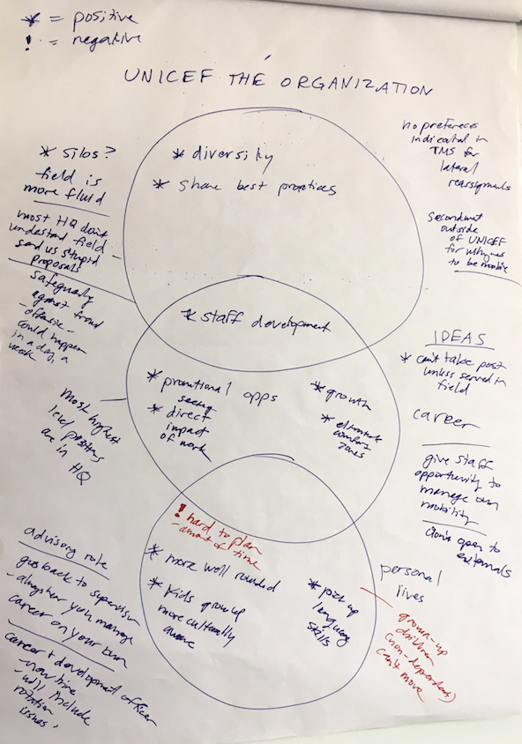 | NAIROBI  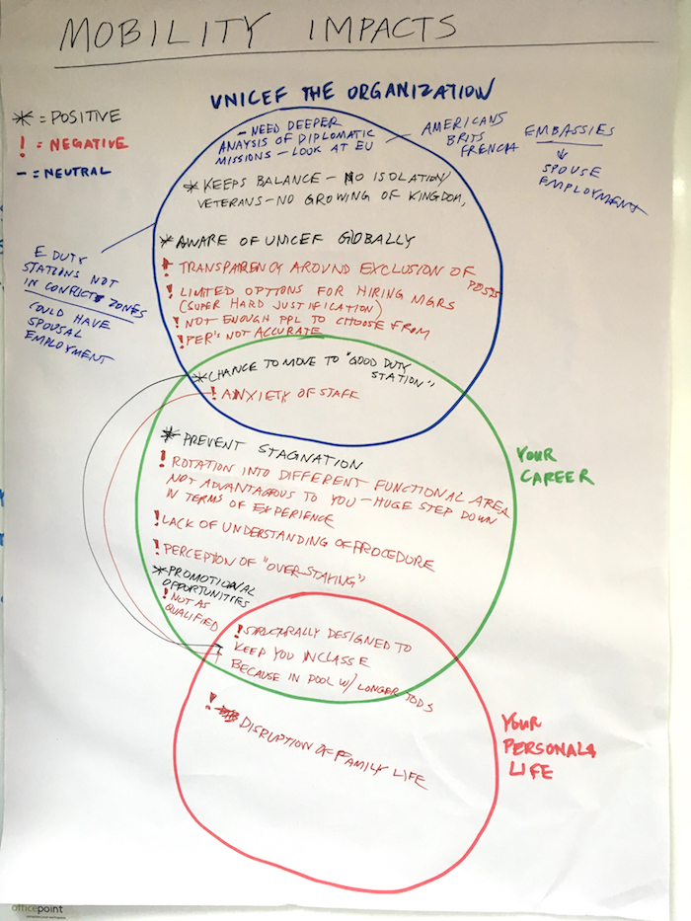
GENEVA | GENEVA
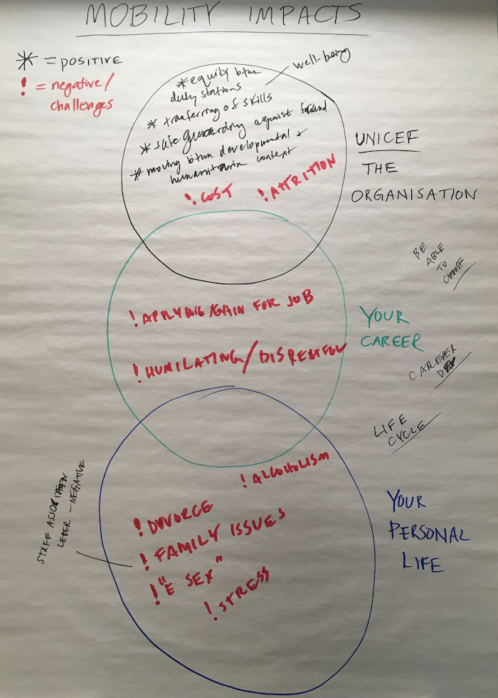 | 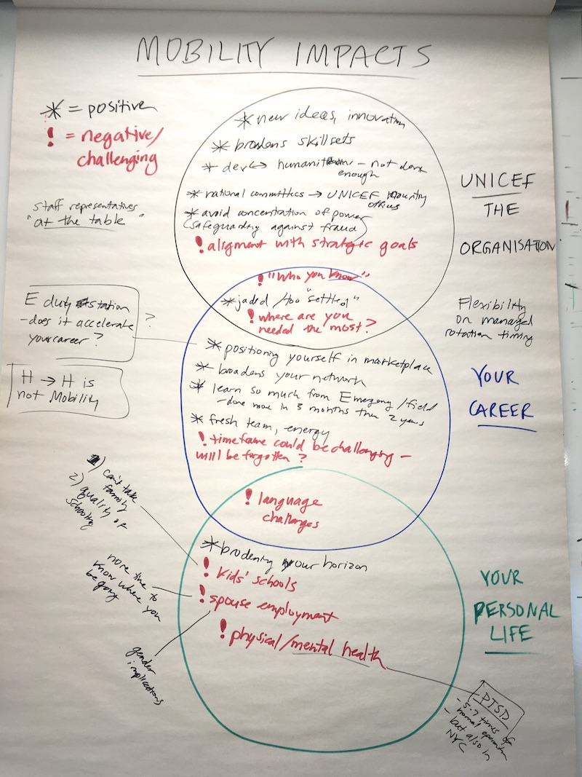
GENEVA
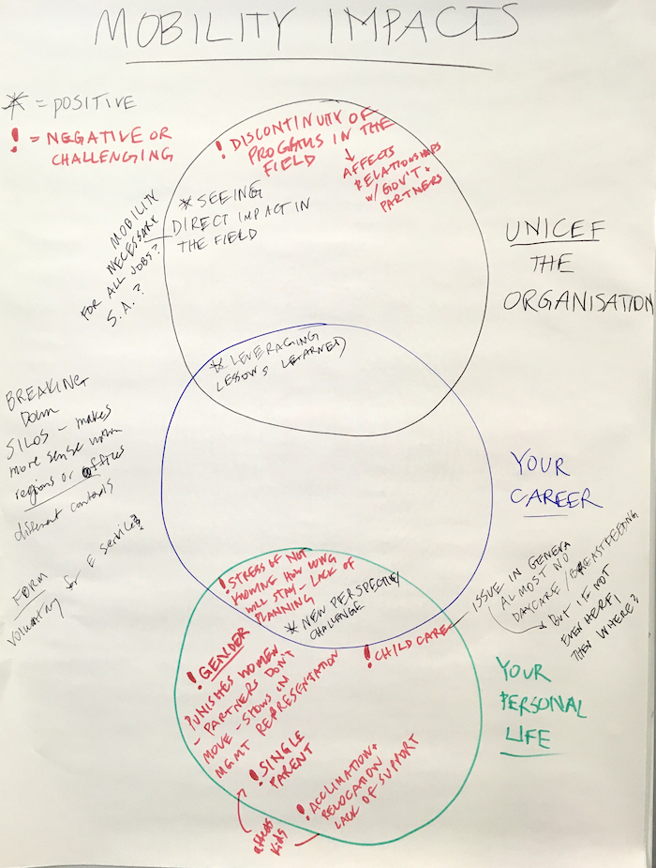
COPENHAGEN  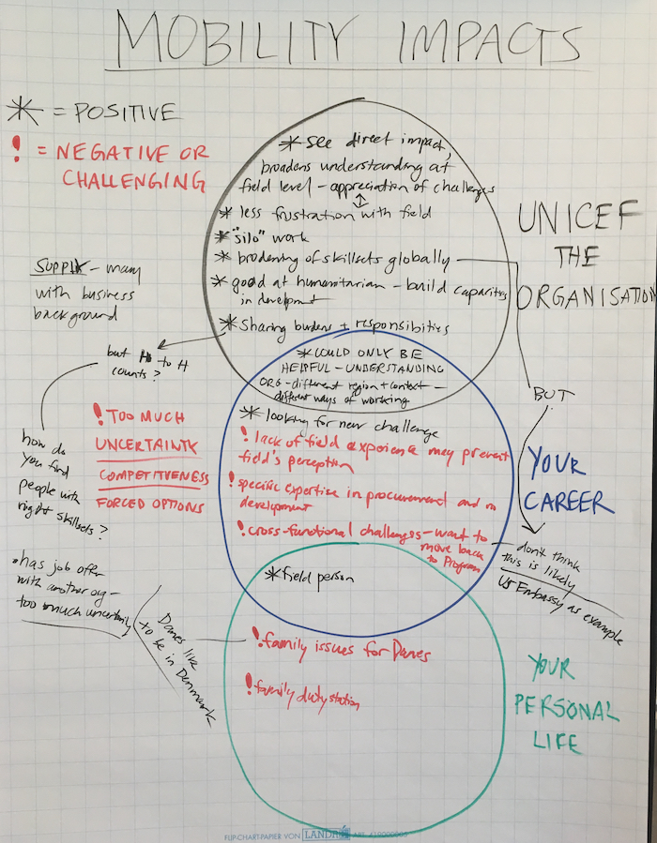 | COPENHAGEN  