Bloomberg UX & Conversion Analysis for iQuanti
submitted by Susan Stuart, October 23, 2018

Background

This UX analysis focuses on how the subscription experience for Bloomberg.com could be improved, by examining user pathing, marketing information and pricing strategies, and competitive strategies.

Analytics have indicated that a key page of Bloomberg’s subscription path is hardly being viewed at all, —the What You Get page—making it clear that the current design has not achieved as robust a pitch for subscription as intended.

Touchpoints with the Offer

Home page

Bloomberg.com takes a less proactive approach than some of its competitors in providing subscription CTAs on landing, showing only a Subscribe button in the upper right corner. Instead, its main CTA comes in the form of a warning to users as they read complimentary articles that the number of ones they can read for free will soon expire.

It’s worth noting that most competitors, aside from the New York Times and CNBC, advertise their subscription offers on their Home pages:

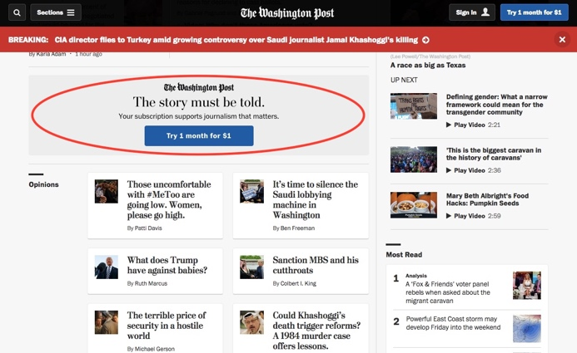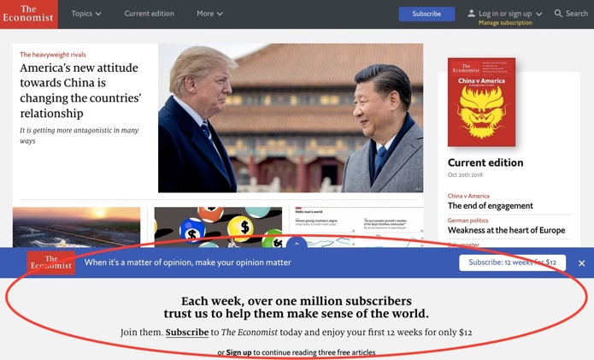
Washington Post has a prominent CTA in the upper left. The Economist has a prominent CTA at the bottom of the page.
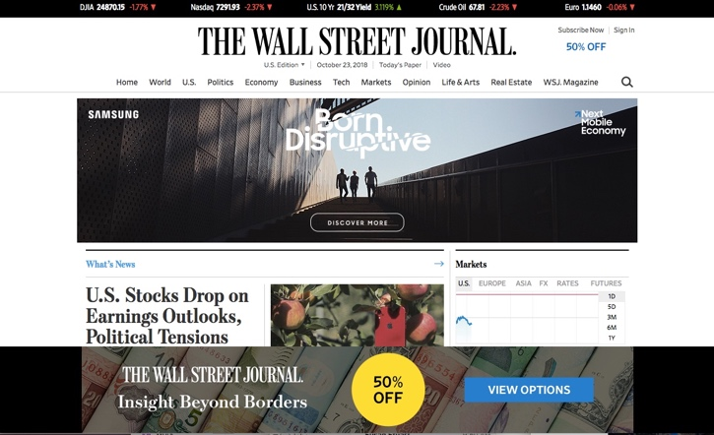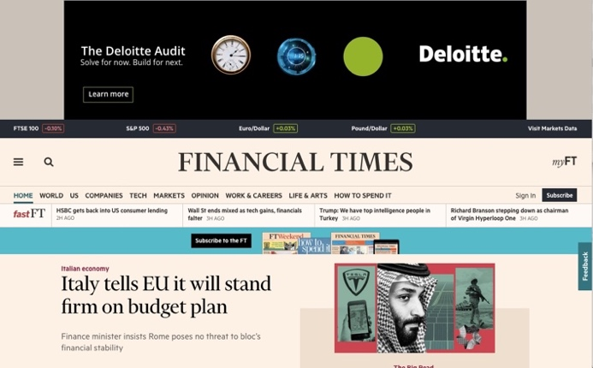
The Wall Street Journal has a prominent CTA in its footer, which splashes large and then narrows. The Financial Times has a colorful CTA strip between its global nav and content.

Article Paywall

Even after a user has reached the 10 article read limit, there is no bolder CTA than a small subscribe button on the Bloomberg.com Home page, or any other pages aside from the article pages, which have the paywall CTA that blocks the majority of the article content. This CTA leads to the Subscribe page as expected, which outlines subscription plan options.

Subscribe Page Outflow

Analytics have found that many users leave the Subscribe page to navigate to the Content Group Market and Content Group Quote pages, which do not have a paywall or any other CTA. Almost no users click the What You Get link to consider its marketing content in weighing the subscription offer and value. Because the number of users actually landing on What You Get is so small, we don’t know how well that content would factor into conversion (signing up for a subscription).

The What You Get link is very small and not positioned in the range of focus on a rather long, boldly styled page:

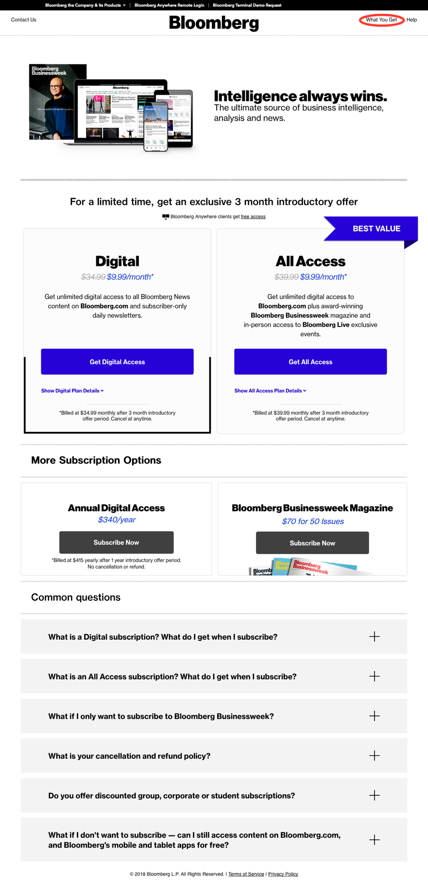

A new content and pathing strategy should be considered to maximize the effectiveness of both the content on the Subscribe and What You Get pages.

Competitive Subscription Paths and Strategies

Competitors approach their presentation of a subscription offer differently, with some choosing to focus on the components of the offer only, and others providing a “quality of content” promotional section to sell the value, not just in terms of the components and formats, but richness of the content and journalism itself.

The Wall Street Journal and Washington Post keep the subscription landing simple and focus on the components of the offer only. The result is an easier to navigate subscription path, but they also clearly delineate their offers in terms of the exact components (print, digital, premium digital, and student/ gift options) and tiered pricing by month, week or year. These offers are equally easy to navigate on a mobile device because of the simplicity and concise content.

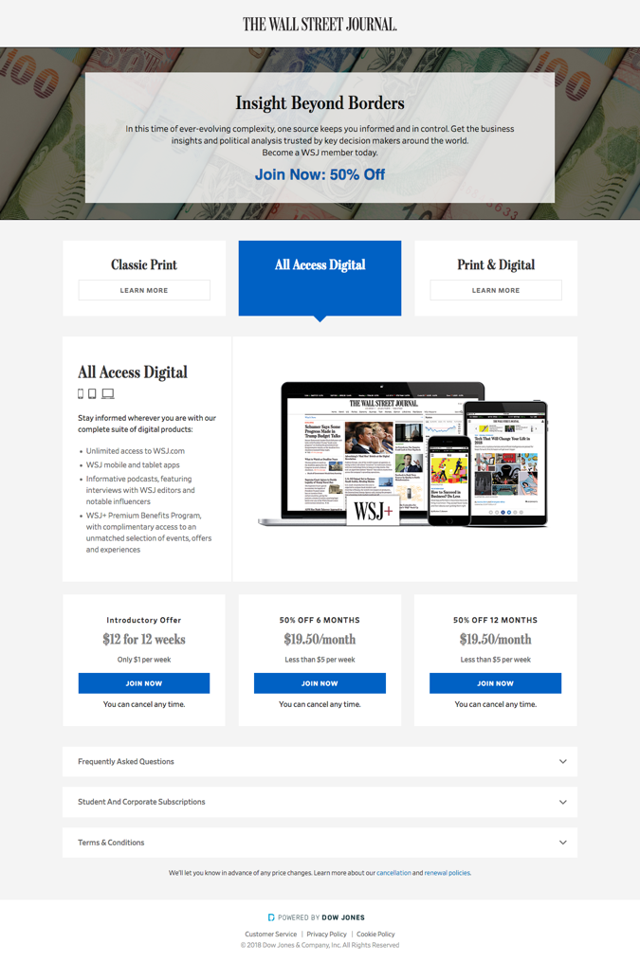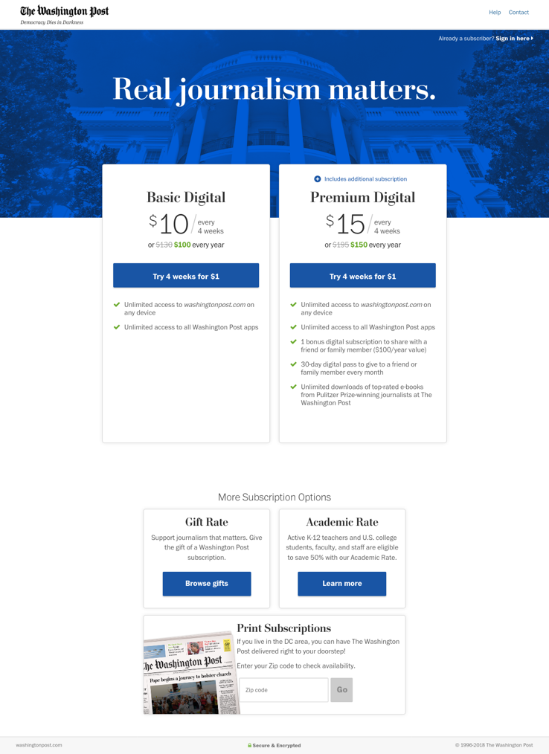

The Economist spends a bit more effort on subscription components and integrates the quality of journalism message briefly on the same page, via testimonials and brief features and benefits summaries:
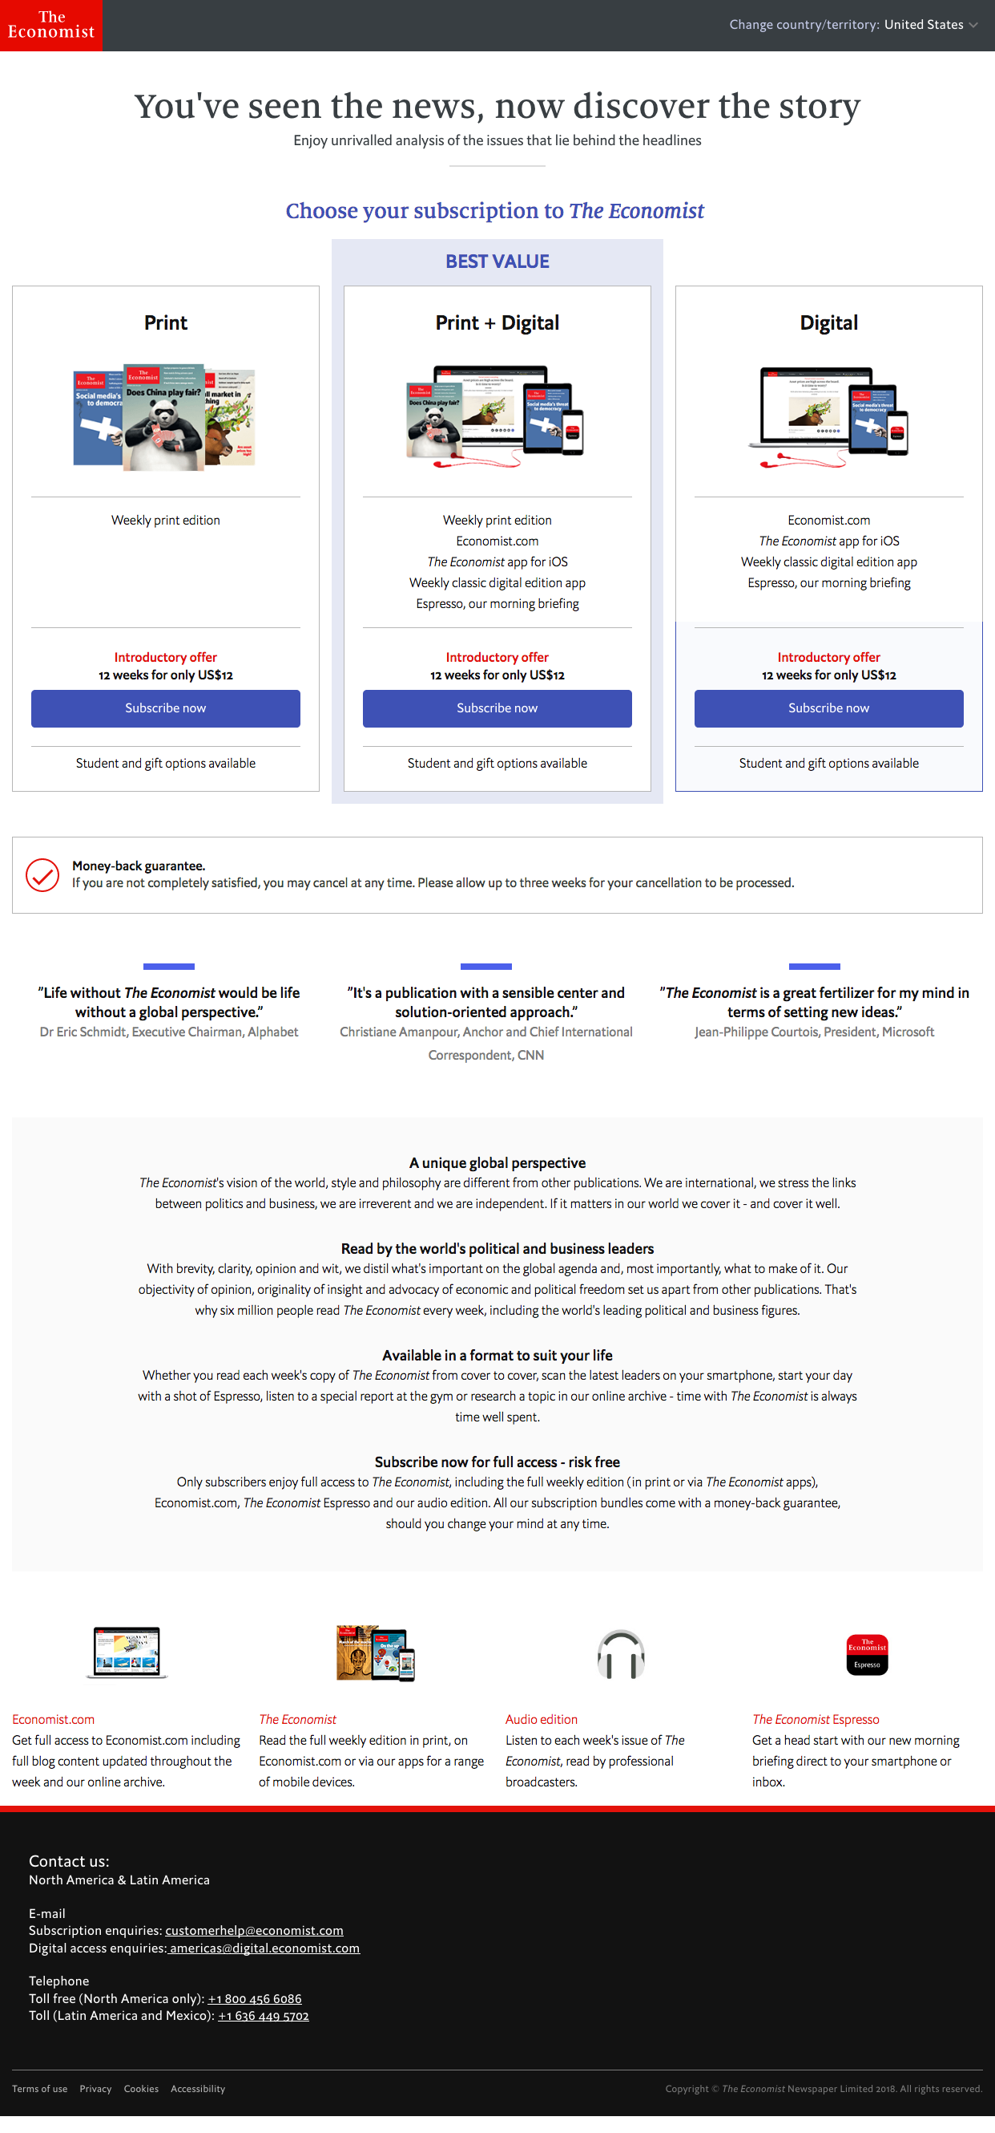
Its second subscription path page provides the opportunity to mix and match various subscription options, as a way of letting users confirm their choices:
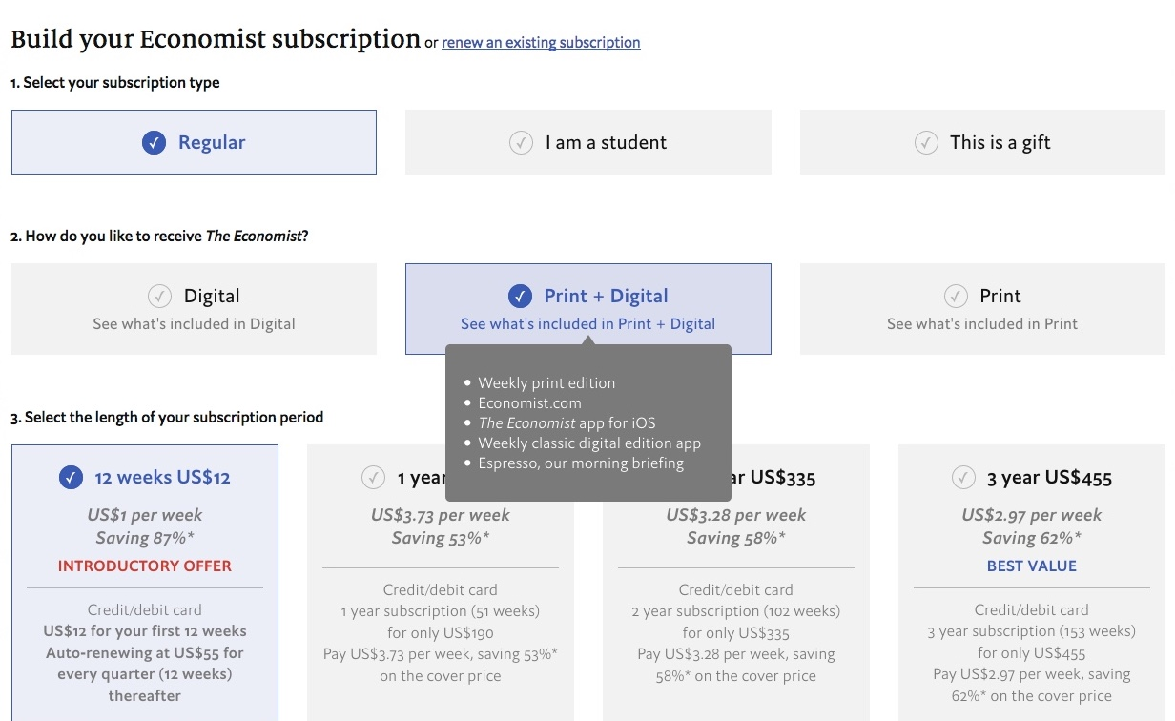

CNBC and The New York Times take a different approach, like Bloomberg, and provide at least one page detailing the quality of the content itself. However, in CNBC’s case, the page is hidden under a tiny Learn More link:

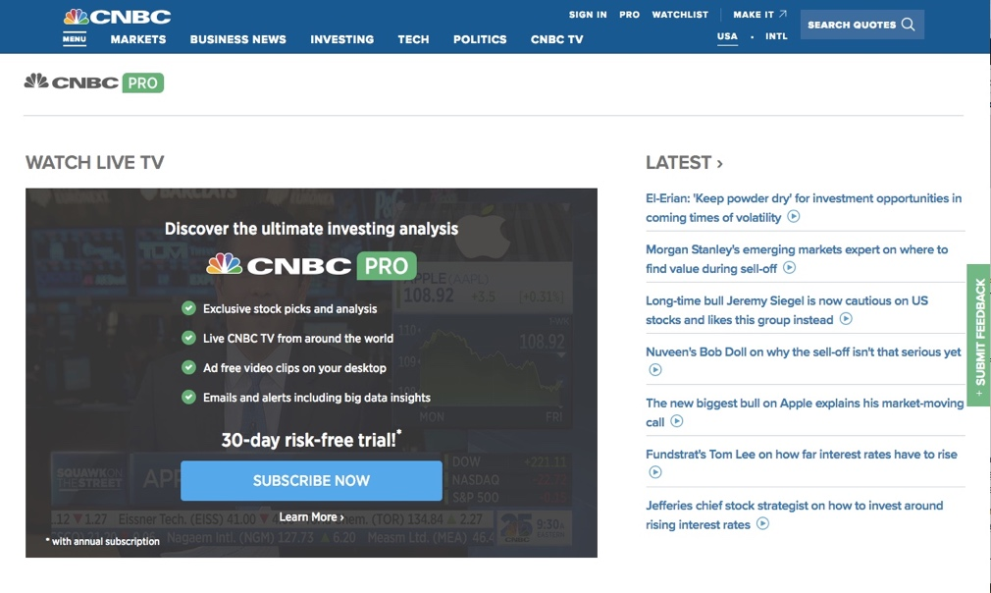
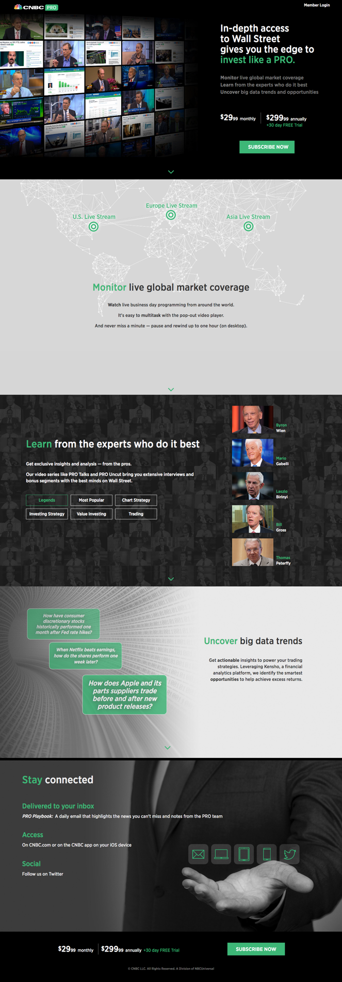
Clicking the tiny Learn More link on the previous screen results in the richly designed screen above.

The New York Times provides a better way to navigate between the core Subscribe page and other pages that may help sell the offer—through a subnav bar at the top of the page. (However, the subnav is handled inconsistently, the Subscribe label changing to Pricing on some pages.)

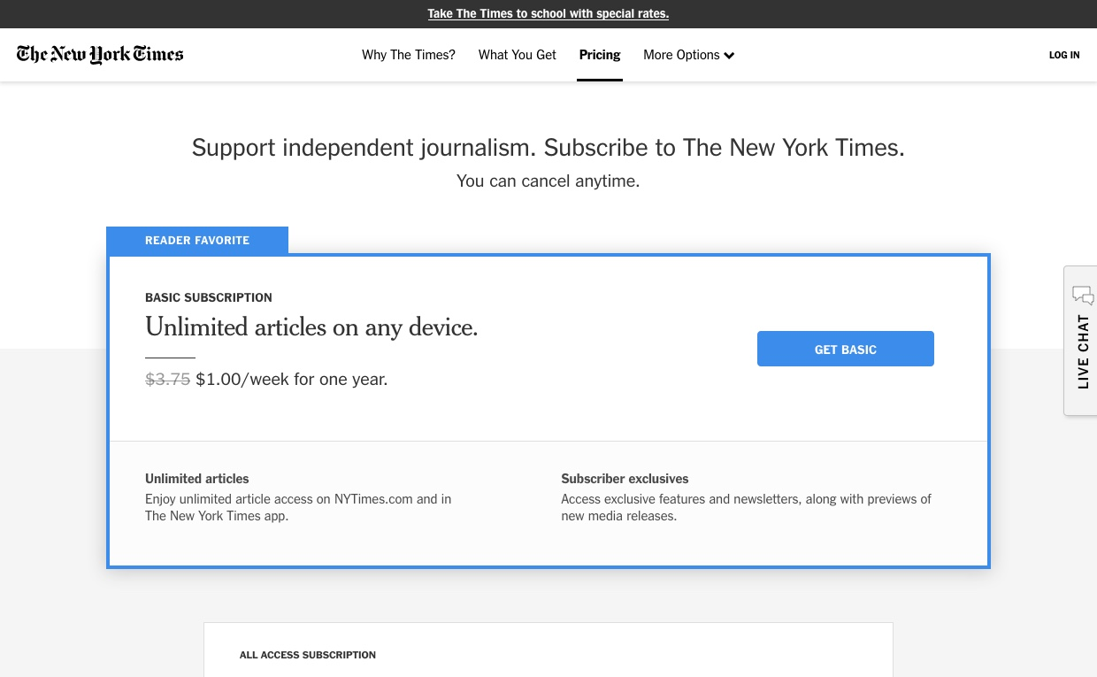

The Times provides two pages detailing the richness of their content—What You Get and Why the Times? Both pages are long, colorful, interactive, and promotional—yet, like Bloomberg’s What You Get page, may never be seen due to their lack of prominence in the flow and navigation, which is still somewhat hidden. It is also quite a bit of content to consider.

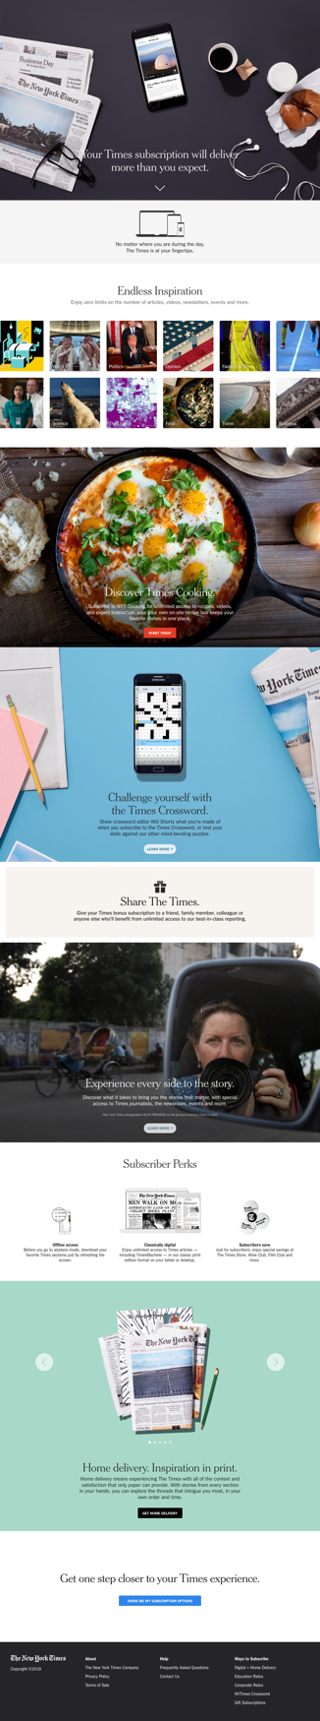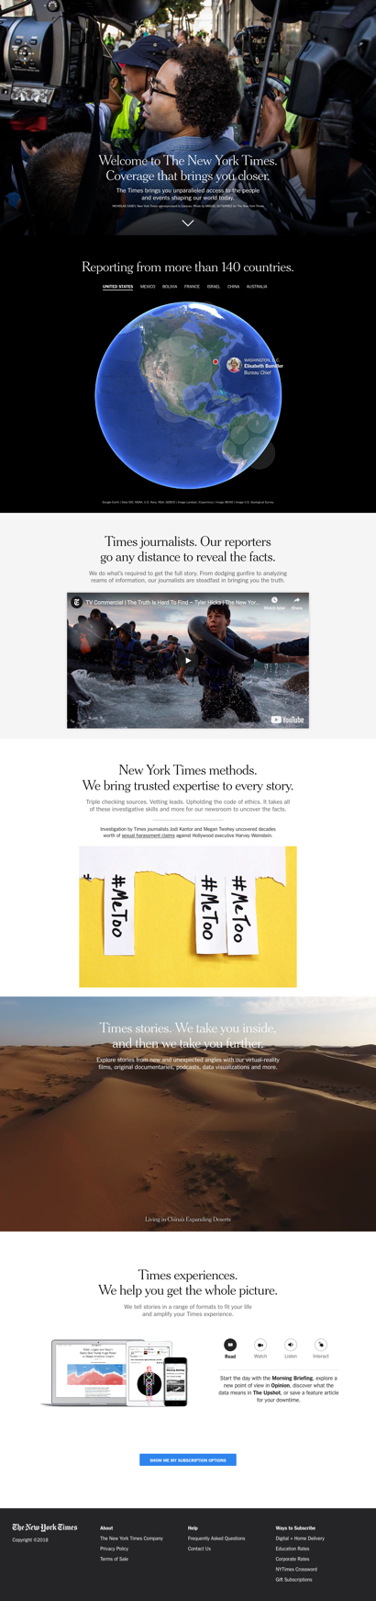
In short, balancing the presentation of pricing, components of an offer, options, subscription terms, and quality of the journalism itself has proven to be a challenge to media outlets in their online subscription paths.

Regarding the actual sign-up/ create account screen, all competitors provide a more intuitive option than Bloomberg, explained further in the Signup section. The following are some competitive examples of the simplicity of function, labeling, and options on this screen:

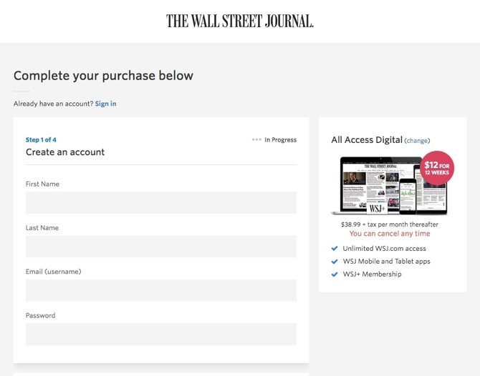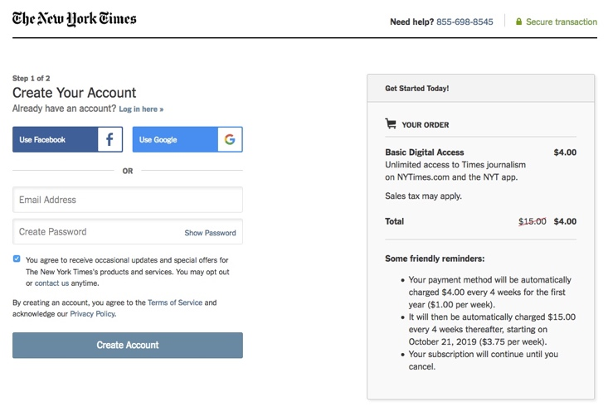
The Wall Street Journal provides a well-designed visual summary of components, promotional price, and cancellation policy on the right, while the account form is clearly laid out on the left (continuing below the fold shown here). The New York Times provides a friendly order summary with conditions on the right, along with Facebook/ Google connect options for account creation, a customer service phone number, and secure transaction confirmation.

Analysis and Recommendations for the Bloomberg Subscription Path and Strategy

Bloomberg has chosen to focus more screen real estate on a robust Subscribe and What You Get (quality of journalism) page than on CTAs throughout the site, for example, or a clear sign-up page. We feel this strategy needs to be adjusted, particularly in terms of the subscription path itself: clear, focused, easy to access, and concise content will help create a more successful path. The following are key problem areas with recommendations for redesign integrated.

We recommend a two-page path: Subscribe followed by Sign Up, with possible mouse-overs, expandable content or modal windows, to minimize users getting lost in content that may not add much value for those considering a subscription.

Subscribe page

The current subscribe page makes it easy to see the two main subscriptions on offer: Digital and All Access, as these are large, prominent, and highlighted in color. Below these two are, presumably, less popular offers of a yearly subscription and Businessweek subscription only. Below these offers are FAQs. There is also a hero area at the top of the page with key brand messaging and various media images—a print magazine and different digital devices showing Bloomberg content. Finally, there is a tiny line about Bloomberg Anywhere clients getting free access (with a link to the sign in screen) and also a tiny Contact Us, What You Get, Help and meta-level Bloomberg corporate and Anywhere/ terminal demo links.

The following are the main problem areas and recommendations for improvement:

Page overall and global nav

Though the page leads fairly quickly to subscription options, it is a long page and not labeled. Give it a header or label such as “Subscribe to Bloomberg.” The corporate links in black don’t really seem to have a place on this page, so if they can be eliminated, that would be best. Finally, the Help and Contact links and small and scattered—it’s best not to hide these but make a clear choice of how to integrate support options here or on the Sign Up page.

Hero

While a concise tagline is good, the digital devices displayed without clear differentiation in content don’t add much. We recommend considering if is there a way to show or at least allude to native apps and the advantages that come with different media types. This area could also incorporate a link to a Why Bloomberg? or Bloomberg Advantage slideshow modal window (or expandable page area), so the user wouldn’t have to leave the main Subscribe page to read about Bloomberg’s journalistic differentiation.

Offers

The pricing is a bit confusing, as the blue $9.99 “pops” visually for both offers, but doesn’t differentiate them. The similar $34.99 vs. $39.99 full prices in gray are difficult to see. These prices are also not as aggressive as most of the competitive offers to try a subscription.

The Plan Details links are easy to miss, and here’s where the offers might benefit from editing of the components and integration of some verbal points from the current What You Get page, possibly coupled with icons or visuals to reinforce how much users are getting with all the various features of the offers. (See What You Get for recommendations on incorporating some of that content here).

Annual Digital Access could be integrated with the Digital offer above it as an option instead of a separate offer. Bloomberg Businessweek seems to indicate that just the print magazine is included, but because a Businessweek app and access to Businessweek.com is mentioned elsewhere, it would help to be specific.

Bloomberg Anywhere is not explained as an offer, which might leave some users wondering why they are not being invited to consider it.

FAQs/ Common Questions

The first three FAQs seem unnecessary if the offers were better detailed, pushing the last three, which seem more helpful, down the long page.

What You Get

As mentioned previously, this page might work better as a modal window or expandable area of the main Subscribe page, so users don’t veer off the path to conversion. However, because some of the content points to details about the actual components of the subscription offer and other content highlights the style, topics, and journalistic benefits, it might be best to determine which could be separated out and incorporated directly into the offers area on the main Subscribe. Separating this content in the fashion below would also help make it not so overwhelming.

Inventory of What You Get features and benefits content
CONTENT-SPECIFIC POINTS:  feature these in the modal window clickable from the hero | COMPONENTS OF OFFER:  integrate these with the offer sections (in a modal window or expandable area if necessary)
- Award-winning  - Targeting decision-makers and unlimited content  - Key topics: Business, Tech, Markets, Politics, Luxury  - Style: immersive, concise, data-viz, video | - The App – Bloomberg? Portfolio-tracking tools, market data. Maybe highlight this first since we know users are leaving the Subscribe page to go to market pages.  - Live-streaming, podcasts (TicToc, OddLots, Bloomberg Surveillance, Trillions, Decrypted, Masters in Business), live radio, text-to-voice (play on the go with a tap of a button), live events and networking  - Businessweek: .com, app, magazine (this is not highlighted in the Businessweek subscription offer—make this clear)  - TV – 24-hr coverage in every market around the world, business leaders  - Exclusive events –in-person and live-streaming  - Newsletters

Note that the global nav of this page shows Subscribe as selected, instead of What You Get, which is confusing.

Sign up

This page does not communicate very well that the user is entering a payment path. The “sign in” elements stand out the most, as they take up the most space, and the phrase itself is stated four times, so at a glance, it looks like a sign in screen and therefore an error to land here. The Create an Account function is visually downplayed with one e-mail field only, and both the subscription selection confirmation bar as well as the tiny subscription selection text on the right are easily missed.

If a sign in/ sign up need to be the same screen, the two options should be very clearly separated and labeled. See the competitive designs included in The Competitive Subscription Paths and Strategies section for best practices, including a design that better indicates an order/ shopping cart area.

Other Pages

Consider incorporating subscribe CTAs on the Content Group Market and Content Group Quote pages, as we know users are navigating to these pages after leaving the subscribe path. Encountering CTAs with rotating featured (and possibly unexpected) offer components—the app, live events, etc.—may help build interest over time in the offer for repeat visitors.

