Citibank/ Citicards UX & Conversion Analysis for iQuanti
submitted by Susan Stuart, October 22, 2018

Background

This report is based upon the analytics work of the Citibank Citicards site performed in recent months and one year prior by iQuanti. Analytics data is quantitative and informs us what is happening on a site in terms of click behaviors; a qualitative analysis based on UX heuristics is necessary to determine why these behaviors are taking place. This document is a summary of suggested qualitative explanations for the click behaviors supported by the quantitative data. It also includes a competitive analysis and recommendations for design improvements.

Key Findings

In some cases the findings below are based on first impressions and best practices that are then correlated with quantitative data findings, and in other cases the qualitative conclusions are derived more directly from the quantitative analytics themselves.

1) First impression: the Credit Cards Home page lacks boldness, a human touch, and a clear path forward. It’s also not very scannable.

While uncluttered, the Credit Cards Home page appears more like what is expected on the “inside” of a banking site—that is, the account interaction experience, after becoming a customer. In other words, it feels transactional, rather than like an invitation to consider a well-crafted offering with clear CTA’s. There are no eye-catching visuals, no quick summary or easy browsing of what’s on offer, and it lacks bold verbiage as well. The number of navigation options are also a bit overwhelming, and the wide variety of visual treatments for them adds to the confusion.

Quantitative insights that correlate: Users’ most common paths through the site to conversions (application submissions) are not always the areas emphasized on the Credit Cards Home page currently, implying that users are having to be “pioneers” (wander and dig for information) to get to what they most need. For example, the most common pages clicked after the home page for converters are:
      - View All Credit Cards (VAC)
      - Most Popular Credit Cards (MPCC); and
      - Prequalify
VAC and Prequalify are featured in the rotating banner/ hero, but the hero has had very low click rates in the past (no recent data on this). MPCC appears to only be accessible via a rather large, difficult to find submenu (it’s hidden under the “Credit Cards” submenu, an element which is already highlighted/ selected upon page landing) and is hard to scan due to the large number of text link options that have little organization or hierarchy:
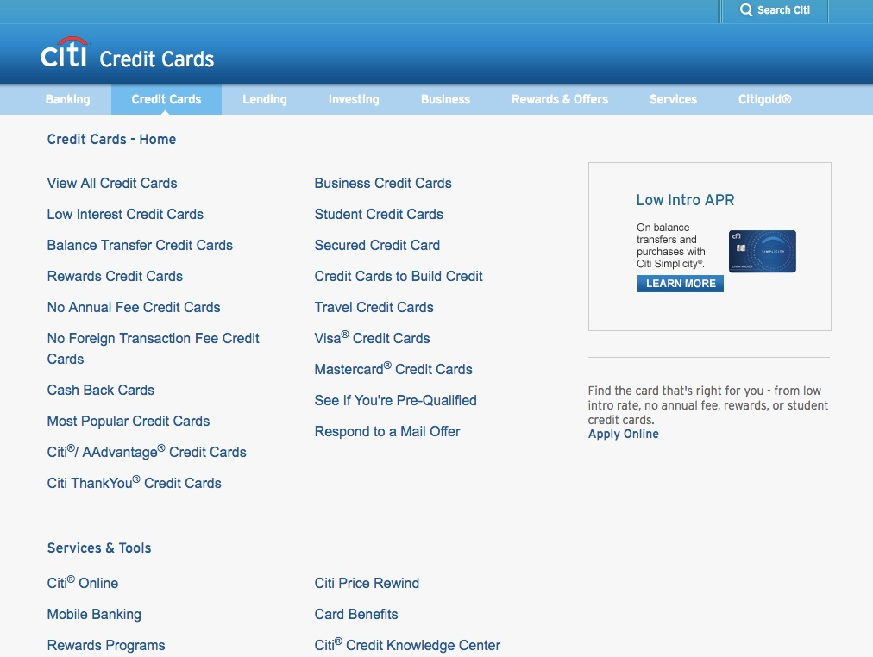

Rotating hero areas are typically difficult to fully read and interact with due to the screen motion and timing out. The messaging in the Citicards hero is also uninspiring (for example, “Citicards just for you” is non-descriptive), and there are no human faces or lifestyle visuals that naturally attract a user’s eye.

VAC as a global nav option is difficult to identify (it looks more like a page label than a link/ button), and Pre-qualify is a tiny link beneath the browser fold.

This variety of visual treatments of clickable items on the Credit Cards Home page creates a dissonant experience where the user can’t be sure what to click, and perhaps not even what is clickable:

As detailed in a previous analytics analysis, the image combining the Citi brand with “Credit Cards” in the top left does not incorporate intuitive click behavior, as most users expect a brand logo to link back to the default brand Home page. In this case, the Citi brand is only clickable in conjunction with “Credit Cards,” and just refreshes the Credit Card landing page. Multiple refreshes were detected in one of the analytics reports.

Finally, the Select Card Category, Search Cards, and Compare Cards navigation options have an intuitive click affordance (the pulldown triangle) and placement on the page where users’ eyesight naturally lands, but these functions and labels aren’t necessarily intuitive themselves, and have proven to have a low click rate. It’s unlikely that users would know what to search on within the Citicards offering at this stage, nor which category to choose—and hiding the functionality under these options makes the choices here even less inviting. Comparison (Compare Cards) is also something that typically isn’t done at the beginning of a browsing experience. All of these points are supported by the low click rates of these nav items.

Note that loading important pages in a separate tab/ window seems like a fix for the problem of not creating good global nav, and the lack of an active back button to return Home may not meet user expectations (users typically rely heavily on Back button navigation, and this has been shown in the analytics data).

2) The popularity of the View All Cards and Most Popular Cards pages implies that users find value in checking out all or most options that Citibank offers; this path needs to be made prominent and easy.

The majority of users arrive to the Citi Cards site via natural search, for instance, by typing “Citicards.” This finding indicates that users know and trust the Citibank brand and may be interested in exploring the full offering of cards before making their selection, as they have not narrowed their search to a certain card or category. The Most Popular Cards navigation choice may indicate that popularity implies even more trust, which can be a helpful way of filtering.

The View All Cards page is a commonly accessed page, and is often the page users navigate back to, even after viewing the Compare Cards page. For this reason, and because comparison is a secondary activity after the main summary of a full offering is understood, any compare functions should take place from this page, and should be optional. Currently, however, the VAC page is quite long and not all that scannable. In the first analysis, it was found that 40% of users either exit or go back to Home from here. Better design can serve user expectations and help drive users to the Product Details Pages (PDP) for cards from here, or directly to the application.

In addition to making the full card offering prominent on Home Page landing and in the global nav, strategies should be considered for helping users navigate its content without the awkwardly named Select Category global nav and other hard-to-find category global nav options that exist currently. The following are ways that competitors provide options for viewing their card offerings.

American Express
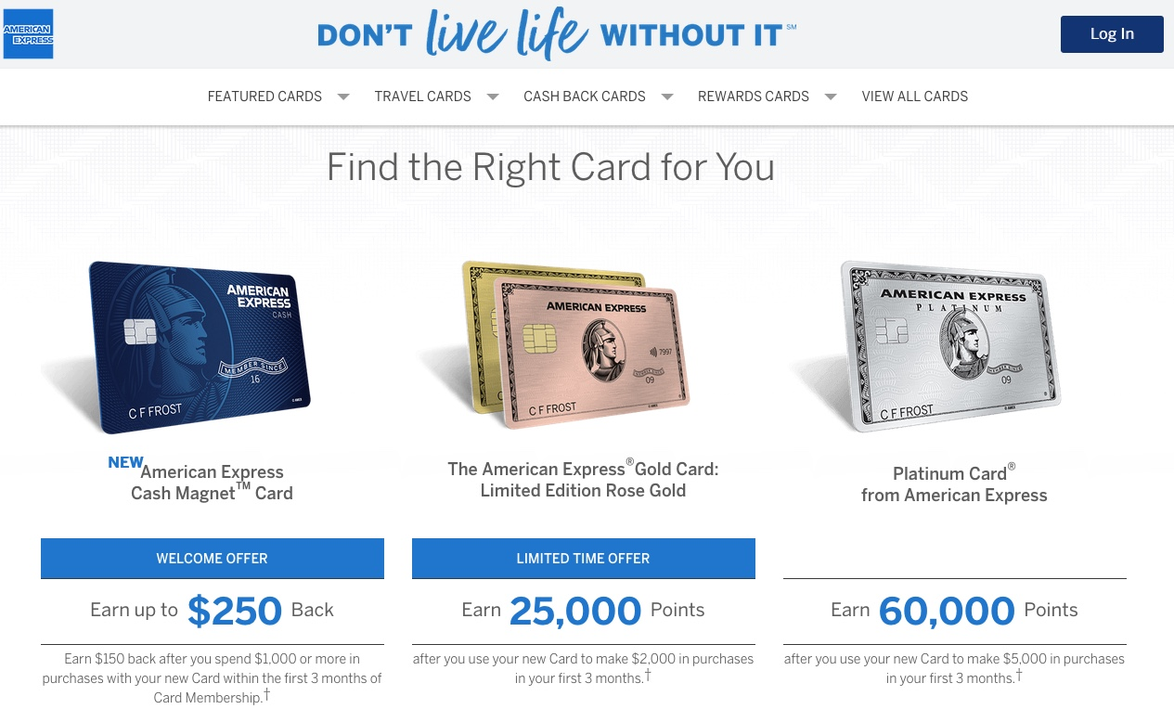  The Home page landing features presumably popular cards, with rewards numbers in bold blue that “pop.” Above these eye-catching visuals is a navigation bar where the user can filter, browse, or view all cards. Simple, limited navigation choices. | 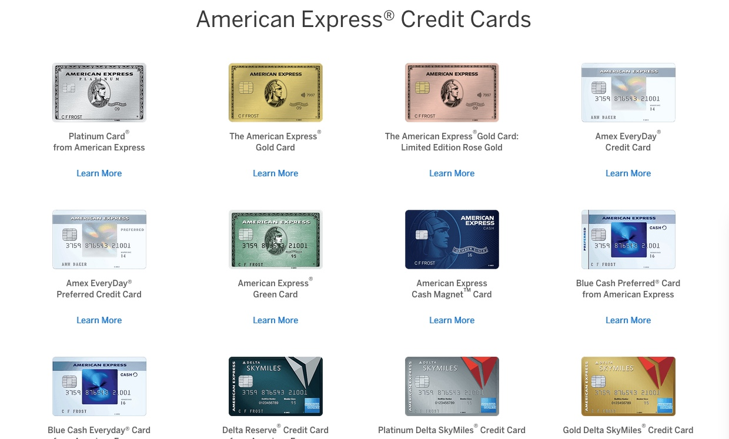  Additionally, AMEX actually lists every card individually toward the bottom of the Home page.

Chase
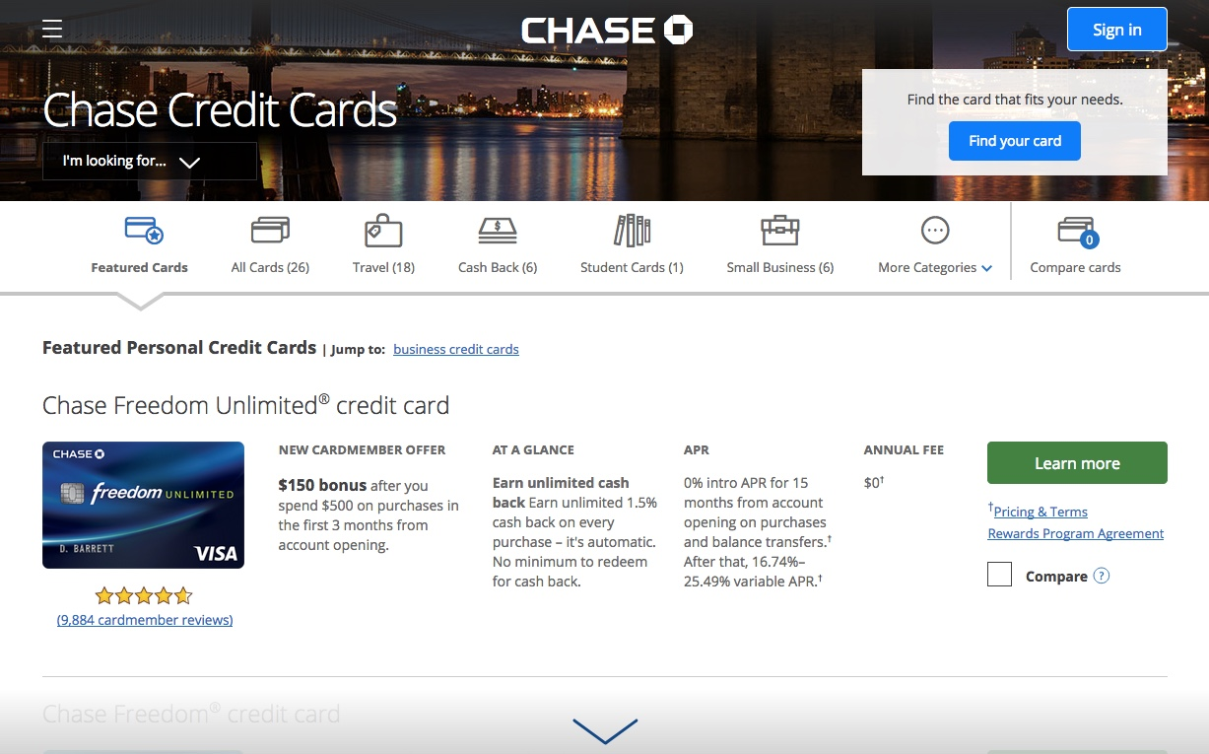  Chase’s Home page gives users an option to enter the “find a card” landing page, shown here (rather than providing a single home page for current card holders too) and provides a variety of filtering options, from a fixed position horizontal category filter bar as the user scrolls down the page, to an interactive assistant. | 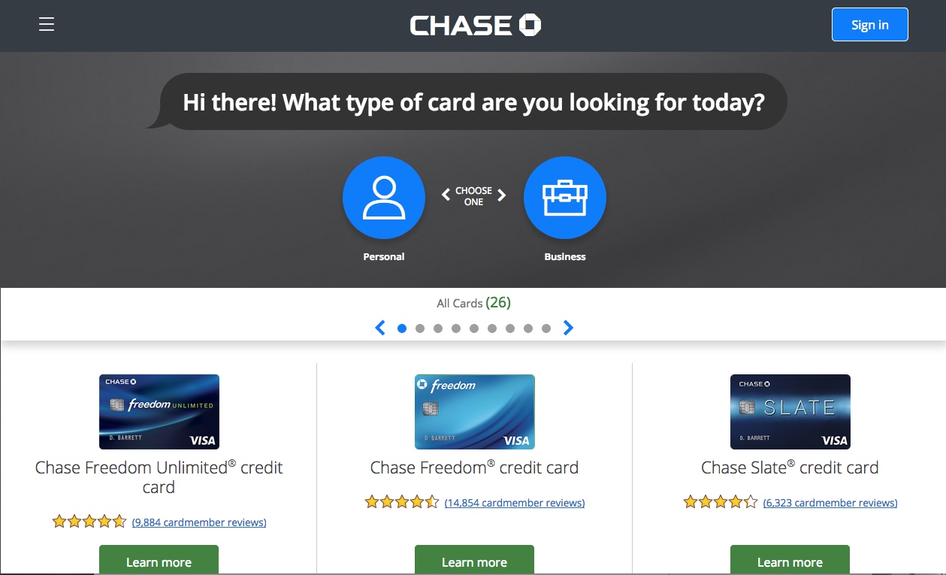  The Find Your Card interactive assistant provides filtering choices, one by one, at the top of the page, helping users narrow suitable choices easily by answering questions about their needs.

CapitalOne
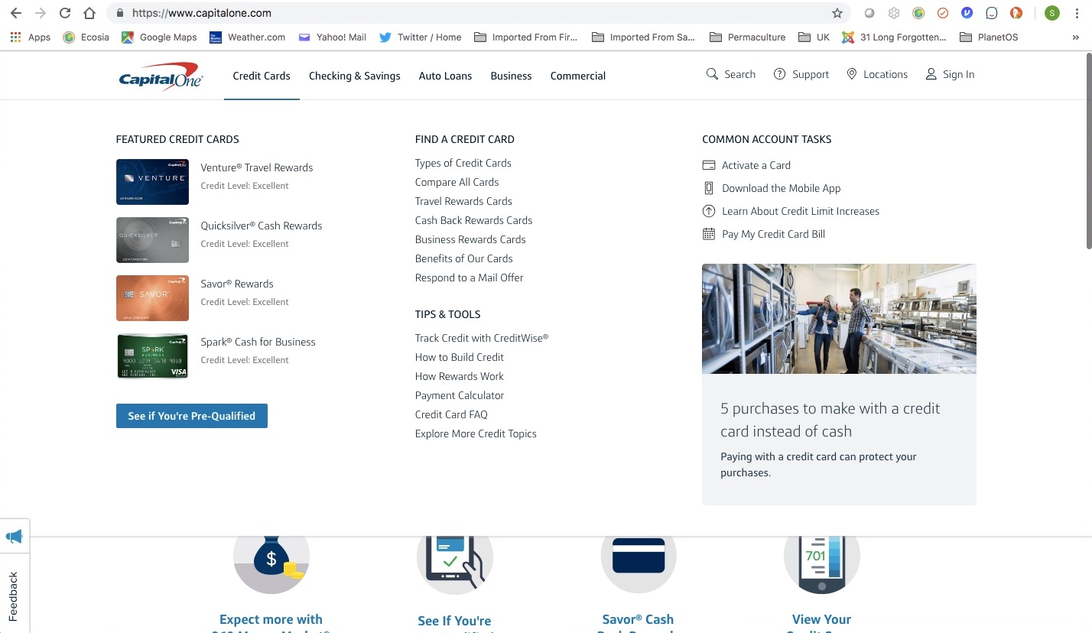  CapitalOne’s primary credit cards entry point is a well-organized menu for navigating card options upon clicking “Credit Cards.” The clean, consistent, 3-column layout of text options with just enough visual interest displayed in a consistent manner makes this menu work well, even with a wide variety of options for current and potential cardholders. | 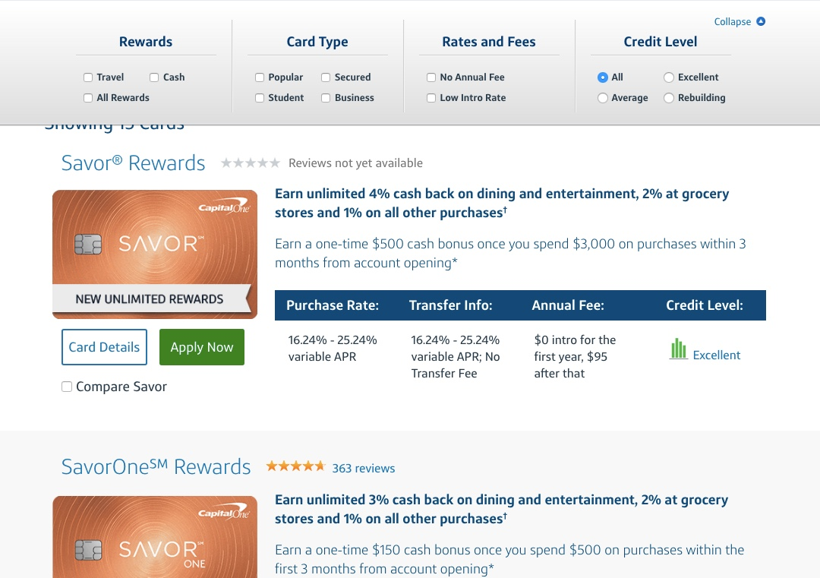  Like Chase, CapitalOne provides a fixed-position horizontal filter bar for narrowing choices on a long scrolling View All Cards page. Comparison is relegated to a checkbox—it’s optional and not emphasized.

Capitalone also has an assistant-type intermediary page in their cash-back category for helping to select the type of cash-back offers geared toward the interests of the shopper, and it helpfully indicates appropriate levels of credit required for each:

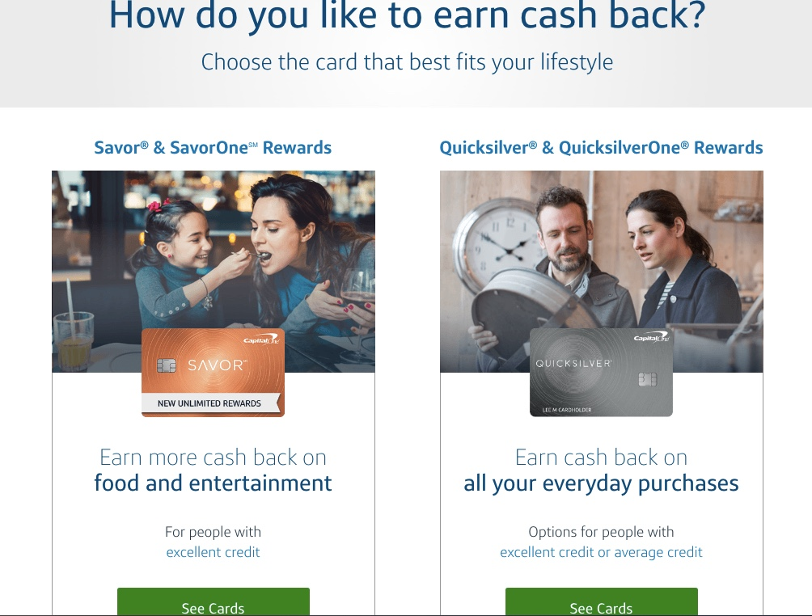

Bank of America
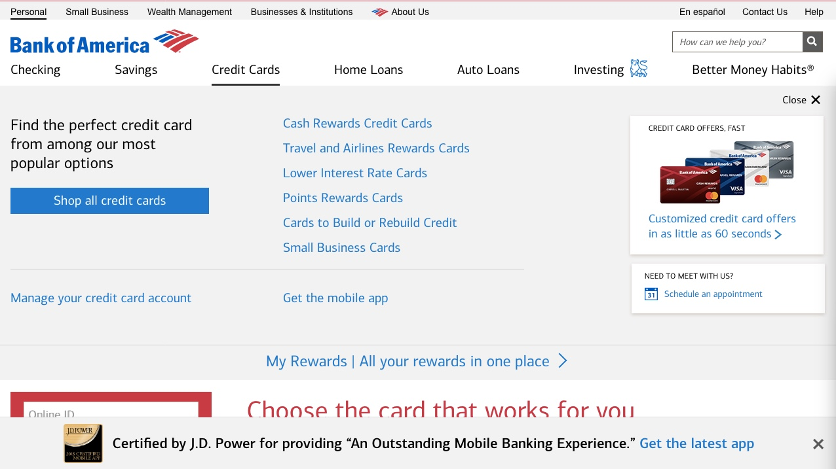  Again, we see a well-organized menu upon clicking Credit Cards, with a visually emphasized “Shop all cards” button. | 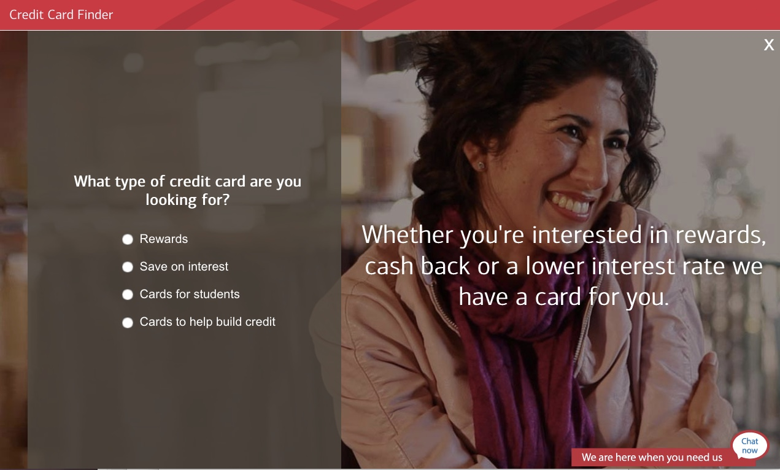  Bank of America also features a card selection assistant with simple Q&A and lifestyle photos for a more human appeal. Their interactive chat widget is also prominent in the lower right corner, should the user have any questions and want to talk to customer service.

Discover
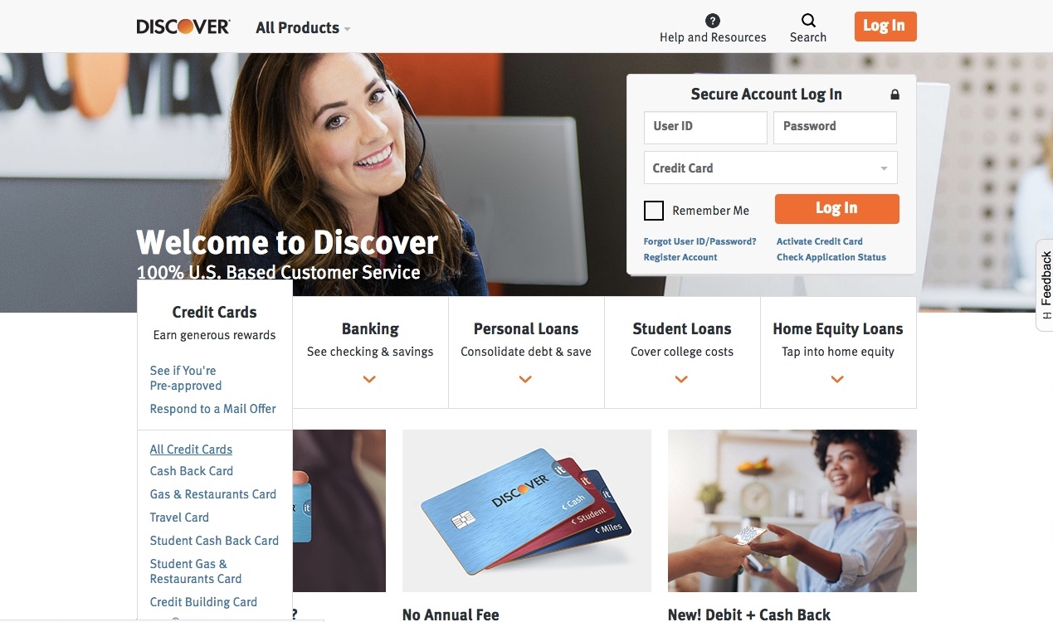  Discover’s credit card menu is relatively small, fitting elegantly into the scheme of their page and near friendly lifestyle visuals, but the menu is still well-organized, its primary options for high-conversion paths positioned at the top. | 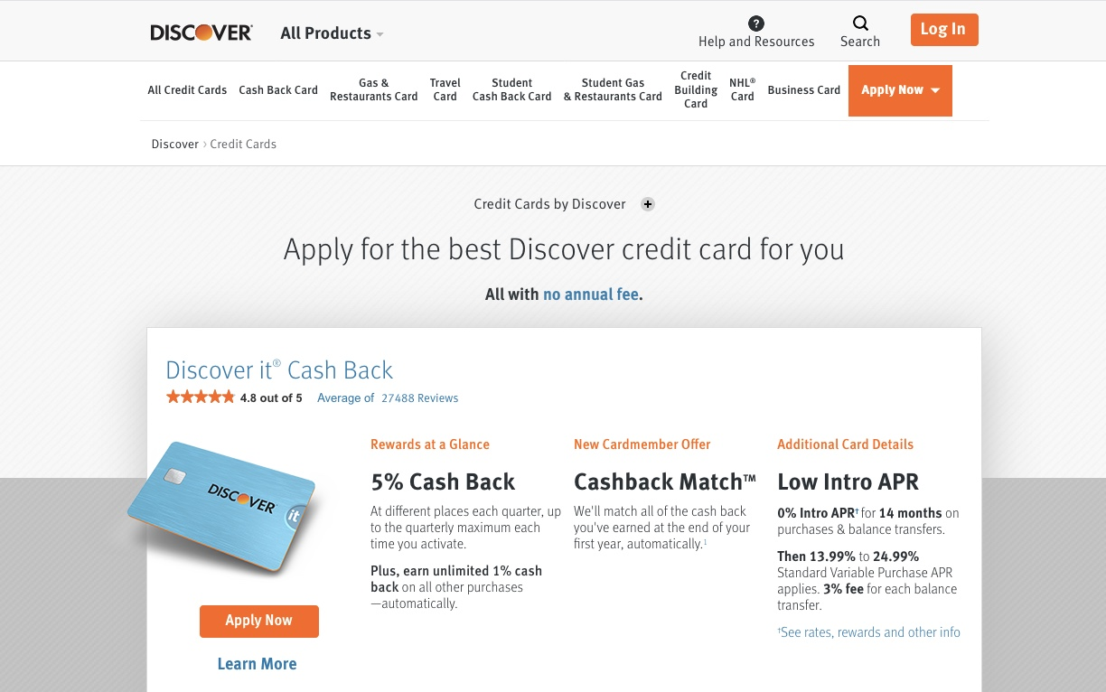  Again, we see a fixed horizontal filter bar and a visually attractive, well organized product preview area on the scrollable view all cards page. The tilting card that breaks the box’s boundaries creates subtle visual interest and a less boxy, repetitive layout.

3) Because the prequalification page is one of the top pages leading to a conversion for Double Cash, we can assume that revolvers find the Double Cash offer valuable (as revolvers would be the type of user most concerned about prequalifying), and that they do usually qualify for it. (Another indication that revolvers are interested in the Double Cash offer is that Balance Transfer is one of the popular category pages preceding a Double Cash conversion.) However, there may be ways to make the pre-qualification path both more prominent and clearer.

While we’ve seen that users are interested in exploring a full offering of cards before making a decision, some have also indicated that they are concerned more with what is on offer specifically for them. The path can be thought of as the opposite from “show me everything, I want to make sure I’m not missing anything” to “show me just what I can get, I know it’s not everything.” Prequalification is the mechanism that can tell users this, and we’ve seen through the analytics that they do seek it out. Only 35% finish the prequalification form, but we know that drop-off is common for forms in general. However, there are ways to explore reducing drop-off and helping users find the prequalification page in the first place.

Making the prequalification CTA more prominent on key areas of the site, such as above the fold on landing, is one way to help users find it better—but improved messaging around the risks/ payoff and even how prequalifying works might make more users want to engage. Common messages we see on Citi’s site and competitors around prequalification is how quick it is, how it won’t affect your credit score, and how it’s risk-free. What we don’t learn is how it works. And its primary function—checking qualification for people how have suboptimal credit histories—is not made clear either. It’s likely that the latter doesn’t deter users who actually seek it out, but it can’t hurt to be more specific about who the function is for through messaging such as, “Concerned if you’ll qualify? Check here first, risk-free.”

Questions remain for users who haven’t used a prequalification function before: how can you prequalify someone without checking their credit score? What are you actually doing to prequalify me? Is there a risk of getting a lot of credit card applications in the mail if I provide my mailing address? It stands to reason that providing more transparency into the process—including as much as possible in the CTA—would be helpful and increase user trust. “Hints” around whether a user will qualify (credit score of at least X with Y number of years credit will get you offers for these types of cards) is another way to provide users with the information they are looking for without having to submit a form at all—which is what they usually prefer.

On Citi’s prequalification form, it would be helpful to list the types of benefits (rewards categories) a user can choose from before having to provide their personal information, so they have an idea of what is available to them:

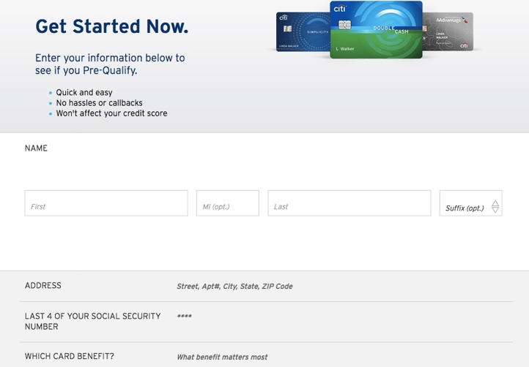  The Citicards pre-qualification form expects users to give up their personal information before seeing types of cards benefits. | 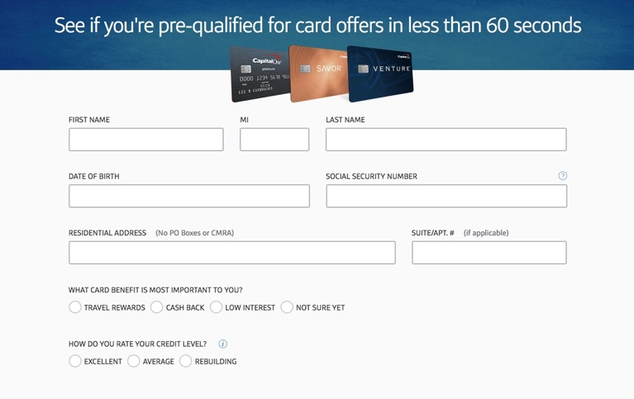  The CapitalOne prequalification form provides clear options for card categories available, as well as a way to voluntarily indicate a credit score without the system checking. The time it takes to get an answer is clearly indicated as well.

At the end of the prequalification process, a user should be shown a limited number of cards, and since Citi now has some information on the user, perhaps some personalized recommendations as to why these cards are being shown could help.

4) While Compare Cards (CC) is a page that is occasionally sought by users, the answers provided there seem to be unsatisfactory, as 94% of people clicking on CC transition to VAC.

Proactive, personalized comparison is not intuitively a first-level task, as users must understand the basics of what’s on offer before choosing what to compare. It’s probably best accessed from a VAC or category page, from within individual card summaries. Additionally, a competitive comparison may make more sense for an offer like Double Cash, which is an industry leader in the cash-back category. Discover is doing this:

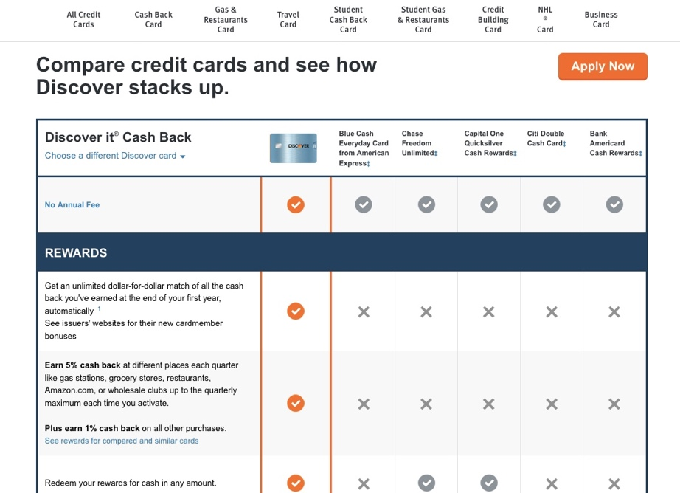

5) Product Detail Pages (PDP) could be optimized through interactive options and including all details on one page.
While users are moving from the PDPs to converting applications on primary paths, the data shows that the conversion probabilities could still be improved.

Organizational hierarchy and completeness of information are the most likely key factors in a satisfying experience for a PDP page. A lot of the text on the Double Cash PDP is spread out and sized similarly, creating a somewhat weak hierarchy of information, and little visual interest in the layout or visuals themselves. Additionally, sections such as “Pricing Details” have additional links such as “Pricing & Information” which takes you to another page. This labeling and architecture creates a scattered information impression, which can lead to frustration and weaken confidence in the offer.

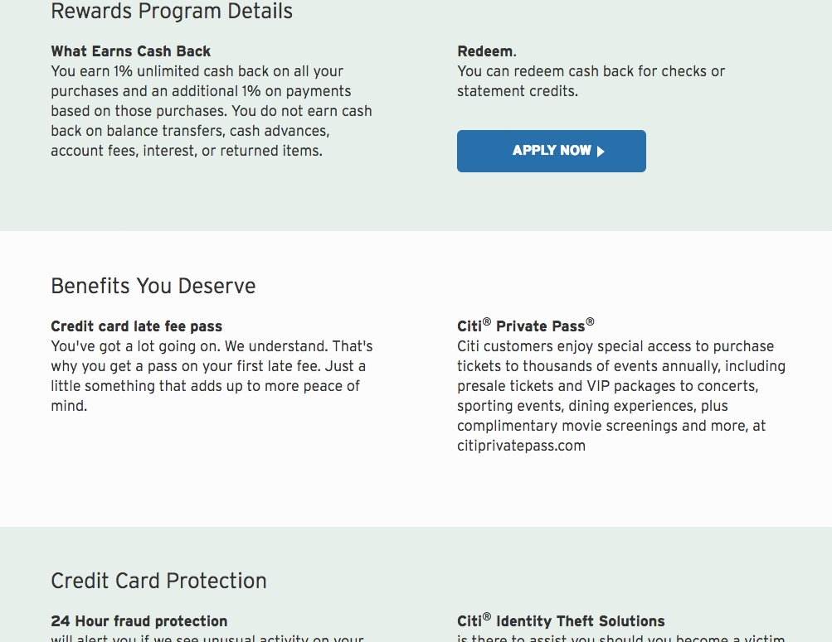

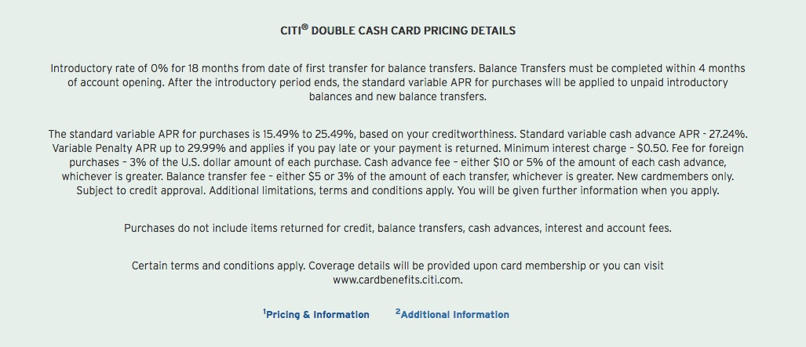

On the other hand, the CapitalOne Quicksilver cash-back PDP has various fixed navigation options to move to anchored parts of the long page, and all the details, including the fine print, on this one page—no need to click and hunt around. It also an interesting dynamic slider/ spending entry mechanism to help the user explore the value of their cashback proposition.

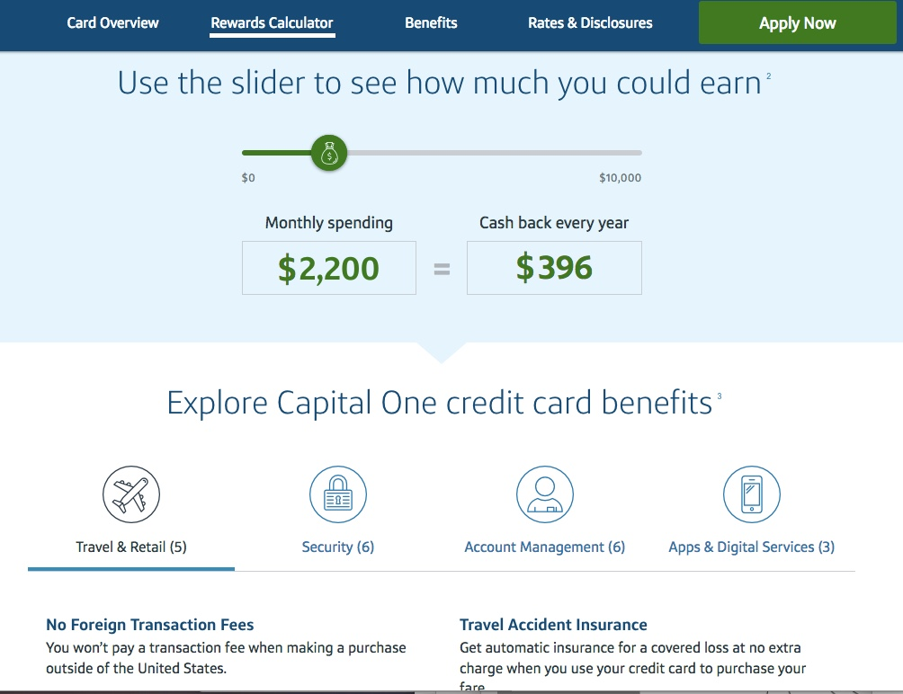

6) There are opportunities to improve messaging and copy overall, but especially where the offer itself is concerned.

The Double Cash offer is touted internally at Citibank as being the best in the industry, but the copy on the site doesn’t say so or explain why. The lack of a bold presentation extends into the messaging itself—which could really benefit from a bolder and clearer claim against the competitors. Something like the following is a more direct challenge to competitive offers: “No crazy shopping categories or tricky rules. We reward you once, and then reward you again when you pay down. All this with a 0% balance transfer option.”

The Double Cash name itself is not all that intuitive, as cardholders aren’t actually getting 200% cashback, so getting specific as to the implications of the name and advantages is important. One part of competitive offers that stands out is the sign-up reward ($150-200 in credit if you spend X amount in the first 3 months), so if a similar reward isn’t available for Double Cash, it’s all the more important that the selling of its advantages is quite to proactive and to the point.

Similarly, don’t forget that customers new to Citibank may be completely unfamiliar with established subbrands, such as AAdvantage. This subbrand is difficult to read, pronounce, and doesn’t capture the travel card category to those who aren’t familiar with it.

