Restarters.net UX Audit
Submitted by Susan Stuart, September 1, 2019

Overview
An audit of the user experience (UX) of Restarters.net was conducted to investigate and identify possible experience flaws and key challenges in using the platform. This was accomplished primarily by browsing the site and performing known tasks the target user base would want to perform, and evaluating these against UX heuristics and best practices. This audit focuses on key impressions, and does not include recommendations on every UI detail that may be in need of adjusting. Secondary research that helped inform this investigation included staff stakeholder interviews and a review of site analytics, user feedback via the staff section of the site, past survey results, user journey documents, and user typologies document.
Note: a minimum screen resolution of the iPhone SE/ 5 was used to assess the mobile experience.

Key Findings + Recommendations
- From the analytics, mobile (phone) appears to be used often to navigate the site, so move forward with a mobile-first redesign strategy for minimum screen resolution of iPhone SE/ 5.
- Global navigation and nomenclature issues appear to be among the top impediments to understanding and navigating the site.
- The three modules (Dashboard, Talk, Wiki) need to be more seamlessly integrated into one experience.
- “Less” should be considered “more” where functionality and navigation options are concerned; users likely feel overwhelmed by the all options and “busy” UI now.
- The out-of-the-box Discourse UI is not ideal and should be refined if possible.
- The Wiki is being visited the most, so make sure it’s serving users well.
- User research could be helpful in determining which tasks are most critical, and more about motivations.
- Some bugs exist; be realistic about how much functionality you can ensure works smoothly, and focus rigorous QA on the most critical tasks gleaned from user research.
Detailed explanations on the above findings follow.

Target User Base: Who is Restarters.net for?
The target user base of Restarters.net is the most active part of the Restart community: hosts, “volunteers” (i.e., repairer tutors or mentors), repair activists (presumably often the same as repair mentors or hosts), and educators. It’s worth nothing that it may not be intuitive to these target users that the site is just for them (and not general participants or attendees); general participants did indicate interest in the site via the community survey.

Motivations for being part of the Restart Project, and for using Restarters.net
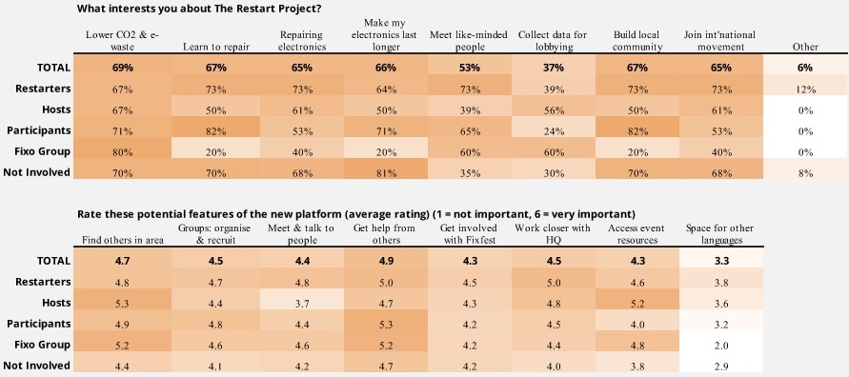
from the 2018 Community Survey
The image above shows the results from the Community survey on interests in the Restart Project itself, and in the members’ platform, Restarters.net. Prior research and analysis of user typologies or personas (in the typologies document) appears, perhaps, overly specific in terms of discrete types of participants in the Restart community. However, from this research, as well as the community survey results, it appears that at least one of the following broader motivations can be assumed for those who get involved with Restart:
- environmental concerns
- enjoyment of repair/ hands-on work (i.e.,”tinkerers”)
- concerns with system/ politics (activists)
- educational opportunity
- personal finance concerns
Many also expressed interest, via the community survey, in the purely social aspect of the repair parties, although it’s not known for how many this would be a primary motivation. Could one additional potential segment be “de-clutterers”—those wanting unused items out of the house, but not necessarily discarded? Trends toward down-sizing and minimalism would seem to indicate there could be outreach potential here.
Educational users appeared to perhaps be a bit under-addressed on the platform and even on TheRestartProject.org. The Bronx case study is quite impressive (and not even located in Restart’s primary geographic area), and yet the CTA to fill out a contact form doesn’t really build user confidence that their request for information will be acted upon. An indication of next steps or startup kit for schools might be in order, and addressing the educational community, as well as highlighting children as repairers on Restarters.net would seem to be a good idea. (Also, making sure terms are clear for users who are minors: are they welcome on Restarters.net?)
The survey results indicate that general motivations for using the Restarters.net site were weighted fairly evenly (get help from others, find others in the area, organise and recruit groups, work more closely with HQ, meet and talk with people, access resources, get involved with Fixfest). When everything is weighted nearly the same, it doesn’t help form conclusions about what’s a priority for users, but these categories of interest were worded in a general way in the survey. Research methodologies that illuminate specific pain points and high-priority tasks should be considered.

Discoverability and First Landing (unauthenticated)
While anyone can sign up for Restarters.net, the CTAs that lead to the site from TheRestartProject.org include “Host a party”/ “Start a group”/ “Get Involved” (addressed to hosts), and “Share your skills organising events or fixing/ Join our community” (addressed to hosts or repair volunteers). These CTAs are not very prominent, and don’t describe where they will lead. Also, there do not appear to be any CTAs to join the platform geared to activists or educators (despite a Schools page). However, stakeholders noted that Restarters.net is also advertised via word of mouth by members to other members.
The features and benefits on Restarters.net/about and in the Welcome after registration are described in somewhat vague terms. Registering, learning and navigating any new site takes a bit of effort, and the payoff for signing up might not be obvious, as reflected in the analytics bounce rate of 33% on average (for the past 8 months) for Restarters.net/about:
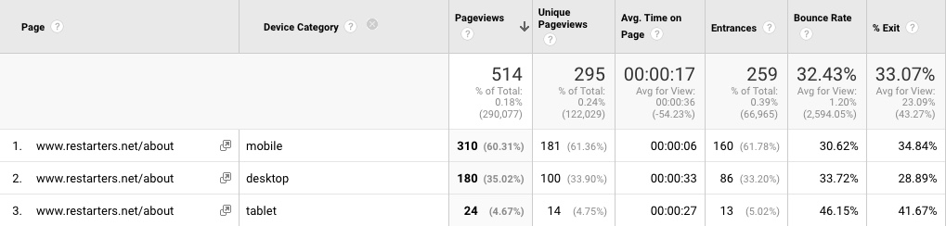
Of course, this page URL is not easy to remember for word of mouth referrals, either, but did get over 500 visitors over the past 8 months. In terms of pathing, 28% of users clicked “Create Account” from this page, and 28% clicked went to the Login page.
It’s challenging to get anybody to register for anything online, as registration takes effort, and people are understandably reluctant to invest more precious time into repeated online activities, even when privacy and data breaches are not a significant concern. It’s therefore recommended that the features and benefits communications of Restarters.net be thought through a bit more strategically, that the rotating hero areas be reconsidered (they don’t seem to add much value), and that registration itself be streamlined, if possible.
Note that on desktop (average screen resolution for a laptop), the Sign Up/ Log In buttons are below the browser fold on the Restarters.net/about page, causing some confusion as to what actions a user can take.
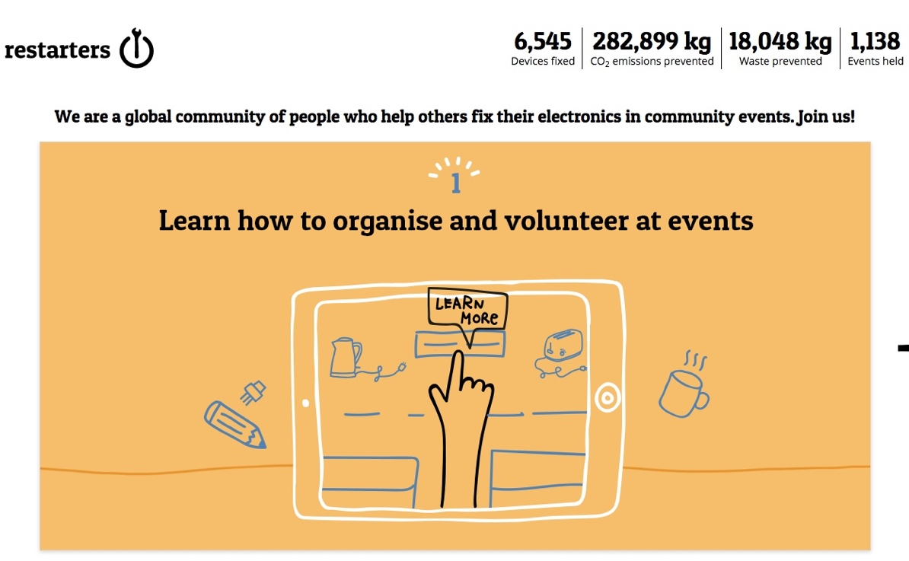
Restarters.net/about on Firefox/ desktop

Registration
Registration could benefit from a step indicator widget (displaying the number of steps/ pages until complete), as it’s common for users to abandon any form filling process; indicating few rather than many steps could encourage them to complete the process. Cutting as much content as possible from the registration might also be considered—could skills selection be handled later, for example, or could you simplify the intent of the skills section to just ask if users are interested in hosting or helping others repair (and trust they have the skills)? Could communication preferences be handled elsewhere? One strategy would be to cut the length of registration in half and then walk users through a very brief setup and optional tour.
A key bug was noted in the mobile registration: the Personal Data and Repair Data checkboxes appear as bullets, even upon zooming in, making registration impossible:
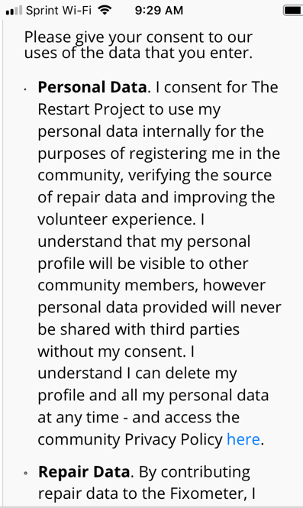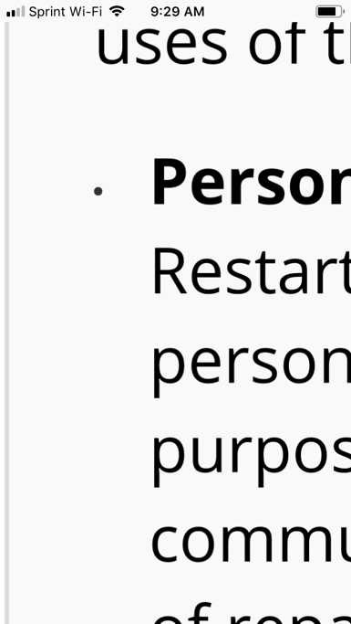
On desktop, the only worrisome part of registration for me was the indication of a city. While this field was optional, I was curious to see how geographically near Restart groups were, and expected some nudging toward existing groups or event locations—probably a likely mindset for most users—so I filled out the city field. I expected an auto-complete function or a menu to pop up, and when it didn’t, I felt very uncertain that the system would recognize my typed input, or thought this might be a bug, or perhaps Restart just didn’t exist anywhere near me (“maybe this platform or organisation isn’t meant for me,” is the thought). Consider other ways of handling location, such as a metro area selection menu that is contextual to the country menu—even if no Restart groups or events exist there yet.

Dashboard and First Experience

Onboarding/ Getting Started
The Welcome screens weren’t disruptive, but also weren’t especially helpful in terms of showing me what to do next. As mentioned previously, a tour (perhaps combined with as setup wizard) that points to elements in the interface is a more common paradigm that can help new users get accustomed to a UI, and can be accessible under a menu if users want to consult it again in the future. However, the best interfaces are self-explanatory, and if users see that they have to be taught how to use something, they may become more skeptical about the entire experience.
In the mobile experience, the Welcome flyover screen navigation buttons (Previous and Next) were below the fold in the (I had to use a simulator for this experience, as I could not complete registration on my mobile; see previous section), and there are button layout issues:
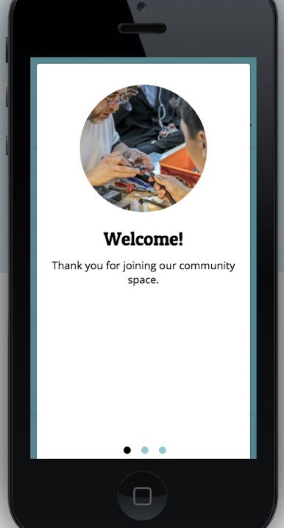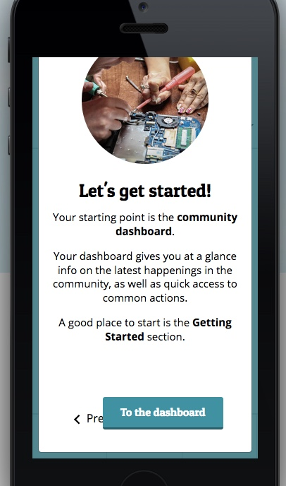
While the Getting Started module and alerts (such as the Notification alert) are helpful, other strategies that take up less real estate on the page and are less disruptive might be considered. The landing page (dashboard) itself presents some logical content at first glance—except if you haven’t chosen a city that’s full of parties, as I did the first time, when I got an empty Upcoming Events module. Consider providing an entry that is appealing for everyone, regardless of location, where there is a better visual hierarchy of content, and casual, browsable content separated from concise CTAs for popular tasks (which will hopefully be discovered and prioritized during user research).

Dashboard
Overall, this page looks a bit busy and “boxy,” especially after scrolling down. There is quite a bit going on in the content, some of which is cut off (the events table) and some repetitive (two Getting Started modules). It also doesn’t match the most visible global nav of Events, Repairs, and Groups—so the site architecture is not obvious, giving the impression that it may be easy to get lost if you click around. On first glance, Getting Started versus Events was clear enough for me, but Topics, Wiki, Getting Started with Community Repair, and Community blog modules all started getting mixed up—it’s not clear how these are different from one another.
The Global Impact seems an afterthought, yet could be quite motivating and a source of pride for this active group. A global search for the site is also not present, and the global nav itself is quite extensive after you see the options under the left menu. While a global search may not be feasible, reducing the complexity of the global nav and having it match the basic page structure would go far in helping users feel at ease with exploring. Also, while there must exist loads of fun groups photos and videos from the events, none are visible here (or elsewhere on the platform). So while the verbal tone is welcoming, the UI appears as a fairly “dry” software-like dashboard.
Stakeholder interviews indicated that the organisation’s goals and users’ goals aren’t necessarily reflected in the functionality here. For instance, would a user wanting help with funding or press releases know what to click? And if a key goal is to get activist repairers involved in policy, the dashboard should be designed to invite them into relevant tasks; it doesn’t appear to speak to them, or to policy issues at first glance.
Finally, while there is the Getting Started (with Community Repair) module, it has to do with getting started on the platform more than getting started with being a host or other basics that I might expect to be more upfront (like the Restart Party Kit). Guidance, Saftey, Risk, Insurance also seems pretty basic and needed to know upfront too.
Because there are different user types with different interests, consider customizing some of the content under a “For Hosts” or “For Activists” type of label; also consider giving these role badges to users on the platform after they’ve indicated their interests, so they can identify one another by various roles.

Events
The Events page is fairly logical, although it’s not clear why a long list of past events appears. If the intent to provide a place to start from which repair data can be added, consider creating a clearer CTA to do so. Alternatively, adding data could be done elsewhere and events could be handled just in a scrolling list on the dashboard.
The Add to Calendar function needs procedural steps (even if under a Help button) for all calendars; it took me a bit to figure out how to subscribe via URL to a calendar in both iCal and Google.

Repairs
The intent behind this page is not altogether clear: what should users do with this data? And why is this not called the “Fixometer” (more on that under the Global Navigation + Nomenclature section).
There was also a bit of awkwardness in the swiping/ horizontal scroll for viewing this info on mobile:
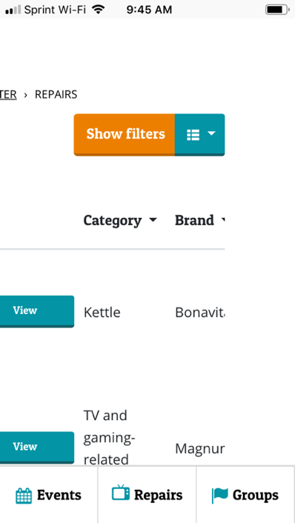

Groups
“Follow” vs. “Join” terminology was confusing. I might have also appreciated being put into groups automatically, as I’m not sure what “joining a group” really commits me to? Especially considering I might only be “following.” This does bring up an interesting point, and that is, whether the delineation between groups and locations is intuitive to users. Isn’t the Restart Project one big group—why create sub-groups except by city and occasional specialized interests? In any case, The groups page is what I might expect to see on first landing on the site, perhaps with a map entrypoint. Most groups’ names really don't communicate much, which is why a map might be a more meaningful way to make a choice.
The individual Group pages don’t have a forum/ chat function, so at first glance, I’m not sure of their purpose. There is a great deal of space devoted to repair data, but I don’t sense that this would be my primary reason for interacting with this group or group page, aside from maybe using it to gauge if the group is active.
Groups had a similar problem on mobile with swipe/ scroll action not being obvious at first glance:
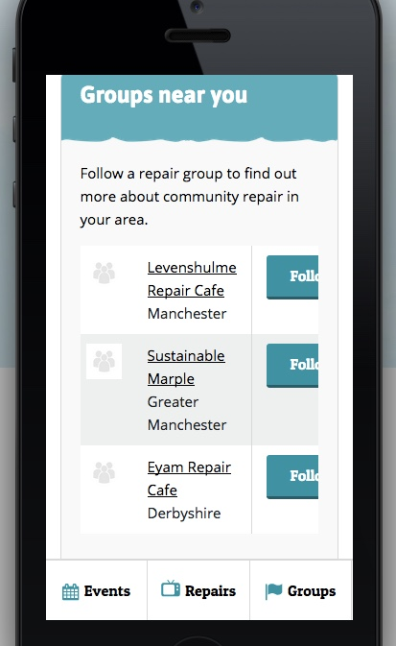

Global Navigation + Nomenclature
Global navigation and some nomenclature are highly problematic on Restarters.net. Currently, there is no consistency in the global navigation that appears across modules, and in the case of the Wiki, there isn’t a way to even get to other modules or back to the dashboard. It seems that the spawning of new browser windows/ tabs was an attempt to provide a workaround to what might be an out-of-the-box UI issue for these modules, but the opening of new windows/ tabs doesn’t happen on mobile. The numerous open windows or tabs on desktop is a clunky experience.
Space for navigation at the top of the page is currently used more for what could be considered sub-navigation of each module, which is an unusual practice: sub-navigation should appear lower in the navigation hierarchy (such as under a menu), and if navigation appears across the top of the page, it should reflect the foundational structure of the site—in this case, the three modules of Dashboard, Wiki, and Talk. Because mobile is a critical use case, global nav must be kept concise visually, in future redesigns.
Other problems include:
- visible navigation elements for sections such as Events, Repairs, and Groups not staying highlighted upon selection
- the hamburger menu being used in an unusual way for sub-navigation in Talk (hamburger menus are normally used for global nav)
- unnecessary sub-navigation adding to users’ cognitive load (in Talk and Wiki especially)
- pages missing headings/ labels
- missing breadcrumbs or UI for navigating back to module landings pages
Additionally, there are some significant nomenclature problems, the most serious one being the use of “Fixometer”—which isn’t really defined, but implies a tool used to measure fixing data—which would lead users to believe it could help with data entry and tracking. This term probably evolved to internally refer to the entire Dashboard-centered module, but is now imposed on users as jargon—in the UI, it appears to be used to signify the Dashboard. This is highly problematic, as it takes a while to figure out that clicking “Fixometer” in the global nav or breadcrumb is the only way to get back to the Dashboard (and this detail will likely not be remembered by infrequent visitors). It’s recommended that this term be defined for users with only one specific meaning and corresponding section (right now, I’m not sure if I’d choose Repairs or an individual Group page to mean “Fixometer,” but I definitely wouldn’t use it for the Dashboard.)
Another basic nomenclature issue is the vague use of “Restarters” for all kinds of community members, and the vague term of “volunteers” to mean expert repairers. It’s time to get more rigorous with use of these terms to avoid confusion; perhaps “hosts” vs. “repair mentors” vs. “repair participants” would be more descriptive. (At this time, I’m not sure what to suggest for the data volunteer role, as I’m not entirely sure of the tasks they would be performing.) One other note on verbiage for community members: I was unsure whether “Rosies” was a cultural gender reference I didn’t understand because I’m not British, and of its possible negative connotations for women—and therefore, I felt uncomfortable with it at first glance. I would recommend, at the very least, explaining it prominently (but concisely), and making sure all members know that events by default are designed to be fully inclusive of all genders.
More minor nomenclature issues like using “topic” (similar to “category”) for “post” in Talk might be causing some confusion. (Even the section name, “Talk,” is a bit awkward.)

Wiki
The pages of the Wiki appear to be among the most popular on the platform, especially on mobile (mobile pages highlighted in yellow below), possibly connoting that users are accessing the wiki pages on their phones at events, and that the least dynamic content on the platform is actually the most useful:
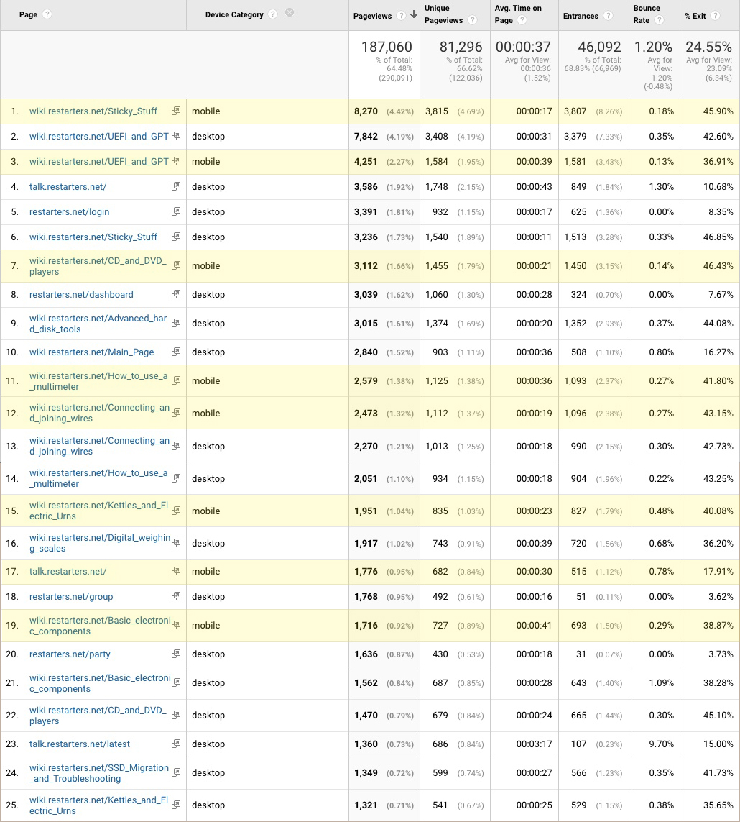
Most visited pages on Restarters.net within the last 8 months
As users don’t have to log in to view all of these pages, they make for easier access. Users might also have pages bookmarked for reference at events. If these conclusions are true, they could have implications for improvements on the platform, such as bookmark or favoriting functionality and a place to save additional instructional content that hosts and repairers would like to share.
The Wiki itself seemed a bit lightweight in content, considering the amount of how-to content out there on the web and the enthusiasm that many people bring to it on platforms like YouTube. I expected a bit more of an instructional strategy here, and to see many more links and notes that users had added. I had a difficult time finding information about upgrading my laptop; this information was buried, rather than at a high level as I would expect. There seems to be no rhyme nor reason as to which information is loaded via an anchored link on the same page, and which loads a new page, but the loaded pages provide no breadcrumb or other navigation to get back to the Wiki landing, so the user must click the browser’s back button.
The “clicked” state of Wiki section links appears to be nearly black and almost indistinguishable from body text, making it difficult to detect all of the links; consider a different color for clicked links.
I couldn’t not manage to access the Edit function of the Wiki (apparently due to a bug/ recent update).

Talk
The Talk section suffers from two primary problems at a high level: a categories column of choices that do not appear to be filters for “topics” (although that’s what they really are; the terms “categories” and “topics” are so close in meaning, causing more confusion); and too many navigation/ options both on the page and in the hamburger menu (which is typically used for global navigation on mobile, not sub-navigation). Users might struggle with what to click from the landing state of this page, as analytics indicate that they clicked the “Latest” filter at least 10% of the time, even though latest posts are apparently being displayed in the right column. This might not be obvious at first glance, with so much going on in the labeling and layout.
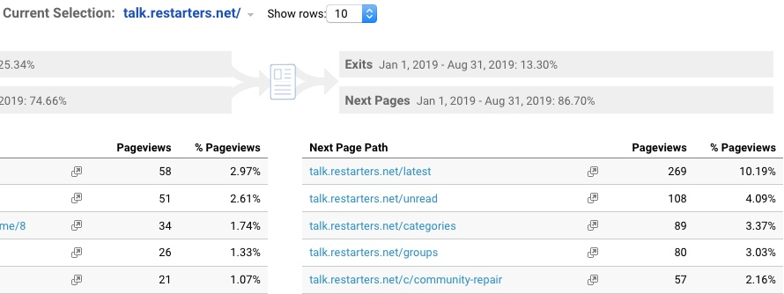
Redesign of this UI is recommended to reduce or downplay the number of options, and to make categories look like filters.
I believe you could do away with all of the subnav in the hamburger menu and not lose much (just provide a way to get back to the landing page from reading and replying to a topic/ post). At the moment, this menu, meant mainly for mobile, gets cut off on mobile anyway (the below images show screenshots of having swiped/ scrolled to the right):
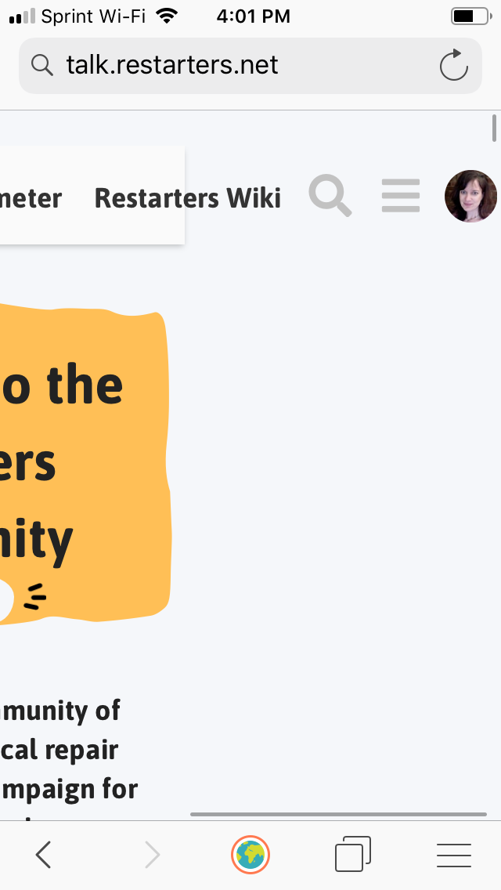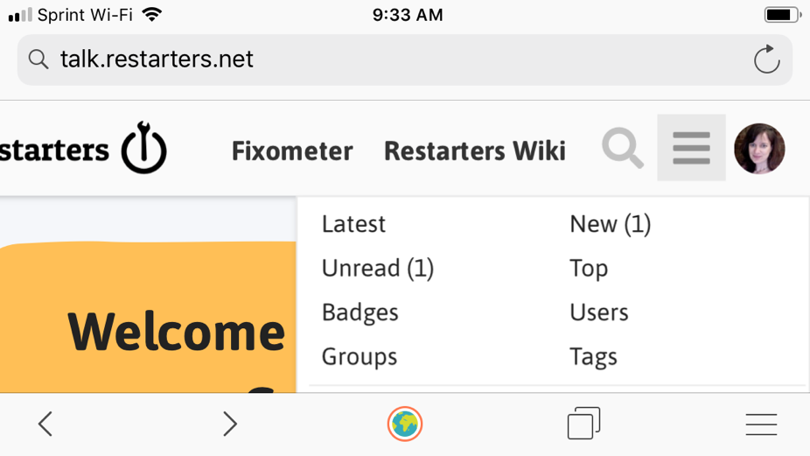
I believe I missed the Reply window the first time I clicked “Reply” to a topic, and thought it was a bug that nothing appeared. Consider graying back the rest of the screen to make sure the Reply window is obvious.

Profile
It may be confusing to users that their profile is not synced across the modules, so it would be advisable to fix this technically, if at all possible, even if it means doing it manually on the back end. It’s especially noticeable for elements like photos and settings.

Hosting Tasks
I performed as many tasks from the following list as possible on the staging instance:
- create a new group
- invite volunteers to the group (both people on the platform and not on the platform)
- create a new event
- invite people to the event
- add repair data to the event (only possible for events that have already started or are in the past - to test this, you can create an event with a date in the past)
- share impact stats from the event
While the tasks were relatively easy to perform, my events weren’t viewable on any pages after I created the event (aside via the View Event button on the same event creation page). If this is because the event is pending admin approval, there should be a way to see the event with a “pending” status; otherwise, users will worry their event did not save properly.
One bug: I never received an invitation to my e-mail address when I attempted to send one as a host, and I had trouble the first few times even sending through the invitation. Note there is no indication below of why the “Send Invite” button won’t activate:
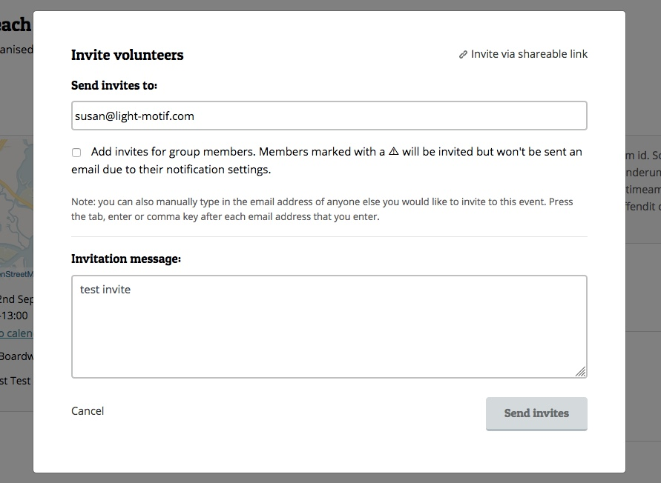

Bugs Not Mentioned Previously
- can't click off of a lot of UI elements (like Add to Calendar URL window); have to click the UI element again to close it
- French text not all in French
- miscategorisations in Talk (for example, I saw two topics labeled as "English" instead of “How to repair in your community” category)
- external web links loaded in same browser window, rather than in a new window (several links in Talk)
- it took 8 minutes for reset password email to arrive (not really a bug, just a bit slow/ worrisome)
- TV and couch analogies don't make sense to me (data stats), yet take up a lot of room (more of a verbal “bug”?)

