Product Requirements Document (PRD)
Reading Coach
Authors: Susan Stuart and
Reviewed and Approved: Month dd, yyyy
Version: 1.1

Related Documentation

The following table provides the list of related files associated with this PRD.

Date | Document Name | Description | Author
11/2/09 | ReadingTutorWireframes-1.indd (InDesign) | Early wireframes | George Schneiderman
? | Usability videos | Usability sessions conducted at Carnegie Mellon on their Reading Tutor software with students | ?
1/25/10 | RC_flow_v3.pdf | High-level application flow | Susan Stuart
1/25/10 | RC_Student_UI3 | Wireframes for the student interface. Includes basic functionality and early creative ideas around engagement | Susan Stuart
1/25/10 | RC_Teacher_UI3.pdf | Wireframes for the teacher interface. Includes basic functionality and early ideas around data visualization. | Susan Stuart
1/25/10 | RC_AdditionalWFs | Additional wireframes created around authentication, to try to avoid having teachers log in every student. | Susan Stuart

Additional group discussions and files can be found on BaseCamp at:

https://wgitops.basecamphq.com

State of the Project – 1/25/10

High-level points regarding the state of this project upon its temporary termination are as follows:

• Authentication – The solution we landed on for now is for a teacher (and/ or admin, if an admin can be trusted with a teacher’s mCLASS user name and pw) to log in each student for use of the application. It is recommended that other solutions be explored with a technical lead so as not to burden teachers with multiple logins for students. Some ideas include access to downloading a particular key, or some network-licensed use that allows access only within a firewall. The solution should be flexible to allow remote access as well, but having a parent log in for a kid each time at home would be acceptable.
• Engagement – Only early ideas for student engagement (with gaming components) have been presented in the UX documentation, and further exploration and brainstorming with a creative team would be needed.
• Technical/ logic – On the back end, corrective behaviors should follow the research-based options already coded into the CMU Reading Tutor, but not all options necessarily need to be employed, and different UI conventions could be used.
• Pedagogy – The flow of the reading application as well as the data available to teachers should be reviewed by pedagogy experts.
• Visuals in WFs all placeholder – Note that the wireframes include rough visual ideas, but should not be considered final design. However, color recommendations should be considered where they are indicated (especially avoiding over-reliance on colors like green/ red as the sole indicator of state or information, when a significant percentage of users cannot see green/ red).
I. Business Rationale and Product Overview

A. Product Description

The initial release of the literacy intervention and practice application for young readers, referred to here as “Reading Coach,” is a Web-based version of the software technology supplied by Carnegie Mellon University’s Reading Tutor. There will be a prototype version (for Beta) and a version that is fully integrated with mCLASS. This document details the features envisioned for both the Beta and Full version of the product.

B. Users

Users of the software will be teachers of primarily 1st through 4th grades, as well as students in those grades (widest age range of 4 -10). The students can be assumed to be emerging readers who are either very new to reading, or have repeatedly struggled with literacy skills. The product may eventually expand to support literacy improvement for higher ages.

C. Customer Relevance and Benefits Drivers

D. Competitive and Related Products

- Carnegie Mellon’s Reading Tutor

Reading Coach will leverage the technology developed at Carnegie Mellon University for their Reading Tutor product—specifically the fluency practice module, where the student reads out loud and the system provides guidance and corrective feedback.
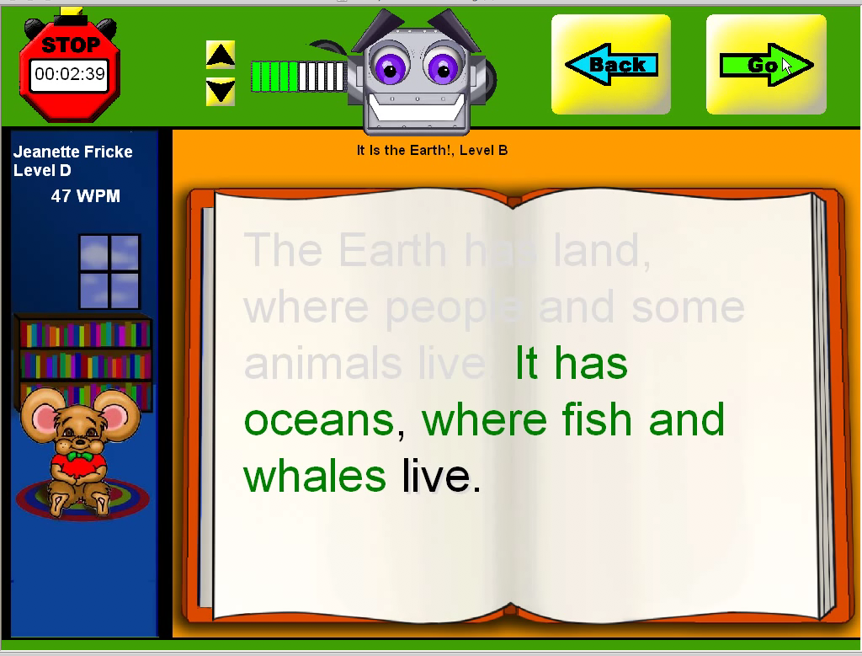
Figure 1: Carnegie Mellon’s Reading Tutor Student Interface

2. Soliloquy Reading Assistant

A CD-ROM/ Windows-based program, this is the closest competitive product to Reading Coach. Students can select books from a library, read and record their readings, be read to through a model reader, play back their readings, look up words in a glossary with fun facts, save a personal glossary, accrue power points, and review their own reading sessions. Some of these features (such as record and review) are appropriate for parents too. Corrective feedback is given to readers along the way.

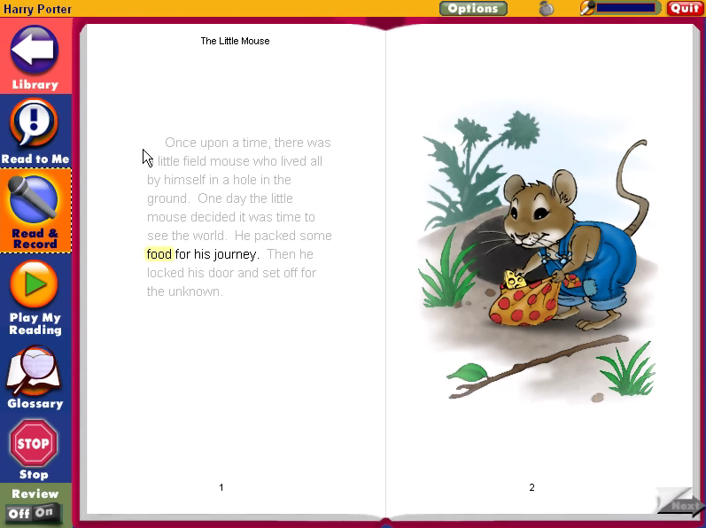
Figure 2: Soliloquy Reading Assistant’s Student Interface

3. Headsprout

An impressive Web-based animated cartoon and game-like interface for teaching brand new readers letters and sounds within a story and setting. Episodes are instructionally progressive, and higher levels of episodes have more advanced tasks involving fluency, vocabulary and comprehension. Parents are sent a summary e-mail of child’s progress after each episode is completed, and a progress map is also provided.

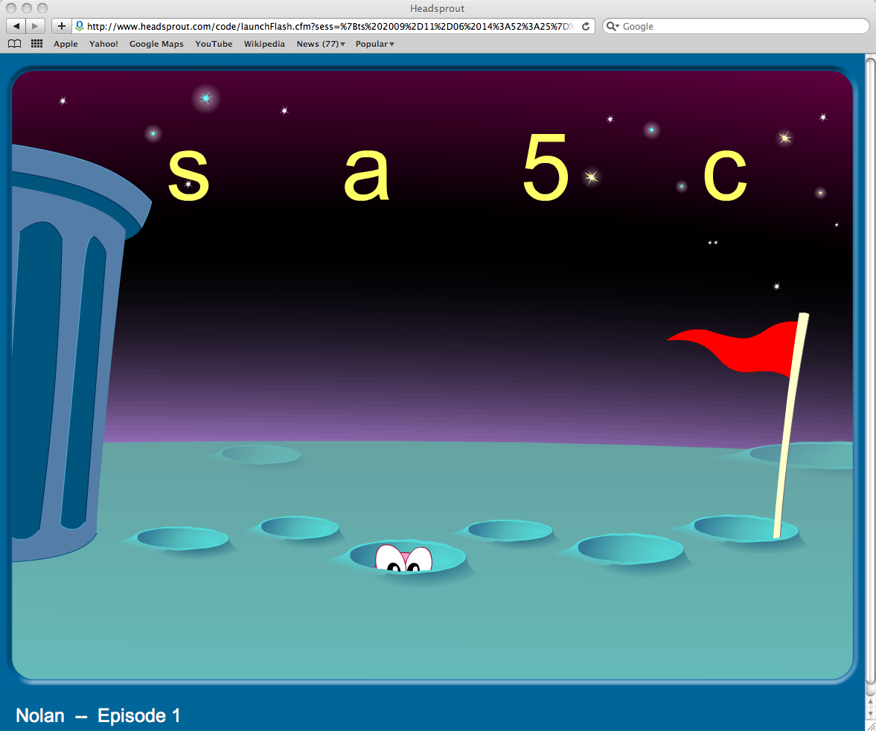
Figure 3: Headsprout’s Student Interface for Phonemic Awareness Game
4. Raz-kids

An interactive reading program on the Web, Raz-Kids provides a large library of books, many with guided reading, but without voice detection and corrective feedback. Some books are in listen mode with interactive with audio and animation, and some are static, read-only pages. In listen mode, each word or sentence is highlighted as it’s read. Audio sound FX add interest to the stories as they are read. Some stories also have comprehension questions, and downloadable/ printable worksheets are also available.

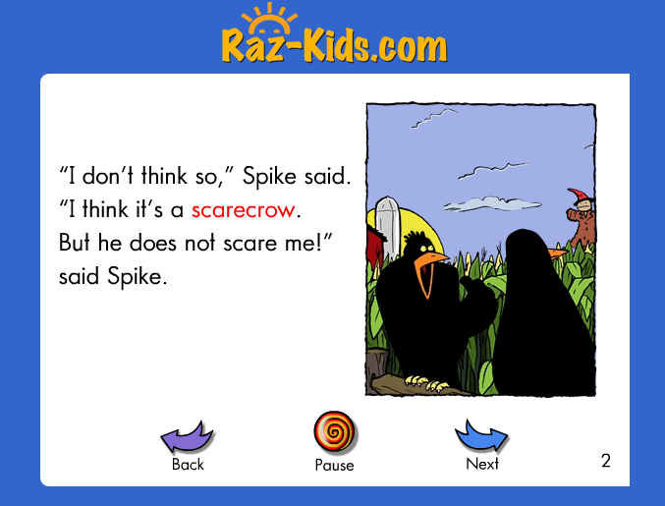Figure 4: Raz-Kids’ Student Interface. Visuals have some animation and audio.

5. IBM Reading Companion

Web-based reading tool that provides corrective feedback phrase by phrase as the student reads. Versions for an adult audience are available as well.

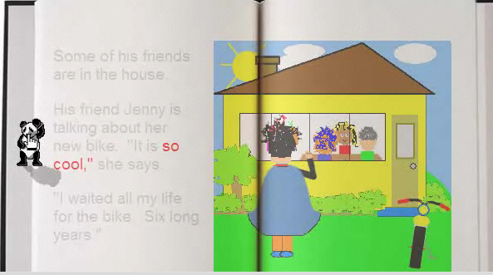
Figure 5: IBM’s Reading Companion for Young Readers. Immediate audio feedback on both correct and incorrect phrase readings.

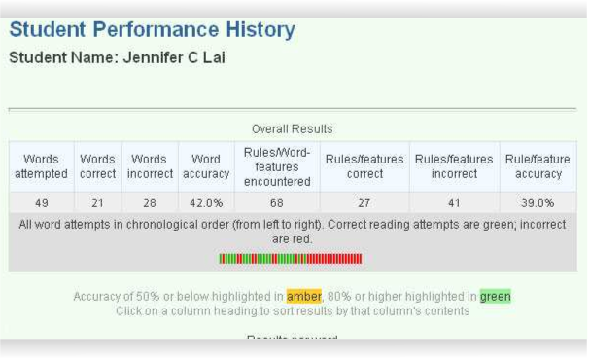
Figure 6: IBM’s Reading Companion Student Performance History—Overall Results.

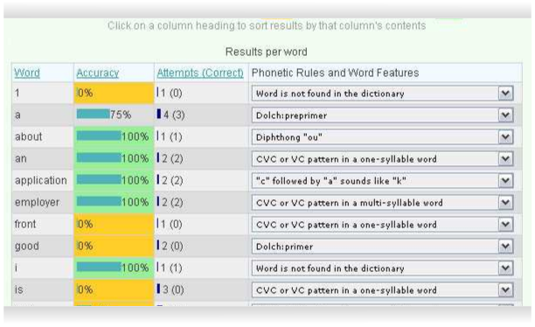
Figure 7: IBM’s Reading Companion Student Performance History—Results Per Word.

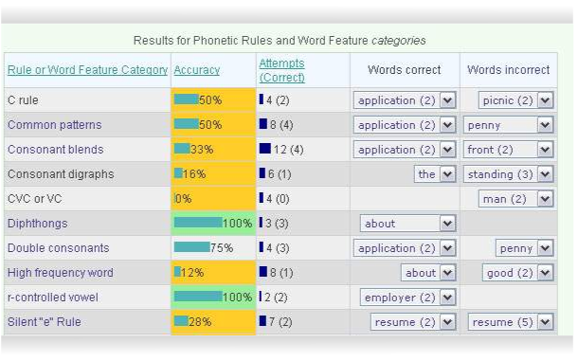
Figure 8: IBM’s Reading Companion Student Performance History—Results for Phonetic Rules and Word Features Categories.

6. TUNEin to Reading

Following a theory that progress is made through repetition and kids are more likely to want to sing a passage repeatedly than read it, TUNEin to Reading incorporates a “sing along” methodology in their reading software. This software can identify individual sounds within words that were incorrectly read, then analyze data from a reading to identify problem areas in pronunciation for students.

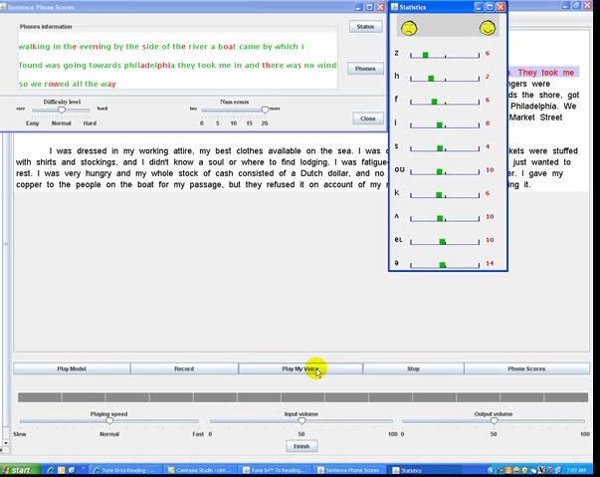
Figure 9: TUNEin to Reading’s Phonemic-Level Analysis Screen

7. Readio

Readio provides corrective feedback through audio only as a child reads from a printed book.

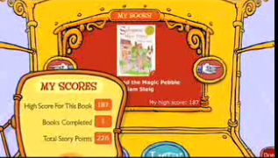
Figure 10: Readio’s Home Screen

8. Pearson QuickRead and QReads

Installed locally, this software helps students build fluency, comprehension, and vocabulary through independent practice with advanced, research-based technology. They have an individual version and an enterprise/ server-based version.

9. Read Naturally

Publisher of various literacy products which include audio CDs/ cassettes, books, group support products, home products and a software edition that is goal-oriented and keeps track of student progress.

10. Rosetta Stone Totale (related product—language learning)

Notable for its live tutor/ Webcam instruction, as well as social networking components where learners interact virtually.


II. Reading Coach Feature Set

Reading Coach will incorporate the following features through its initial setup and sign in, teacher mode and student mode. A possible Parent Mode—accessible via a unique user ID and pw remotely—is a possibility for this product as well, so that parents can track their kids’ progress, but is not specified in this document or associated wireframes.

A. Initial Setup and Sign in (Teacher and Student)

Release | Feature Description
Beta and Full | Initial Authentication (by an adult). An initial screen prompts a teacher (or possibly a parent) to log in to the application for either student use or to track student progress. mCLASS user name and password should be employed here. NOTE: This is a less than ideal solution for logging in multiple students; further exploration with the technical team might be considered around authentication.
Beta | Application/ Teacher Setup. Simple import of class data from mCLASS by teacher may be necessary for Beta version. Teachers import entire classes and multiple schools as appropriate, and are prompted to verify and/ or complete student data (especially birthdates, needed for student authentication) and optionally create groups. Note: for Full Release, mCLASS data will automatically get pushed to the Reading Coach application, and a separate import step will not be needed.
Beta and Full | Teacher’s login is persistent (remain logged in until user logs out).
Beta and Full | Headset image. Students should be shown an image or audio with a prompt to put on an audio headset properly early in the application flow, as many functions in the interface are audio-supported.
Beta and Full | Student authentication (to ensure both security and proper identification of unique user) will be performed through selection of gender, age, and birth month/ date, as well as first and last name. Predictive text with audio support for emerging readers may be employed. Students are logged out after X minutes (TBD) of inactivity.
Beta and Full | Student Setup. Microphone calibration - may be needed on first login, or possibly if a different IP address is detected so that the system can calibrate to the student’s voice and system audio configuration, for the most accurate voice detection. A screen showing proper positioning of headphone and microphone should be available to a student, and more detailed help will be available for an administrator. Also as part of setup, students choose an avatar which will support engagement through possible social networking aspects and story progression.
Full only | Teacher can launch Reading Coach from within mCLASS.

B. Teacher Mode Interface

Release | Feature Description
Beta and Full | Home/ Class Summary. Teacher Home should present the user with a simple and intuitive way to view data about the class, group, or Burst group, as well as the ability to switch between groups, classes and schools, as appropriate. The actual Reading Coach performance to display here is TBD, and should be considered in conjunction with pedagogical experts. (This data would sync each time Reading Coach is launched, or for Beta possibly a manual sync would be needed?).
Beta and Full | Switch to Student Use Mode. Teacher should be able to switch to Student Use Mode at any point.
Beta and Full | Create/ Delete Group. Teachers can create their own groupings of students, and assign them a custom name or number. Deleting a group does not delete students from the classlist.
Beta and Full | Add/ Remove Student. Teacher should be able to manually add or remove a student from the Reading Coach classlist. The classlist in Reading Coach will initially contain all students imported from mCLASS, but the teacher can edit the list down only to the students who use/ need Reading Coach if desired.
Beta and Full | Lock Level. Teacher can optionally lock a student at a level (optional).
Beta and Full | Restrict book type. Teacher can optionally restrict book type to fictional or informational (if student is reading too many of one type of book.
Beta and Full | Set Up Class/ Student Profile Edit. Teacher can edit student setup/ profile information, in one spreadsheet-like screen for an entire class.
Beta and Full | Student Detail. Can drill down into detailed performance data on Reading Coach by student. Option for a graphical/ progress view of data as appropriate. Again, the actual data to be displayed should be considered in conjunction with pedagogical experts.
Beta and Full | Review Session. Ability to access and review each student’s readings, in whole or by sentence, visually.
Full (P2 for Beta) | Review Recordings. Ability to access and review each student’s recordings of readings, in whole or by sentence. Also able to review students’ personalized answers to questions about the story (see Student Mode Interface, Comprehension screen).
Full (P2 for Beta) | Enter Session Notes. Teacher can enter notes about a session after reviewing the session detail screen and/ or recordings.
Full (P2 for Beta) | Functionality for downloading recordings to iPod, smartphone, etc.
Full (P2 for Beta) | Access to Reading Coach reports from mCLASS. Reading Coach data can be integrated within other Web applications’ (such as Burst) data lists through the use of an icon or symbol with score or other relevant Reading Coach data per student.

C. Student Mode Interface

The Student Interface should be simple but intriguing and fun, with UI affordances appropriate to the motor skills of those ages 4 through 10. Audio support should be provided wherever text is used for emerging young readers. Usability as well as engagement should be considered in the User Experience for students, as instructional goals are only achieved with this product through repetition and practice. Intriguing visual elements, animation, characters, points, level rewards, and perhaps a storyline should be considered to encourage repeat and progressive use, and social sharing among Reading Coach students.

1. Home

Home should display activities available to the student, as well as track what the student has accomplished so far. The student should be able to quit from this screen, as well as adjust the volume and get sound help. Interface elements are spoken aloud as user mouses over them, to support emerging readers.

Release | Feature Description
Beta and Full | Shows the points accumulated for books completed so far. Option to integrate creative metaphors for progressing through points and levels, and these would be displayed visually.
Beta and Full | Shows list of on-level books available for reading and number of points each book is worth. Books should be level-matched according to Guided Reading from Reading 3D. Books that student has started but not finished are indicated through a visual/ animated state.
Beta and Full | Student can change level of books available for reading (move up one level), if the teacher has not locked this privilege. (If teacher has locked level, it will still change on its own according to student progression.) Level is pre-determined based on Burst or 3D data, as well as any previous progress made in Reading Coach.
Beta and Full | Student can navigate through screens of available books (if all cannot fit on one screen).
Beta and Full | Shows list of books student has read with student’s ratings, and/ or points earned per book. Interface should implicitly encourage user to choose new books over previously read (through size, color, placement, metaphor, etc.).
Beta and Full | On mouse-over of book, audio and visual teaser of book content should appear to give student an idea of the content.
Beta and Full | On click of book, confirmation dialog lets student confirm s/he would like to proceed in reading book.
Beta and Full | Student can quit/ log out. Takes user back to Initial Authentication (where adult must log in for student). Students are logged out after X minutes of inactivity (number of minutes TBD).
Beta and Full | Student can adjust volume and get sound help. An image or video will be displayed to show child how to wear audio headset. (Adult/ administrator settings available as well to adjust sound settings.)

2. Read Story

There are three progressive modes for reading any story. First, there is a Cold Reading by the student on the book with no corrective feedback (but assistance if student gets stuck). Second, there is a Model Reading of the entire story (this is also available at any point during the story). Finally, the student is guided through a Corrective Reading, where student reads and receives immediate corrective feedback. Fluency is assessed here, and student can repeat corrective reading as many times as s/he likes. Subsequent corrective readings could factor into a cumulative WCPM and/ or accuracy score, but additional points are not awarded upon completion. EXACT PEDAGOGICAL FLOW TBD.

Release | Feature Description
Beta and Full | Introduction. The Read Story activity will provide brief aural instruction at the start of the activity for student.
Beta and Full | Student Cold Reading. Student is prompted to read the story on first viewing. As the student reads, the interface indicates the sentences it detects have been read. No corrective feedback is given during the first reading (cold reading). If a student pauses for more than 5 seconds, the model reader finishes the sentence for the student.
Beta and Full | Model Reading. After a user has finished reading a story, a Model Reader (possibly character “voice” of chosen avatar) reads the story to the student, and the sentence currently being read is highlighted appropriately. This Model Reader is accessible to the user at any time (to read entire story, or just receive word help). At the end of the reading, the application prompts the student to read the book again.
Beta and Full | Corrective Reading. The interface highlights words read correctly, and will not continue past a word read incorrectly. The user can then click the avatar to hear the word correctly spoken.  Corrective feedback behaviors should be based on the logic embedded in the CMU Reading Tutor application, and exact pedagogy from available options should be determined by a pedagogy expert. In the interface, the following conventions can be employed:  1) When word help is given, word size increases and avatar speaks word.  2) Student can click avatar next to text at any time to hear the next word spoken. Words are not clickable for help, so as to not encourage too much assistance without trying, and to provide a way to surface vocab definitions if available.  3) When any kind of visual phonetic help is needed, avatar holds up card with word/ sounds and speaks them.  4) If student does not get word after multiple attempts, avatar holds up video screen of mouth pronouncing word (optional).  5) On any subsequent wrong attempts, the word turns purple and student can continue reading.  Stopwatch is paused during any corrective feedback.
Full only | Vocabulary Option. Student can mouse over words to get a visual cue that a word definition is available for review upon clicking.
Beta and Full | Stopwatch/ Stop Reading. A “stopwatch” is present that times the student as s/he reads. Clicking it surfaces a dialog to confirm stopping, and upon stopping, the student returns to Home.
Beta and Full | Story Pause. If student hasn’t completed story (has clicked Stopwatch or interrupted with Model Reading), the subsequent session will prompt a student to choose whether s/he would like to pick up where left off, or start at the story’s beginning.
Beta and Full | End of Story – Tally Points. Student is rewarded with a point tally animation upon finishing a story, and point level is increased.
Beta and Full | End of Story – Rate It. Rating page elicits feedback from student on how much they liked the book.
Full (P2 for Beta) | Comprehension Screen. Two options are available for comprehension questions: multiple choice, or record an answer in student’s own words. Some examples could include:  - Tell me what this story was about.  - Make up your own ending.  - Tell me what you think of [character] and why.  - What was your favorite part?  - What was your least favorite part?  Possibility for teacher to choose which types of comprehension questions are employed for stories.
Full (P2 for Beta) | End of Story – New Point Level Reached. As an incentive and reward to keep reading, student could be given access to a virtual social play area upon reaching a new point level (for example, every 10 points). Student avatars could  interact with each other in (possibly in real time, and points  metaphor could change to reflect new level (bricks, apples, gold coins). Storyline TBD. Students could access each other’s recorded comprehension answers through their avatars, or  interact otherwise according to the storyline.
Full (P2 for Beta) | End of Story – New Reading Level Reached. Students will also be given access to the virtual social play area, with a congratulatory animation integrated, when a new reading level is reached.

3. Read Again

When a student finishes a reading of the story, there is a prompt asking the student if s/he would like to read another story, which would return the student to Home, or quit.

4. Word List

Word List could be an optional (P2) interactive practice screen for problem and vocab words for a session, or simply be an option to print or download on exit.

5. Adjust Volume

Student should be able to adjust volume at any time through the interface volume buttons.

6. Sound Help

Student should be able to get help with sound issues (e.g., not hearing sound, system not detecting voice (sound input), calibration) at any time.

7. Done (Exit)

Student should be able to log out and return to Student Mode login screen.

III. System Requirements

A. OS/ Browser

B. Screen resolution

C. Integration with other products

Teachers add students to classes in mCLASS so that student will appear in Reading Coach. mCLASS will also allow teachers to request a list of students who need fluency practice after they have been through a Burst group that included fluency instruction. (Burst could automatically suggest adding these students to Reading Coach?) Reading Coach reports should also be accessible from mCLASS.

IV. Content Requirements

Books integrated per level, using Guided Reading books.

V. Documentation Requirements

VI. Timeline

VII. Key Stakeholders and Contacts

VIII. Definitions and Abbreviations

IX. Policy/ Legal Requirements

X. Testing/ Beta Requirements

